

Research and implement technology sales website project, Used C# programming language with

ASP.NET MVC framework with support of Bootstrap framework

Tutorial By : Le Ngoc Thanh

Student name: Trinh Nguyen Huong Huong Kieu

Student ID: tk0099x

Class: TCS2012

Table of Contents

Introduction 2

1) Aims 2

2) Objectives 3

**Research documents on e-commerce** 3

**Planning to build the project** 3

**Project implementation** 4

**Testing and debugging** 4

I. Literature Review 4

1) C# 4

2) HTML 4

3) Boostrap 5

4) Css 5

5) JavaScript 6

6) Arjax 7

7) MVC 7

8) Visual Studio 8

9) SQL server 8

II. Methodologies 9

1. V model 10

III. Requirement Analyst 11

1. Roles 11

2. System requirements 12

IV. Design 16

1) Database Design 16

**1.1.** **ERD Relationship** 16

**1.2.** **ERD Diagram** 17

2) Use Case Diagram 23

**2.1 Admin/Customer Login** 25

**2.2 Admin manage Account** 26

**2.4 Admin manage Category** 27

**2.5 Admin manage Product** 28

**2.5 Admin manage Order** 29

**2.6 Admin Manage Contact** 30

**2.7 Amin/Customer Coupon** 31

**2.8 Admin/Customer Comment** 31

**2.9 Customer View Product** 33

**2.10 Customer Order Product** 34

3) Flow Chart 35

**3.1 Login and Register process** 35

**3.2 Resset Password process** 37

**3.3 Order procsess** 38

4) WireFrame 40

4.1 Home Page 40

**4.2** **Detail Product Page** 41

**4.3** **Category Page** 43

**4.4 Shopping Cart Page** 44

**4.5 Check Out Page** 45

**4.7 Admin Product Page** 47

**4.8 Admin Add Product Page** 48

**4.9 Admin Dashboard Page** 49

5) Class Diagram 50

5.1 Class Diagran 50

5.2 List of classes 51

5.3 Detail of classes 51

51

53

55

57

58

60

6) Sequence Diagram 61

**6.1** **Login Sequence Diagram** 61

61

**6.2** **Register Sequence Diagram** 62

62

**6.3** **Category Sequence Diagram** 62

62

**6.3.1.1** **Product Sequence Diagram** 63

63

63

**6.4** **Comment Sequence Diagram** 64

64

64

**6.5**  **Comment Sequence Diagram** 65

66

**6.6** **Shoppingcart Sequence Diagram** 66

66

**6.7** **Check out Sequence Diagram** 67

67

**6.8** **Admin manage product Sequence Diagram** 68

68

**6.9** **Admin manage order Sequence Diagram** 69

69

**6.10** **Admin manage product Sequence Diagram** 70

70

**6.11** **Admin manage category Sequence Diagram** 71

71

**6.12** **Admin manage account Sequence Diagram** 72

72

7) Site Map 73

7.1 Site map for customer 73

73

7.2 Site map for Admin 74

V. Implemention 75

1) Home Page 75

75

76

2) Categories 78

3) Search Product 80

4) Product Detail 82

82

5) Comment 84

85

6) Register 88

7) Login 91

91

93

8) Change/ Reset passoword 94

95

9) Shopping Cart 98

98

99

101

10) Check Out 103

106

11) Check Out by paypal 107

12) Check out by cash 109

13) History Order 109

14) Send to email to confirm order 114

115

15) Profile 116

16) Mange Product 118

118

1) Add Product 119

119

2) Update Product 122

3) Delete Product 122

17) Dashboard 123

18) Manage Order 128

1) Orders 128

2) Order Detail/Update Order 130

a) Controller code 131

b) HTML code 132

19) Manage Account 133

1) View list 133

VI. Testing 138

1) Aim 138

2) Scope 138

3) Out Scope 139

4) Test Log 140

Customer role 140

Admin Role 143

VII. Conclusion 145

VIII. References 146

The project section is archived here:

<https://drive.google.com/file/d/16ITz1QPYX_R8jK-sUvvaiTq8WNRowH7m/view?usp=sharing>

**Introduction**

Briefly about the information technology industry, let's take a look at it, we can see the importance of the information technology industry, in recent years this industry has gradually returned, extremely useful and important. Directly affecting the life of mankind, it contributes to promoting the development of society towards modernity for all mankind. Therefore, this industry makes a great contribution in today's modern society when in general in terms of technology. This technology and it's own that is the other pages of e-commerce is covered nationwide, and helps contribute a large part to the economy of the country.

1. **Aims**

In the current complicated situation of the ongoing covid-19 epidemic, it is currently very difficult for business establishments to be able to conduct business with direct items at the store, so to be able to attract customers. and maintain the ability to do business in the current times. Build an e-commerce site to be able to do business online, maintain the ability to sell and find more potential customers. To meet that, the commerce site needs to ensure full functionality to serve customers and can help the store easily manage orders and products. In addition, the e-commerce site specializing in providing products related to this technology will solve problems, display products, product information, comments and reviews of people who have purchased, help Other customers have a different experience with an objective view of the product they want to buy, find and browse the product, add the product to the cart and proceed to choose a payment method (Cash or Paypal). Not only that, it also performs well the product and order management features for managers

1. **Objectives**

**Research documents on e-commerce**

First, when we carry out an important project, we need to study the documents related to it, not only that, the collected data greatly affect the level of success. The success of a project, therefore, we must research and draw evidences of reliable data from reputable and influential research sites in the scientific research community. From that, we can draw conclusions. firm argument so that the project can be completed

**Planning to build the project**

After drawing the requirements from the above research, we proceed to draw up a detailed plan to begin the construction of the project. To embark on project implementation, it is necessary to first prepare plans such as the implementation of user interface design for each website, relational design in database, class diagram design, design flowchart and apply model MVC (Model-View-Controller) for building e- commerce website. Then we will outline a clear specific time for each step, the execution time will be clearly and logically divided for each step. However, priority must be given to the steps that are considered the most important of each step. the first project to be implemented, avoiding the uneven distribution of the functions as originally planned.

**Project implementation**

After planning to implement the project as well as finding the technology and model to implement the project, it will proceed to install the tools to build the software, which is Visual Studio, a Easy to use and learn for students who are just getting started with the programming environment, with MVC based on this software. Next, I will start building the first website layout of the system based on the design that I have prepared to build the system, next is to connect to the database to manage the data. User and administrator input. Finally proceed to write the code to build the requested e-commerce site features as planned.

**Testing and debugging**

After the e-commerce site is implemented, there will inevitably be system vulnerabilities and errors when running the program's functions. So this step is also extremely important if you want to put the system into use. I will run the system again and again in different cases to find out the weaknesses of the system, thereby finding ways to service and debug, Help the commerce site reach the consumer in the most complete way.

1. **Literature Review**
2. **C#**

C# is a popular programming language in recent days, it is a programming language developed by Microsoft. The programming language is very popular when it is used by many companies to develop software. In addition, C# is an easy-to-understand language for students to choose to start learning and researching when they are just starting out in information technology. With convenient features such as: Modern and easy, Open source and fast, Cross-platform, Secure,That's why C# was included in project development

1. **HTML**

HTML stands for Hyper Text Markup Language, which means hypertext markup language. HTML is used to format and display text in the browser to the user. It is the backbone of a website. Specifically hmtl helps us to create a website and can customize the design through CSS, Javascript to make the website more lively and aesthetically pleasing to consumers. HTML can only be applied to static websites, and to be able to create dynamic features, it is necessary to depend on back-end languages such as PHP, C #, Java, etc.

1. **Boostrap**

Bootstrap is a framework of open source code/templates written in HTML, CSS, JavaScript, supporting the design/development of websites according to Responsive standards (friendly to all mobile devices).

This product contains many built-in elements: Forms, Buttons, Typography, Tables, Navigation, Modals... and components that make creating Responsive websites easier and faster. Simple: Users only need a basic understanding of HTML, CSS, and JavaScript to be able to use Bootstrap. Besides, you can easily change and customize the open source code according to your wishes.

- Save space: I don't need to download the source code to your machine, so you can save more space.

- Save time: Bootstrap has built-in Responsive CSS on mobile devices, saving users a lot of time and effort in creating responsive websites.

Guaranteed quality: Bootstrap is thoroughly researched and tested by the world's leading programmers, so users can be assured of designing quality websites based on this framework.

- Compatible with all web browsers: Bootstrap displays easily on all browsers such as Chrome, Internet Explorer, Opera, Internet Explorer, Firefox, etc.

1. **Css**

Css (Cascading style sheet ) and html have an intimate relationship that cannot be separated, Css plays the role of beautifying and decorating the website, can support color layout and fonts to help the human interface. In addition, it also saves more time when there is no need to repeat the description for each section. Thanks to CSS, the source code of the Web page will be more neatly organized, more orderly, and the content of the website will be separated. more in the display format. From there, the process of updating content will be easier and can minimize the mess of HTML code.

1. **JavaScript**

JavaScript is considered as a tool to help the website have more powerful and outstanding features.

JavaScript is a logic-based programming language that can be used to change the content of a web page and make it react to user activities in several ways. Confirmation boxes, calls-to-action, and applying new information to existing information are all popular JavaScript applications.

JavaScript, in a nutshell, is a programming language that helps web developers to create dynamic websites. JavaScript, which improves browser default controls and behavior, is responsible for the majority of the operation you'll find on a website.

Since it runs in the client's browser almost instantly, JavaScript is typically very quick. Calls to a backend server do not slow down JavaScript as long as it does not require additional services. In addition, all major browsers support JIT (just-in-time) compilation for JavaScript, which means that the code does not need to be compiled before being executed. JavaScript's success, on the other hand, is one of its advantages, as it is being more widely used on the internet even with the arrival of Node.js. There are various ways to learn JavaScript. Stack Overflow and GitHub also show a growing number of JavaScript projects, which are only predicted to grow in popularity in the coming years.

When using JavaScript, though, there are still some drawbacks. Malicious glitches and surveys can be used since JavaScript programming is run on the client side. Because of this, some users chose to disable JavaScript entirely. Although server-side scripts often produce the same result, different Page browsers can interpret JavaScript code differently. The gaps are minor nowadays, and you can be unconcerned as long as your script is tested in all major browsers.

I'll use JavaScript in the context of the app to bind to the database system and to execute some of the app's operations.

1. **Ajax**

Arjax is a method of exchanging data with a machine that points and updates one or more parts of a web page, it helps to reload the web page without reloading the web page, not only that, but also requires data except the following server. on page reload, get data from server after page reload, send to server, so it saves web page from reloading many times, can receive and provide data directly without needing to manipulating page reload, that makes the website can be more professional, avoid wasting user's time

1. **MVC**

MVC (MVC Design Pattern) stands for Model - View - Controller. It's an architectural pattern, a common programming pattern used to structure many advanced websites and applications.

The application will be divided into three interconnected and dependent parts:

Model, Views, Controller.With the following structure:

Model helps to store the application's data and its state. It can be a database or just an XML file.

View is considered a user interface used by your website visitors to see the data. ASPX pages are commonly used to display views in ASP.NET MVC applications.

The controller is responsible for handling user interactions with the website. It is used to determine what type of view needs to be displayed. The controller is also used for the purpose of communicating with the model.

This model is used by leading software development companies in the world such as: Microsoft, Dell, Visual Studio etc... Also special here, It helps to separate the display part and the data part. data and allows modification in each data without affecting the other data.

**Entity Framework**

Entity Framework was born to support the interaction between .NET-based applications and relational databases. Or, Entity Framework is a tool to help map objects in your application, software and the tables of a relational database .Entity Framework helps Web developers interact with relational data object-oriented approach with less code than traditional applications. Its biggest benefit is to help programmers reduce the amount of code needed to access and interact with the database.

Currently, Entity framework is a powerful framework for developing Web applications with the support of a large community. So its popularity is very high, so it is very suitable to be used in projects.

**Asp.net Entity Framework**

ASP.NET Core Identity is a management library for authentication and authorization that can be used in a variety of projects, including MVC, WebForms, and Web API. Specifically, Entity Framework Code First is used to store user information in a database, and user profiles can be easily customized.

1. **Visual Studio**

Visual Studio Code is an open source editor designed for Windows, macOS and Linux. It is developed by Microsoft and is based on the Electron framework. It is the most popular developer environment tool among others and is great for customization. Also it has a lot of support for learning so it is considered extremely popular for up to now with advantages like It has a rich API to allow debugging tools.Smart code completion, code refactoring and snippets.Supports many plugins and multi-language programming such as HTML, CSS, Java, PHP...

1. **SQL server**

SQL Server is a relational database management system (RDBMS) that uses SQL statements (Transact-SQL) to exchange data between the Client and the SQL Server installed machine. An RDBMS consists of databases, a database engine, and applications used to manage data and the various parts of the RDBMS. SQL Server is designed to run in a database environment with extreme capabilities, allowing it to support thousands of users at the same time. Other servers, such as Microsoft Internet Information Server (IIS), Ecommerce Server, and Proxy Server, etc., can be used in conjunction with SQL Server.

1. **Product Research**

There are many different forms on the online store platform, but for the website "Maccenter.vn"I feel that there are many similarities with the project that I am about to implement. display products, which can be automatically aligned on many devices with different screen sizes such as phones, computers, tablets. All of them are tailored to different types of screens. This website can feature product details view when you choose to click on the product if you want to display more product information.

Since then, my website will build more features than “Maccenter.vn”, In addition to the same features as I mentioned above, my website will have more improvement as a guest. Customers can choose the products they want to add to the cart, can perform features (add, delete, edit) products or quantity. In addition, in the system that I want to build, I will develop a comment feature between 2 roles Customer and Administrator .From there, customers can pay online for the products they want to buy. Not only that, the system also accepts customers to pay online (Paypal).

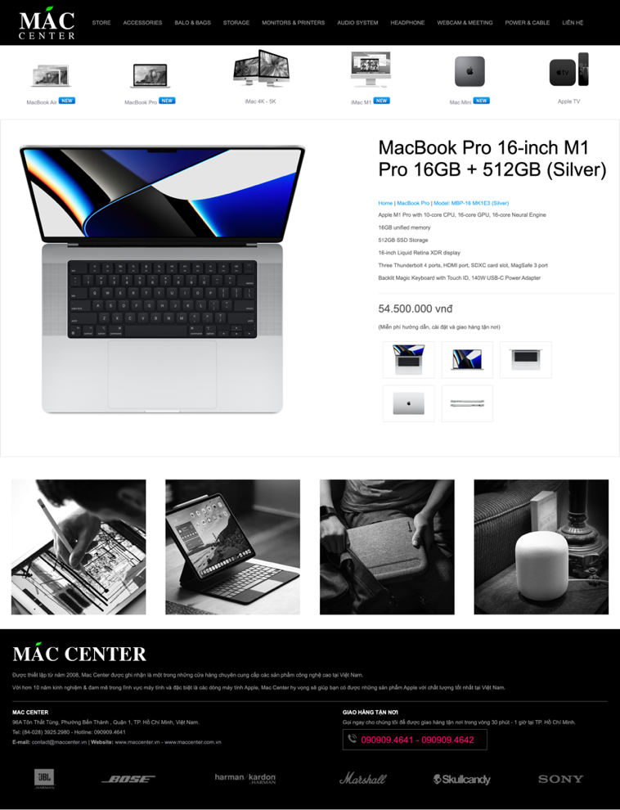

Also I compare with other sales sites like "https://shop.bloclibrary.dev/cart", This Online Shop is finished with relatively high perfection. However in "Shopping Cart" " there is no "Apply coupon" for customers. So my system will develop more "Apply coupon" to become more complete

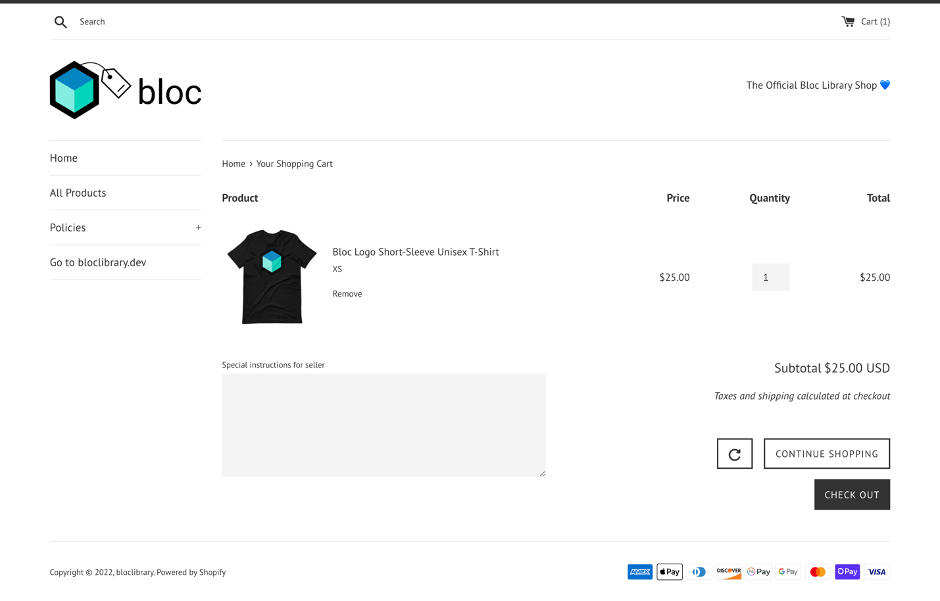

1. **Methodologies**

For systems intended for business enterprises, to develop optimized software requires a software development life cycle (SDLC). This is an important document that can be relied upon to build a system. Choosing a project development process requires an understanding of the project, thereby making appropriate decisions that are critical to the success of the project. Thereby, it is necessary to carefully study the features and requirements mentioned above, and make an appropriate choice. I finally chose V-Model to apply in this project

* 1. **V model**

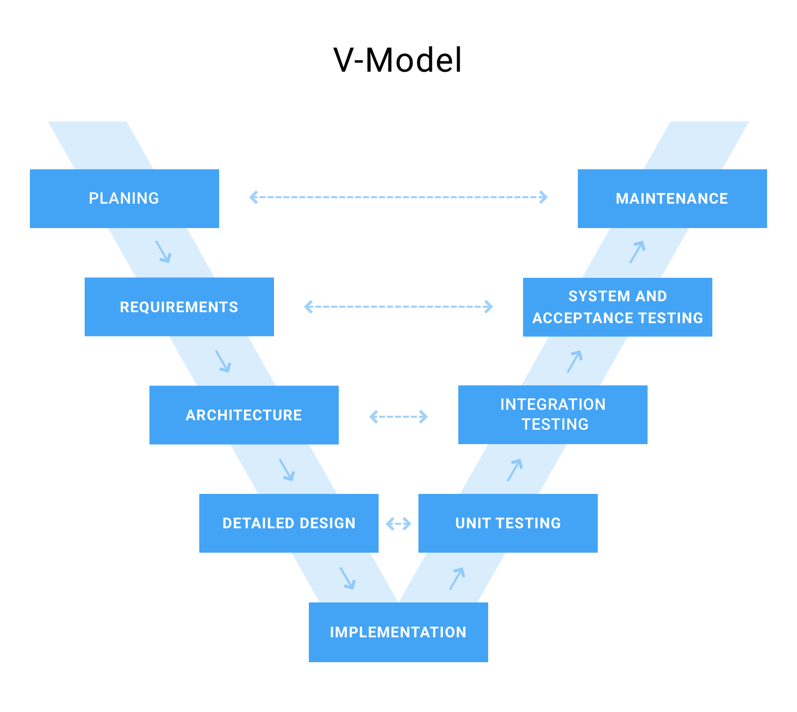First, we will briefly describe V-Model, this is a highly optimized project development model in terms of time, helping to manage and track the progress of the project accurately. It also provides a blueprint for developing, maintaining, changing, or upgrading complex applications. In figure 1 there are 5 pharse including “Planing - Maintenace” ,“ Requirements - System and acceptance testing” , “Architecture - Integration Testing” , “Detailed Design - Unit Testing”, “Implementation”.The plan will be given in a manner. details, and requirements are also stated to be able to follow, then we will follow the steps to complete the project. Just follow the correct process that the model gives the project will be successful.

Figure 1 V-model

**Advantage**

As mentioned from the beginning, the development model in this form helps to optimize time, save a large amount of costs, and also avoid risks in the working process. Keeping a close eye on the process building a system, step by step work, when a risk occurs, it is possible to analyze the error and overcome the risk in the forest to avoid affecting the next steps.

**Disadvantage**

Of course, everything has its disadvantages, however, the V-Model that is applied in the project is more limited than other models. Normally, the V-model is often included in the projects with the specified requirements. Small and medium scale are not exploited much in large and complex projects. It is not suitable for projects where the requirements are not clear and there is a high risk of change. However, to apply this model in this project, it has no such influence so decided to use it. The V-model is still applicable, because every process is meticulously planned to avoid any mishaps design

1. **Requirement Analyst**
   1. **Roles**

The minimum requirements for the e-commerce site system: the system can perform well the function of conveying products to users, users can directly interact with their operations on the system, to serve the needs of customers. The online business system ensures full functionality for users to shop on the system. As for the admin role, they can manage orders and track orders, the interactive functions of the admin need to perform well when interacting with the system.

**For customers**

For design requirements for customers, the system researched and used User-centered Design (UCD) research method. From there, it was possible to capture the target audience of the system, then design plans. Most of the target customers are teenagers and middle-aged people, they are young people with high economic potential and are passionate about technology, so the design is required to be youthful and energetic. Dynamic, easy-to-use features. Design needs to give clear content, fully convey the content of product details and descriptions to users, In addition, the design needs to be a bit attractive to users. ,with outstanding features. This will make customers more reliable for products and systems.

**For Admin**

In addition to focusing on design for customers, the system also pays great attention to designing the interface for Admin. This is where the admin can interact to manage all the data for the system such as: orders, accounts, products, types, track the growth chart of the order. So this is quite important in the success of the project, in terms of design I follow Miller's Law "that most people stored 7 things plus/minus 2 in their short-term memory." That helps increase user interaction. The design needs to ensure all the required features for the Admin

**Summary:**

Whether designing for customers or admins are all very important, this greatly affects the interaction trend of user interaction. All interface design needs to be perfected and adhered to the research and rules of interaction design to be attractive and highly interactive. The main colors for the system are the youthful and dynamic neutrals, The content should be clear, The functions need to be easily implemented. Thus, the system will easily attract people's interaction

* 1. **System requirements**

After I studied the design of the system, I clarified the design and interaction design requirements of the two main user roles in the system: Customer and Admin. In this section, I begin to list the basic to advanced features required in the development of an e-commerce system. Functions are extremely important and necessary parts of the system. From there I will make a list of functions to develop the system. From the system's functional requirements list I will start building the required functionality

**Function Requirements**

|  |  |
| --- | --- |
|  |  |

|  |  |  |
| --- | --- | --- |
| **Functional requirements** | | |
| **User** | **Display** | Customers can view all items on the e-commerce page |
| Have responsive on almost display of the tablet, telephone, computer |
| Product search bar |
| Products are categorized and sorted by category |
| Users can comment on each product and see other comments on that product |
| **Login& Register** | Users create accounts by linking to email |
| User must register and log in to make a purchase |
| User must fill in full information (Full name, address, phone number) |
| Password registration must meet the requirements of characters, lower case letters, upper case letters and numbers |
| When users forget their password, they can retrieve the password by linking to the email that was originally registered |
| All customer information is being strictly confidential |
| **Cart** | Users can choose to add products to the shopping cart and perform functions on the product (add, edit, delete). |
| Users fill in the bank link information to proceed to cart payment |
| The user can customize the desired delivery time |
| Proceed to checkout cart |
| User can view order status (prepared, delivered, successfully delivered) |
| **Admin** | **Login** | Admin must log in to the system to use it |
| **Acount** | Admin can see details of all existing accounts in the system |
| Admin can search for accounts through: ID, name, address |
| **Categoties** | Admin can perform the function of adding, deleting and editing in Categories the system |
| **Products** | Admin can perform the function of adding, deleting and editing |
| Admin can search products through: ID, name |
| **Static** | Admin can export the data of the chart |
| Admin can track best-selling items through pie chart |
| Admin can track the number of orders by month through the column chart |
| **Orders** | Orders,when successfully paid by the user, will be notified to the admin via email |
| Admin can search for orders through: ID, name, address |
| Admin confirms the order and prepares the order |
| Admin confirms the status of the order ( prepared, delivered, successfully delivered ) so that the user can track their order. |
| **Coupon Voucher** | Admin can create voucher |
| Admin can CRUD voucher coupon (create,read, upadate,delete) |

Figure 2 Funtional Requirement tabl

**Summary:**

With the required list of functions listed, two main user roles have been clarified. I will build the system according to the listed functional requirements, implement those functions fully to make the system complete.

**Non- Function Requirements**

|  |  |
| --- | --- |
| **Non- Function Requirements** | |
| Display | Page loading speed |
| Responsive can format on phone or tablet |
| Database storage system can store large amount of data complete |

Non-functional specifications (NFRs) describe software system integrity properties. These give software systems scores based on responsiveness, ease of use, security, mobility, and other non-functional criteria that are important to their performance. "How fast is your website loading?" This is an example of a non-functional search. If the non-functional specifications are not met, the device will not be able to meet the user's needs. For example: page loading speed, system response time is not too slow, Responsive can format on phone or tablet, Database storage system can store large amount of data complete

2. **Design**
3. **Database Design**
   1. **ERD Relationship**

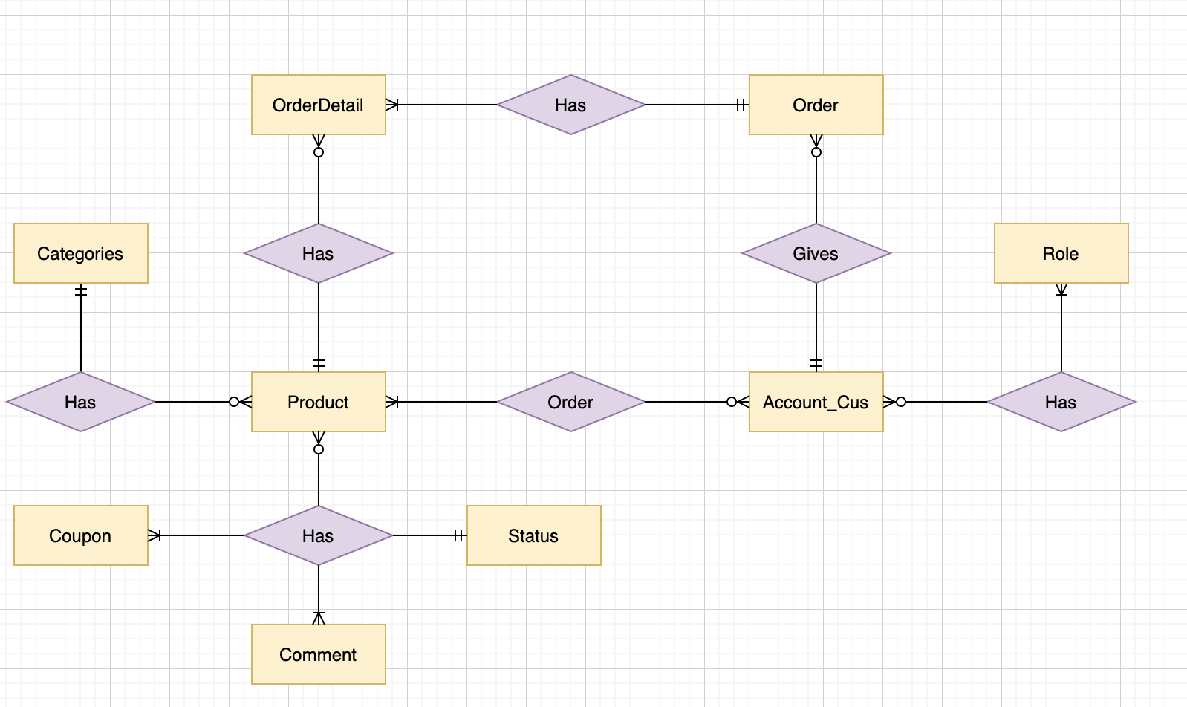

Figure 3 ERD relationship

With the project implementation goals that I have stated in the goal section, I proceed to design the database for ERD relationships, all the relationships shown in the figure above show a lot. clearly and correctly linked together this helps me develop the database in the right direction and complete, Also helps me to manage the database easily, so that later this maintenance or upgrade operations are not difficult, to show how the relationship i will use the following breakdown to clarify the problem

|  |  |  |  |  |
| --- | --- | --- | --- | --- |
| **Entity** | **Multiplicity** | **Relationship** | **Multiplicity** | **Entity** |
| Category | 1 to 1 | Has | 0 to Many | Product |
| OrderDetail | 0 to Many | Has | 1 to 1 | Product |
| OrderDetail | 1 to Many | Has | 1 to 1 | Order |
| Account_Cus | 0 to Many | Order | 1 to Many | Product |
| Account_Cus | 1 to 1 | Gives | 0 to Many | Order |
| Account_Cus | 0 to Many | Has | 1 to Many | Role |
| Status | 1 to 1 | Has | 1 to Many | Product |
| Comment | 0 to Many | Has | 1 to Many | Product |
| Coupon | 0 to Many | Has | 1 to Many | Product |

Figure 4 ERD element table

* 2. **ERD Diagram**

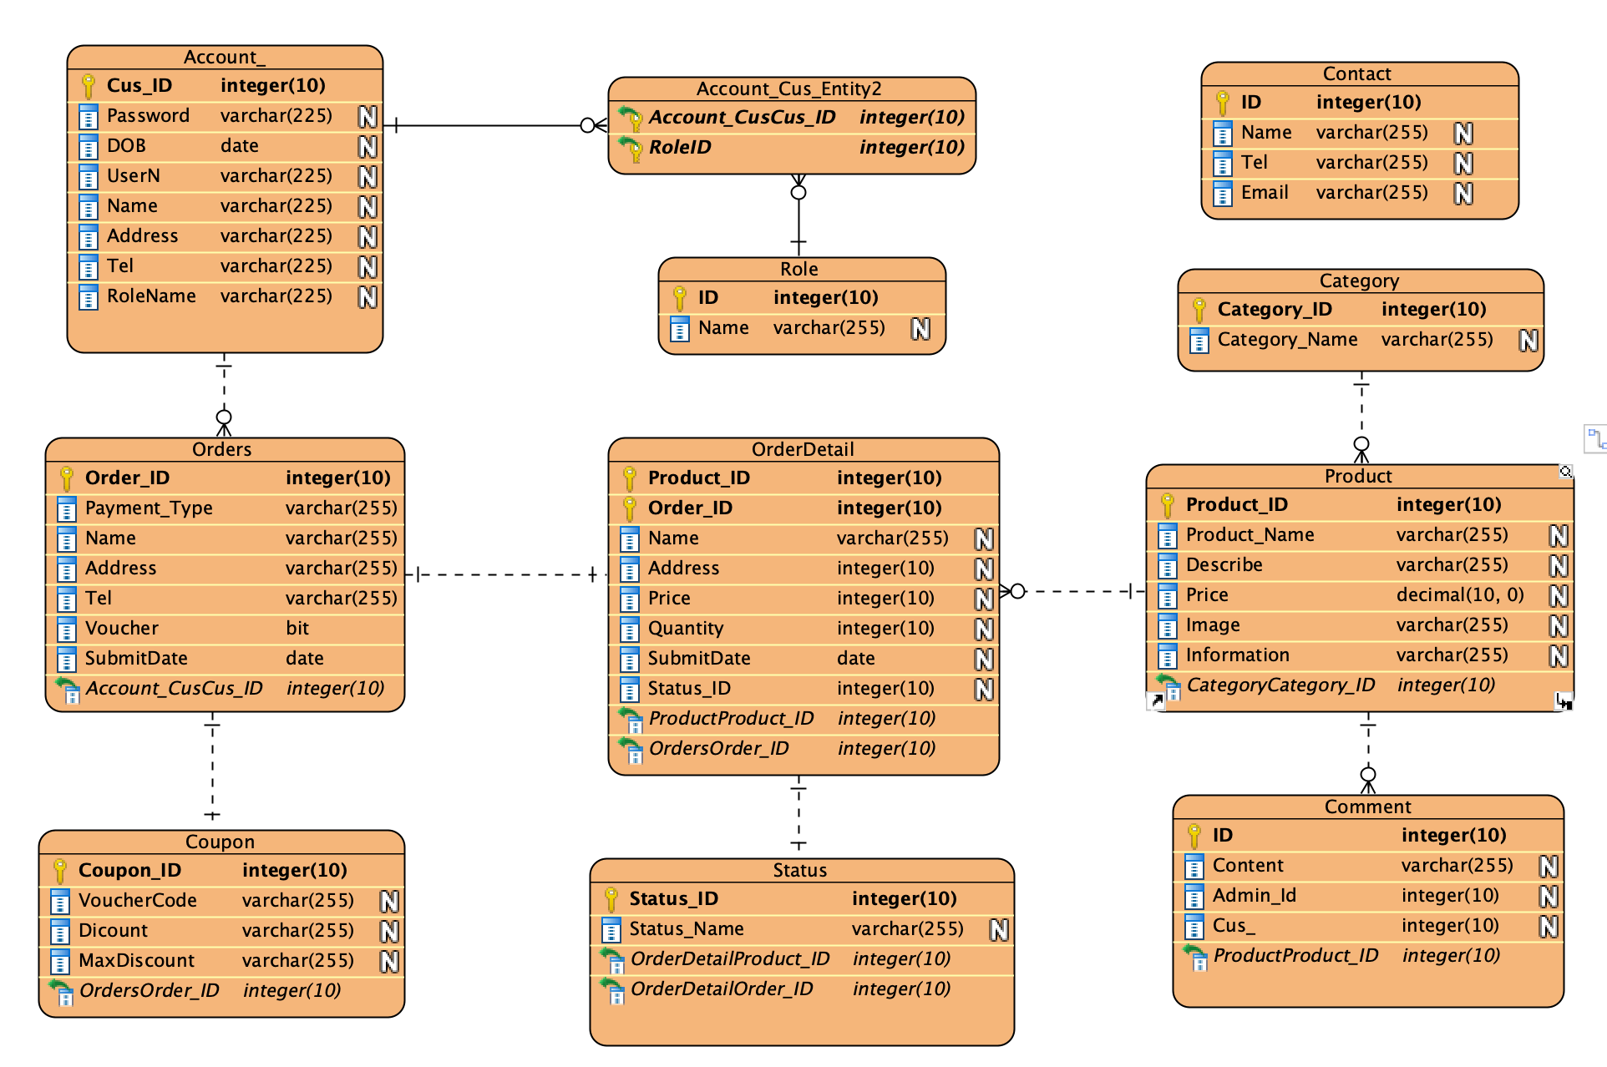

Figure 5 ERD diagram

After carefully reading and understanding the requirements given in the criteria section, I have identified the important databases that are really needed when using in the project. Since then, I have perfected the complete design for the database part to apply to this project. Includes the following tables: Account, Product, Order, OrderDetail, Role, Comment, Coupon, Category, Status, Contact. To clarify the role and function of each table, I will detail in the tables below

**Category Table**

Is the place to store the Category created by the Admin

|  |  |  |  |  |  |
| --- | --- | --- | --- | --- | --- |
| **Attribute Name** | **Description** | **PK/FK** | **Type** | **Length** | **Nulls** |
| **Id** | Category Id | PK | Integer | 10 | Not Null |
| **Name** | Category name |  | Varchar | 255 | Not Null |

Figure 6 Category table

**Product Table**

Is a place to store the products that the admin has created

|  |  |  |  |  |  |
| --- | --- | --- | --- | --- | --- |
| **Attribute Name** | **Description** | **PK/FK** | **Type** | **Length** | **Nulls** |
| **Product_ID** | Product Id | PK | Integer | 10 | Not Null |
| **Product_Name** | Product name |  | Varchar | 255 | Not Null |
| **Description** | Description for product |  | Integer | 10 | Not Null |
| **Image** | Upload image for  product |  | Varchar | 255 | Not Null |
| **Describe** | Describe about each of products |  | Varchar | 255 | Not Null |
| **Quantity** | Quantity of product |  | Integer | 10 | Not Null |
| **Price** | Product price |  | Decimal | 10, 0 | Not Null |
| **Information** | Details Information of each products |  | Varchar | 255 | Nullable |
| **CategoryId** | Get Id from the  SubCategory table | FK | Integer | 10 | Not Null |

Figure 7 Product Table

**Order Table**

This table is used to store orders placed by customers

|  |  |  |  |  |  |
| --- | --- | --- | --- | --- | --- |
| **Attribute Name** | **Description** | **PK/FK** | **Type** | **Length** | **Nulls** |
| **Order_ID** | OrderDetail Id | PK | Integer | 10 | Not Null |
| **Name** | Name of customer |  | Varchar | 255 | Not Null |
| **Address** | Delivery address |  | Varchar | 255 | Not Null |
| **Tel** | Orderer phone number |  | Varchar | 255 | Not Null |
| **Payment_Type** | Orderer payment type |  | Varchar | 255 | Not Null |
| **Status** | Order has been  confirmed or not |  | Bit |  | Nullable |
| **SubmitDate** | Order date |  | Date |  | Not Null |
| **Account_CusCus_ID** | Get Id from the User  table | FK | Integer | 10 | Not Null |

Figure 8 Order table

**OrderDetail Table**

|  |  |  |  |  |  |
| --- | --- | --- | --- | --- | --- |
| **Attribute Name** | **Description** | **PK/FK** | **Type** | **Length** | **Nulls** |
| **Order_Id** | Get Id from the  OrderDetail table | FK | Integer | 10 | Not Null |
| **Product_Id** | Get Id from the Product  table | FK | Integer | 10 | Not Null |
| **Quantity** | Quantity to be ordered  for the product |  | Interger | 10 | Not Null |
| **Price** | The price of product |  | Varchar | 255 | Not Null |
| **Name** | The name of customer get ordered |  | Varchar | 255 | Not Null |
| **Address** | The address of customer get ordered |  | Varchar | 255 | Not Null |
| **Status_ID** | Get Id from the Orders  table |  | Interger | 10 | Not Null |
| **ProductProdutct_ID** | Get Id from the Orders  table | Fk | Interger | 10 | Not Null |
| **OrderesOrder_ID** | Get Id from the Orders  table | Fk | Interger | 10 | Not Null |

Figure 9 Order detail table

**Account_CusTable**

|  |  |  |  |  |  |
| --- | --- | --- | --- | --- | --- |
| **Attribute Name** | **Description** | **PK/FK** | **Type** | **Length** | **Nulls** |
| **Cus_Id** | User Id | PK | Integer | 10 | Not Null |
| **UserName** | UserName |  | Varchar | 255 | Not Null |
| **Name** | Full Name of user |  | Varchar | 255 | Not Null |
| **DOB** | User date of birth |  | Varchar | 255 | Not Null |
| **Tel** | User phone number |  | Varchar | 255 | Not Null |
| **Email** | User email and also  username |  | Varchar | 255 | Not Null |
| **Password** | User password with  hashing form |  | Varchar | 255 | Not Null |
| **Email** | Confirm email after  registration by user |  | Bit |  | Nullable |
| **Address** | User’s Address |  | Varchar | 255 | Not Null |
| **RoleName** | Get Role Name from Role table |  | Varchar | 255 | Nullable |

Figure 10 Customer account table

**Role Table**

|  |  |  |  |  |  |
| --- | --- | --- | --- | --- | --- |
| **Attribute Name** | **Description** | **PK/FK** | **Type** | **Length** | **Nulls** |
| **Id** | Role Id | PK | Integer | 10 | Not Null |
| **Name** | Role name |  | Varchar | 255 | Not Null |

Figure 11 Role table

**Contact Table**

|  |  |  |  |  |  |
| --- | --- | --- | --- | --- | --- |
| **Attribute Name** | **Description** | **PK/FK** | **Type** | **Length** | **Nulls** |
| **Id** | Contact Id | PK | Integer | 10 | Not Null |
| **Name** | Contact name |  | Varchar | 255 | Not Null |
| **Email** | Contact email |  | Varchar | 255 | Not Null |
| **Message** | Contact message |  | Varchar | 255 | Not Null |

Figure 12 Contact table

**Coupon Table**

|  |  |  |  |  |  |
| --- | --- | --- | --- | --- | --- |
| **Attribute Name** | **Description** | **PK/FK** | **Type** | **Length** | **Nulls** |
| **Coupon_Id** | CouponId | PK | Integer | 10 | Not Null |
| **VoucherCode** | Insert voucher code to get discount |  | Varchar | 255 | Not Null |
| **Discount** | Amount money can get discount |  | Varchar | 255 | Not Null |
| **MaxDiscount** | Max amount money can get discount |  | Varchar | 255 | Not Null |
| **OrdersOrder_ID** | Get order ID from table orders | Fk | Integer | 10 | Not Null |

Figure 13 Coupon table

**Status Table**

|  |  |  |  |  |  |
| --- | --- | --- | --- | --- | --- |
| **Attribute Name** | **Description** | **PK/FK** | **Type** | **Length** | **Nulls** |
| **Status_Id** | CouponId | PK | Integer | 10 | Not Null |
| **Status_Name** | Insert voucher code to get discount |  | Varchar | 255 | Not Null |
| **ProductProduct_ID** | Get Product ID from OrderDetail table | Fk | Integer | 10 | Not Null |
| **OrdersOrder_ID** | Get Order ID from Orders table | Fk | Integer | 10 | Not Null |

Figure 14 Status table

**CommentTable**

|  |  |  |  |  |  |
| --- | --- | --- | --- | --- | --- |
| **Attribute Name** | **Description** | **PK/FK** | **Type** | **Length** | **Nulls** |
| **ID** | ID of comment | PK | Integer | 10 | Not Null |
| **Content** | Content that user comment each of product |  | Varchar | 255 | Not Null |
| **Cus_ID** | Get Cus ID from Account_Cus table | Fk | Integer | 10 | Not Null |
| **ProductProduct_ID** | Get Product ID from Product table | Fk | Integer | 10 | Not Null |

Figure 15 Comment table

1. **Use Case Diagram**

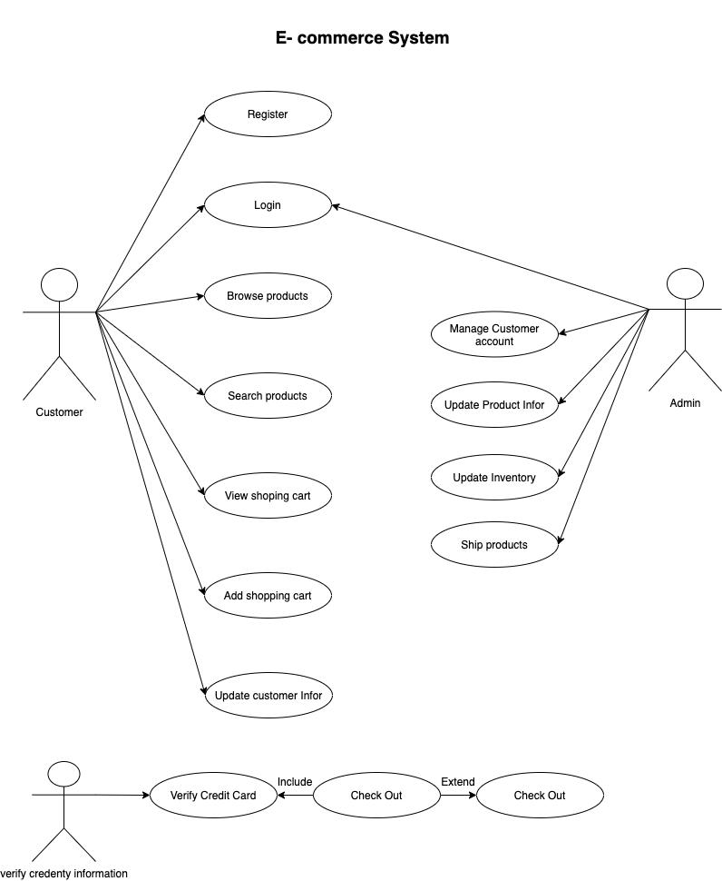After detailing the database diagram of the system, next I want to introduce Use Case. In simple terms, use case is used to present and describe the interaction between the user and the system, because So it needs to be shown clearly and easily, but not without the coverage of the whole system. From there we can approach and build the project better

Figure 16 Usecase Diagram

**Overview:**

From the figure above we can see that there are 2 main roles to build the system, which is the customer and the admin from which the customer will have the following interactions with the system: register, login, browse products , search products, view, comment products, add,edit, delete product in shopping cart, update information , check out by 2 methods (cash, paypal)

As for the admin, they will interact with the system as follows: Mange products, categories, accounts ,orders, reply comments, view dashboard.

**2.1 Admin/Customer Login**

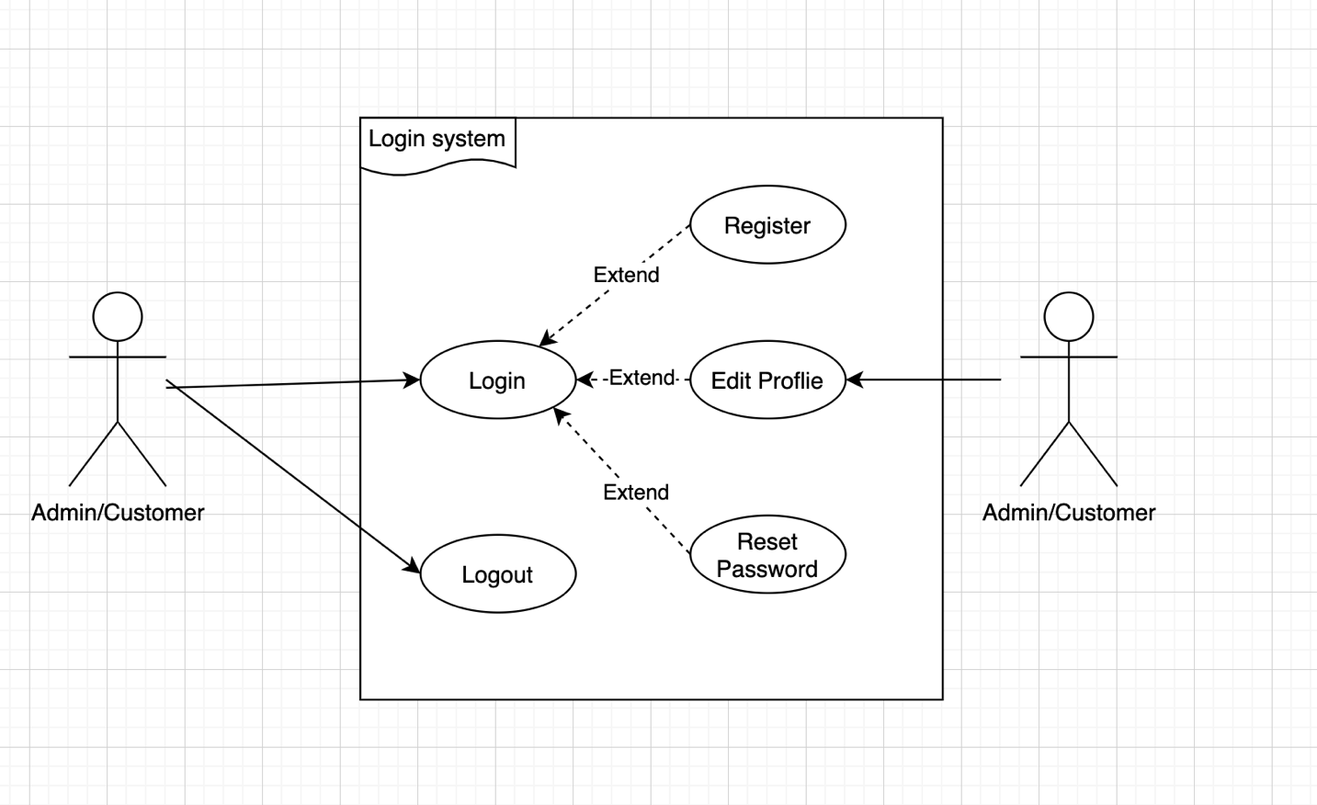

Figure 17 Usecase login

First, both the admin and the customer must perform the login function with their own account if they want to use the system's functions depending on the role of the object (admin or customer). If you do not have an account, you can proceed with the account registration step, the customer's account will be saved in the system's data. If there is no need to log in, the customer and admin can log out of the account. After having an account, the customer can edit the profile, or reset the password by providing the customer email address used to register the account, then the system will send an email to that email address for the customer to confirm. and proceed to reset the password according to the customer's request

**2.2 Admin manage Account**

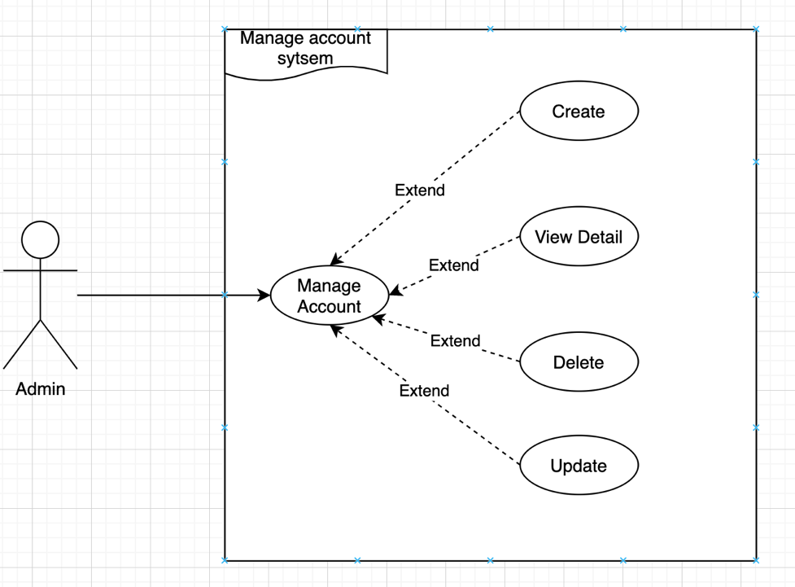

Figure 18 Usecase admin manage account

As an admin, you will manage important data from the system: customer information, product information, order information. As the Figure above describes, the admin manages and performs the rights that the system has granted him, such as: create, view detail, delete, update guest accounts stored in the system's data. Functions:

ceate, view detail, delete, update, the name of the function also says how it works.

**2.4 Admin manage Category**

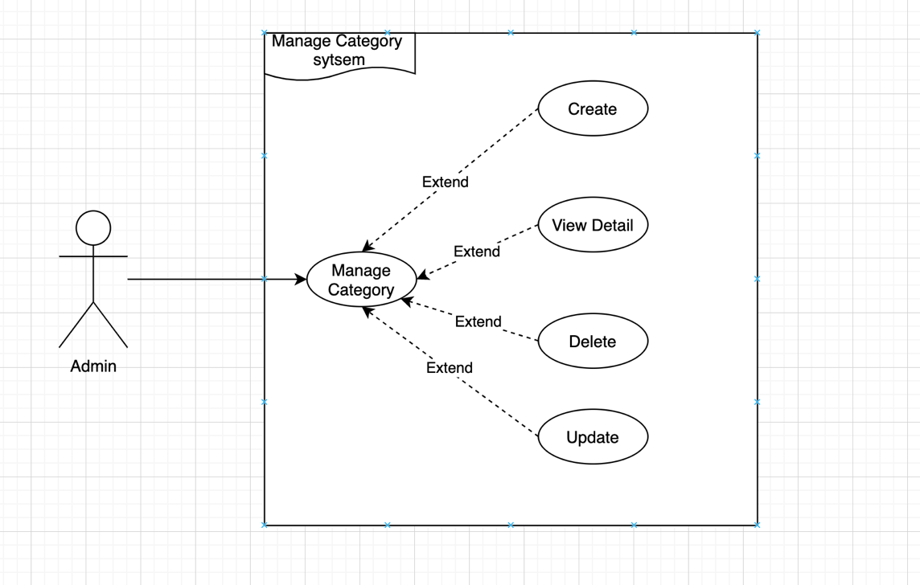

Figure 19 Usecase admin manage category

Similar to account management, admin can perform functions on Category: Create,

view detail, delete, update. Amin will create a category when you want and use the update or delete functions when you want to change details or delete it when the category data is no longer used.

**2.5 Admin manage Product**

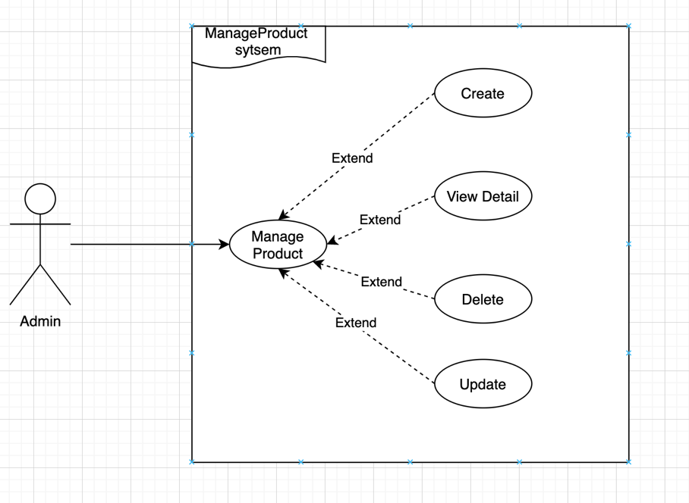

Figure 20 Usecase admin mange product

The role of admin for products is similar to account or category management, with the following functions: Create, view detail, delete, update products. To add products, admin needs to enter some required data such as: Name, Price, Quantity, Image, Describe. However, in order to create a product and store that product data in the system's database, it is necessary to have the first Category, the newly created product must belong to a certain Category.

**2.5 Admin manage Order**

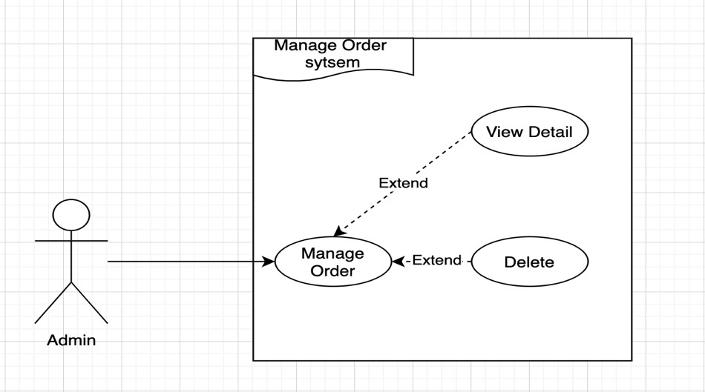

Figure 21 Usecase admin manage order

To do well the role of the sales system. First, the sales management needs to be perfect, Admin can easily manage orders when received from customers clearly, orders and order details will be saved in the database. system data. Admin can see the total quantity and details of each order. In the details of each order, the system will display: Order ID, Product, quantity, customer's delivery information, order status...etc. From there, the admin can view and update the status of each order. order, thereby making it easier to manage orders in the system.

**2.6 Admin Manage Contact**

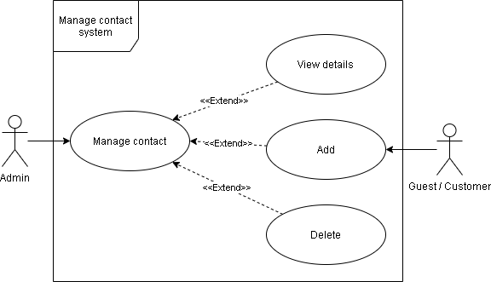

Figure 22 Usecase admin manage contact

In order to develop the system to a wide range of consumers, the system needs to be perfect at the consulting and customer care stages, to ensure that it can receive help requests from customers, so the admin can Management communication system, When customers leave contact information Mail, Name and message. Admin can view and respond to customers about the quality of products and services. That makes customer care more complete and has a large number of potential customers.

**2.7 Amin/Customer Coupon**

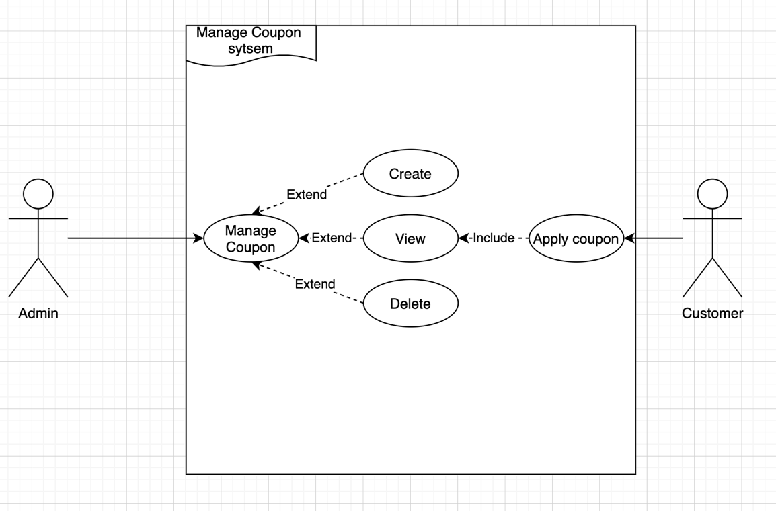

Figure 23 Usecase admin/customer with coupon

In order for the sales system to attract a large number of customers, the system needs to support the application of discount codes to orders. From there to promote the purchase of customers to the system. Admin can create and view coupons. Customers can collect that coupon and apply it to their order to get a discount on each order. .The system only applies the discount when the customer applies the coupon.

**2.8 Admin/Customer Comment**

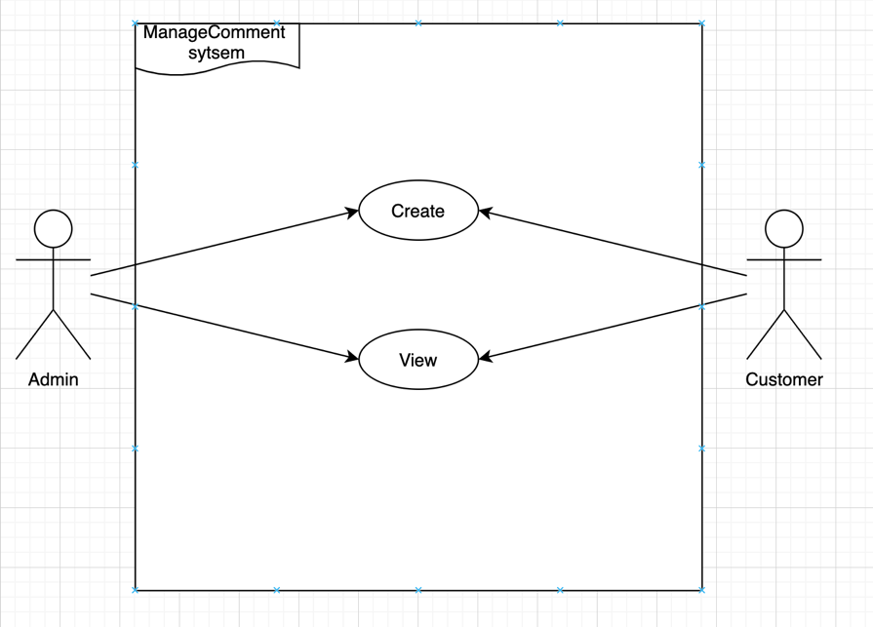

Figure 24 Usecase admin/customer with comment

Admin and customer can both comment on a product they are interested in and admin is responsible for replying to those comments, Both can create and view comments, comments will depend on the product.

**2.9 Customer View Product**

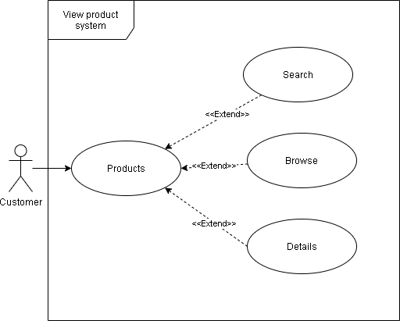

Figure 25 Usecase customer view product

The system will do a good job of presenting all products so that customers can search and choose to buy. First, customers need to go to the search bar to enter the content of the product they need to search for, followed by the function. Browse products, help users find the desired product, finally view product details, Here the system will display details of each product such as: Product name, price, image, describe

**2.10 Customer Order Product**

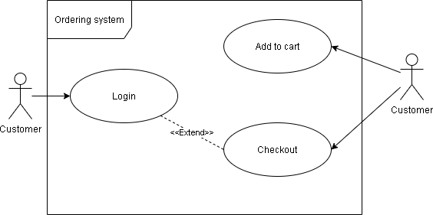

Figure 26 Usecase customer order product

In this step, after the customer selects the products they want to add to the cart, and proceeds to check out, the customer needs to fill in the delivery information (required) and choose either cash or pay-pal, After successful payment operation, the customer has completed his purchase on the sales system.

1. **Flow Chart**

In order for the project to run well, the flow chart is an indispensable chart. It is considered as an important document to describe the operational processes of the project. Flowcharts are extremely useful, because So a clear flow chart will help the project construction process more convenient. From researching and planning the implementation of the project, I conclude that this project has 3 typical processes that are: Login and Register process,Resset Password process, Order process. The processes will be described by flowchart as follows:

**3.1 Login and Register process**

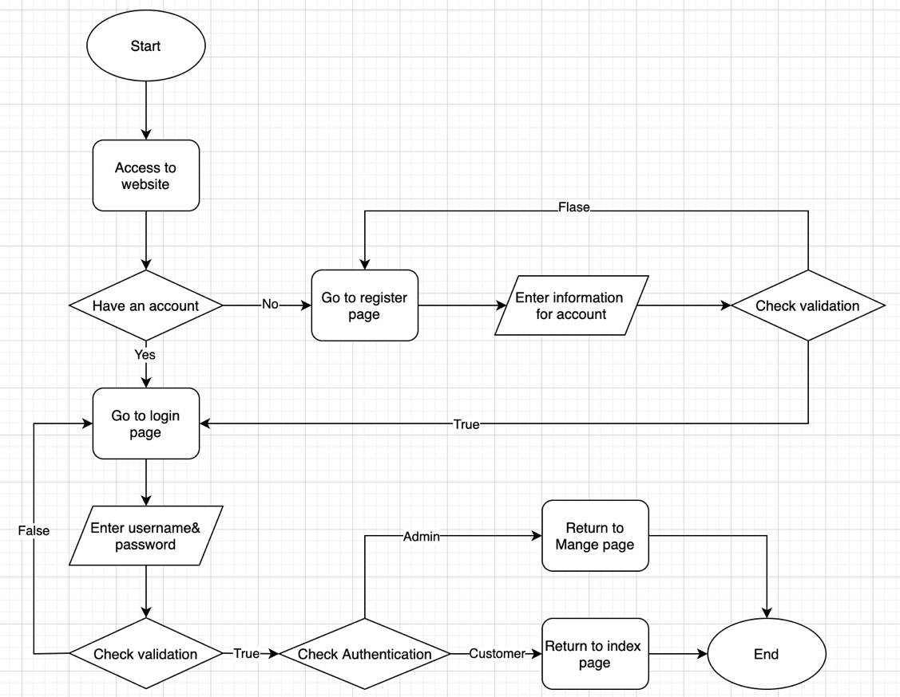

Figure 27 Login/ register flowchart

The process of login and registration is considered an important process of the system. When the customer and admin want to use the features granted by the system, it depends on the role that the system grants permission. However, if you want to use it, They are required to log in to the system. This process is divided into 2 cases: The user already has an account on the system or not

For the first case, the user already has an account on the system, then they will go to the login page to perform the login operation. To do this, they must enter the correct username and password. Next, the system will verify whether the login information is correct. Otherwise it will return the user to the login page so that the user can correctly re-enter the requested information. If the system confirms the correct login information then it will perform a role review of the account. need to login. If it is the customer role, it will be returned to the homepage of the website, and if it is the admin role, it will be returned to the admin's management page. Thus the user has successfully completed the login process into the system.

For the 2nd case, the user does not have an account in the system. They will first go to the account registration page, then enter the required information to perform the account registration process, the system will perform a step to verify the account information is already in the system or not. not yet, if there is, the system will return the registration page for the user to enter other data, because there is already duplicate account information backed up on the system. If the system verifies that there is no duplicate information, the user will successfully completed the account registration step and was taken to the login page to log in to the system. The next process will be similar to when the user has an account on the system.

**3.2 Resset Password process**

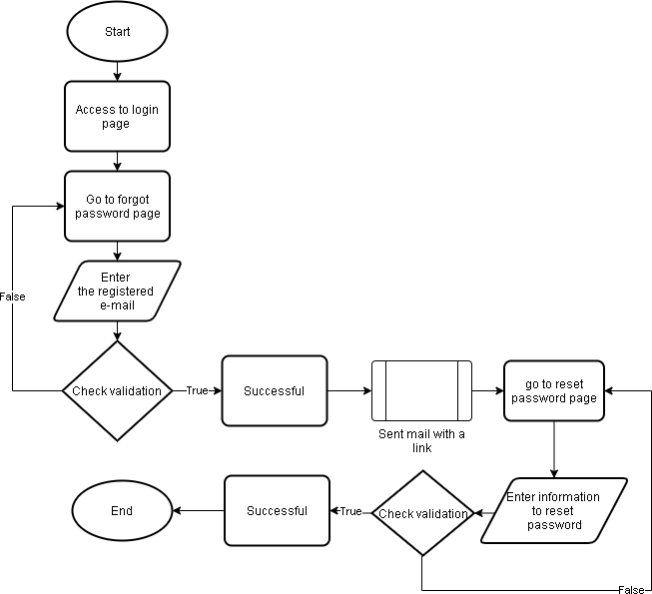

Figure 28 Reset password flowchart

This is where the user resets the password of his account, because he wants to change or forget his account password. First, the customer will go to the login page of the system, then select the Forgot password button, to start the process. The system will ask the customer to enter in the blank the email that the user used to register for that account. The system will start the step to verify the email entered by the user matches the account initialization email or not. If correct, the system will notify success, otherwise the system will display an error message and ask to re-enter the correct email, and send to that email a link to the account reset page. The user needs to Log in to your email account and click on the link to go to the reset password page. After entering the new password, the system will verify whether it's valid or not. If valid, the user has completed resetting the account's password

**3.3 Order procsess**

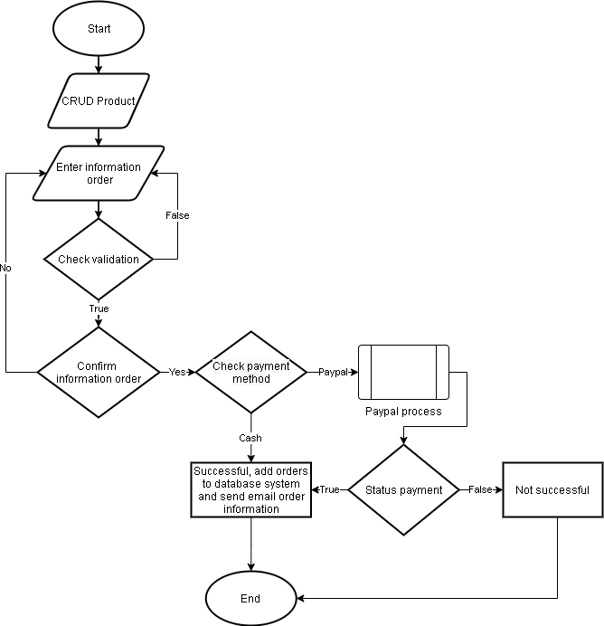

Figure 29 Order flowchart

The ordering process is considered the core process of the project. Customers can perform the following functions after interacting with the system's product display pages, which can be abbreviated as CRUD(create, read, update, delete). These are the functions the system built so that customers can interact with the products. However, in order to shop on the system, the customer is required to log in to the system. After selecting the products that they are satisfied, customers can add products to their cart, can further customize, delete, adjust the quantity according to their needs the products in the cart. Then they will be redirected to the page. check out to enter the required delivery information, so that the system can deliver the goods. In addition, customers also have to choose a form of payment, in the current sales system there are 2 types of payment methods: cash and paypal. If the customer chooses to pay in cash, the system will notify the successful purchase process and return to the successful notification page, and the system will save the order information in the database system. On the other hand, if the customer chooses the payment method as paypay, the system will automatically go to the paypal payment page and the customer will make the transaction there. After successful, the successful payment page will be returned, and back up order data into the system. Both forms of payment, when the customer completes, the system will automatically send the customer a thank you email and notify the customer's order details to confirm. Thus, the customer has completed the order step through the system.

1. **WireFrame**

First to have an e-commerce site that has an interface that meets the requirements of: user-friendliness, ease of use, and high aesthetic factors, I started with WireFrame design, to I got the first interfaces, then I proceeded to build a website. The tool I use is Basamiq, which is a tool to help design in the first platforms in design

### 4.1 Home Page

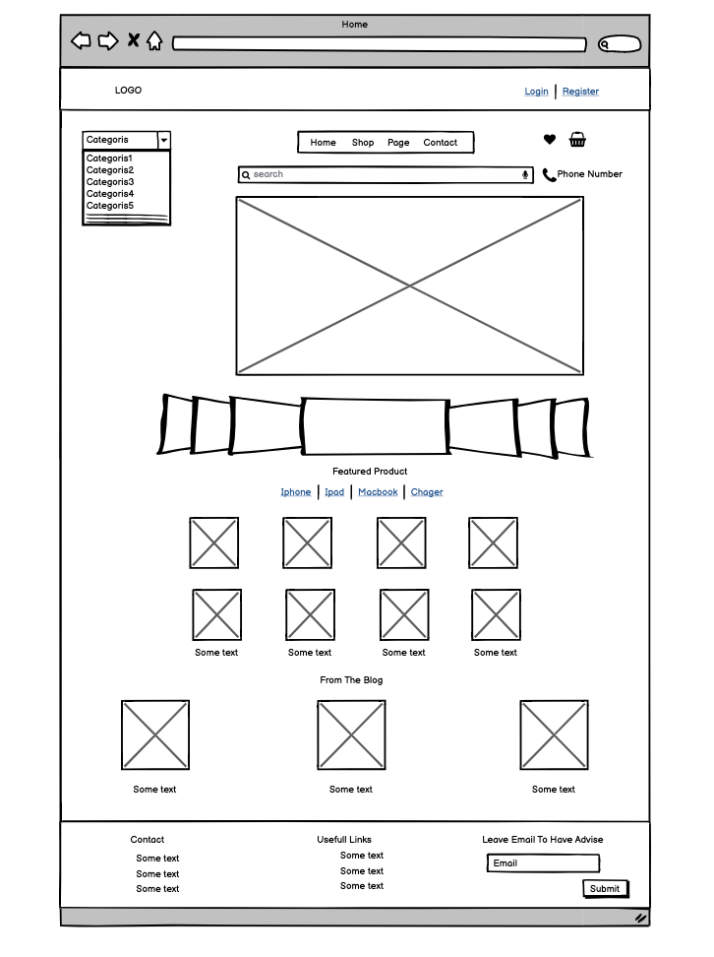

Figure 30 Home page

The first is about the Home Page, it is designed according to the minimalist criteria but still ensures the full display function of a website. The website includes header, navigation, content and footer Header is the fixed part there. Display the Login or Register section for users, Footer displays the necessary parts of a website such as: Contact information, UserFull Links, Or leave an email so that customers need the store to contact to exchange or consult. inquire more about the service. About the Content section showing some of the store's latest products, the Navigation section I put under the header so that customers can easily navigate to the necessary pages.

Overall, the Home Page meets all the requirements that other Home pages need, and it gives a clear and easy-to-use first impression to users.

* 1. **Detail Product Page**

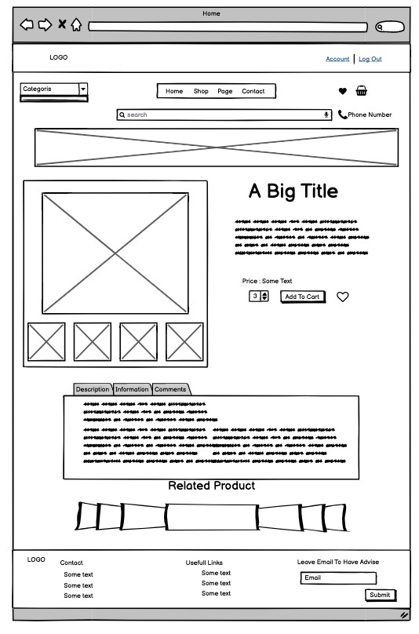

Figure 31 Detail Product

When customers click on the button to view product details, they have a need to learn about the product, then make a purchase decision, on this page it is really important because it determines the buying factor, in Detail Product Page the content of the page displays full information of each product, the image section, a brief description and the price, next to it is the bar to enter the quantity of the need to buy and the button to add to the cart. Below is a summary of products such as: Description, information and customer comments about product quality. Here, we summarize all detailed product information to provide customers with information. Information and comments come to customers in the most clear way

* 2. **Category Page**

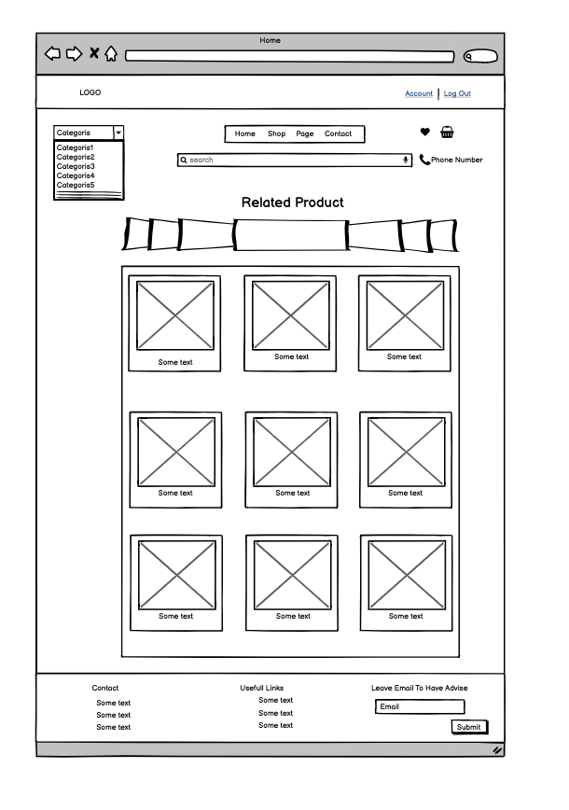

Figure 32 Category Page

When a customer chooses and the product category they want to find, this page will display all the products in that category, for customers to easily select the products, the content of this page will display the Products have been filtered by the category that the customer choose

**4.4 Shopping Cart Page**

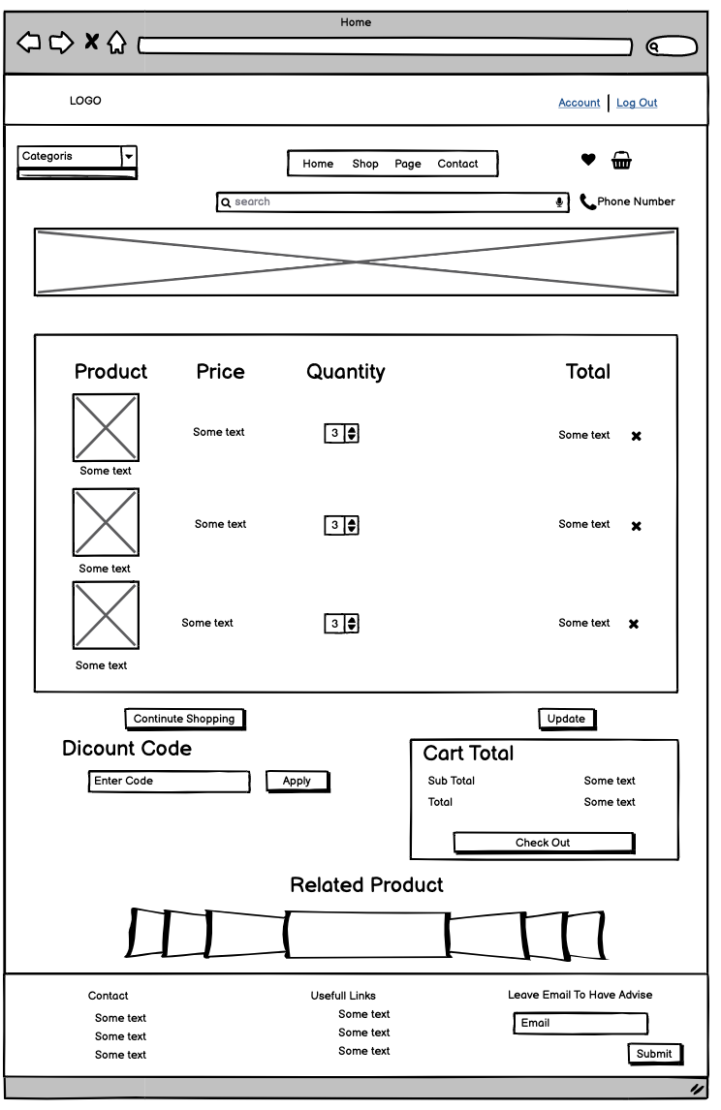

Figure 33 Shopping cart page

In this section, customers will add the products they love and plan to buy and proceed with the payment. The page displays all the products and quantities that the customer has selected to add to the cart, below is the part to enter the discount code when the customer collects the discount code and applies it to reduce the total bill, the right side will is the total amount that the customer needs to pay

**4.5 Check Out Page**

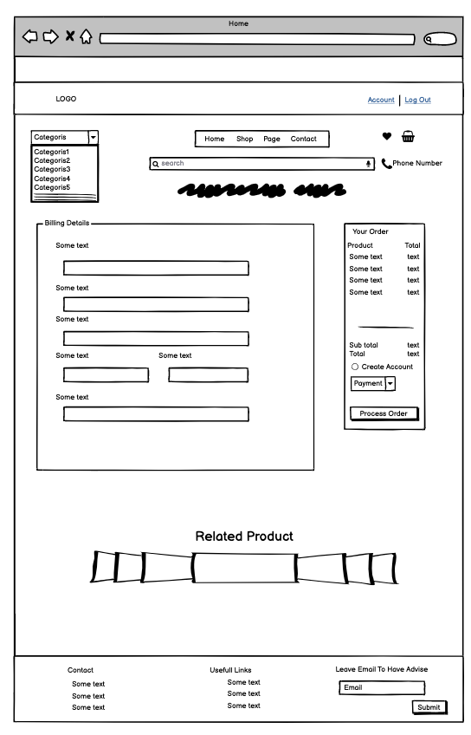

Figure 34 Checkout page

Finally, the check out step if the customer wants to buy the product, in the content of the page, there will be empty boxes for the customer to enter the delivery information, the right side will be the place to display the product and the total amount. of the order, and the payment method (cash, paypal) So that the customer can review his order and proceed to the final step of paying for the order.

**4.6 Contact Page**

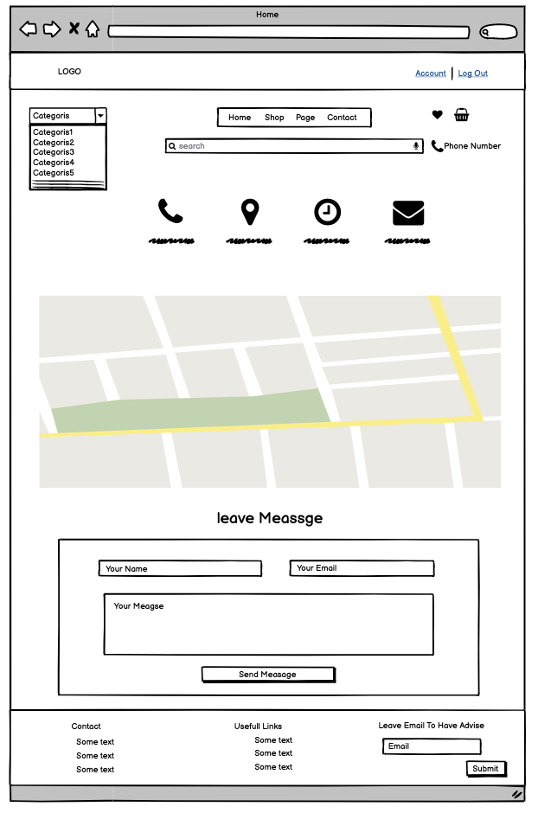

Figure 35 Contact page

As shown in the picture above, this page displays store information so that customers can grasp about: Phone number, store address, hours of operation and email. The center of the content section will display a map (google map) to help customers easily find the store to shop directly. Finally, leave a message, if customers want to receive service support, they can leave contact information and a message so that the store will actively contact directly to advise customers on services

**4.7 Admin Product Page**

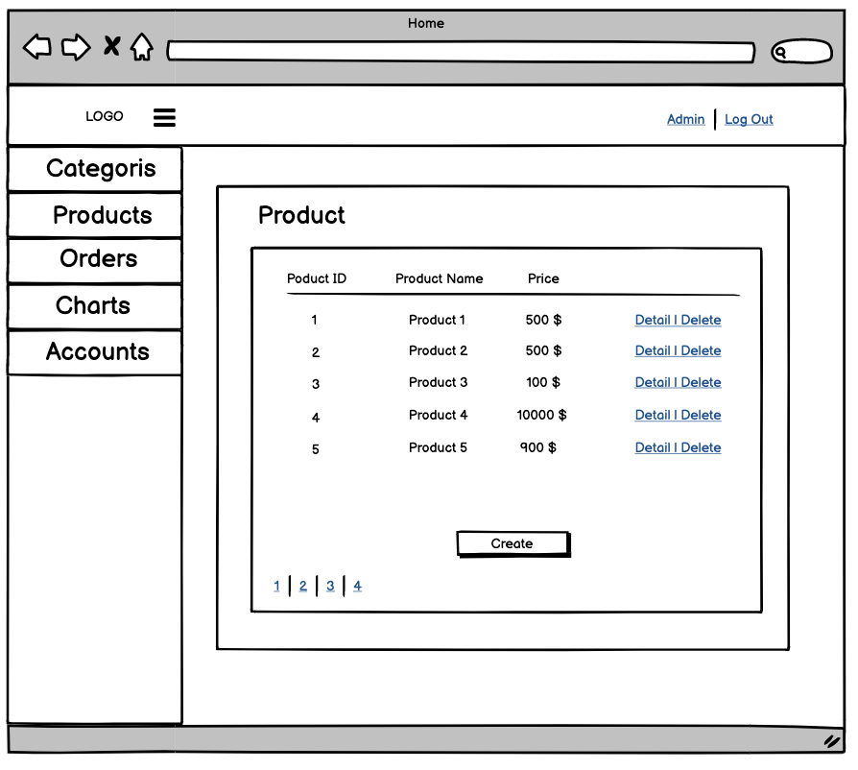

Figure 36 Admin manage produt page

Different from the customer interface, this is an admin interface to manage everything So the layout will become minimalist for admin, Including: Menu and main content

The right side is the Menu section including: Categories, Products, Orders, Charts, Account. In the main content, the Page will show: Product ID, Product Name, Price of each product, and finally the button to create product.

**4.8 Admin Add Product Page**

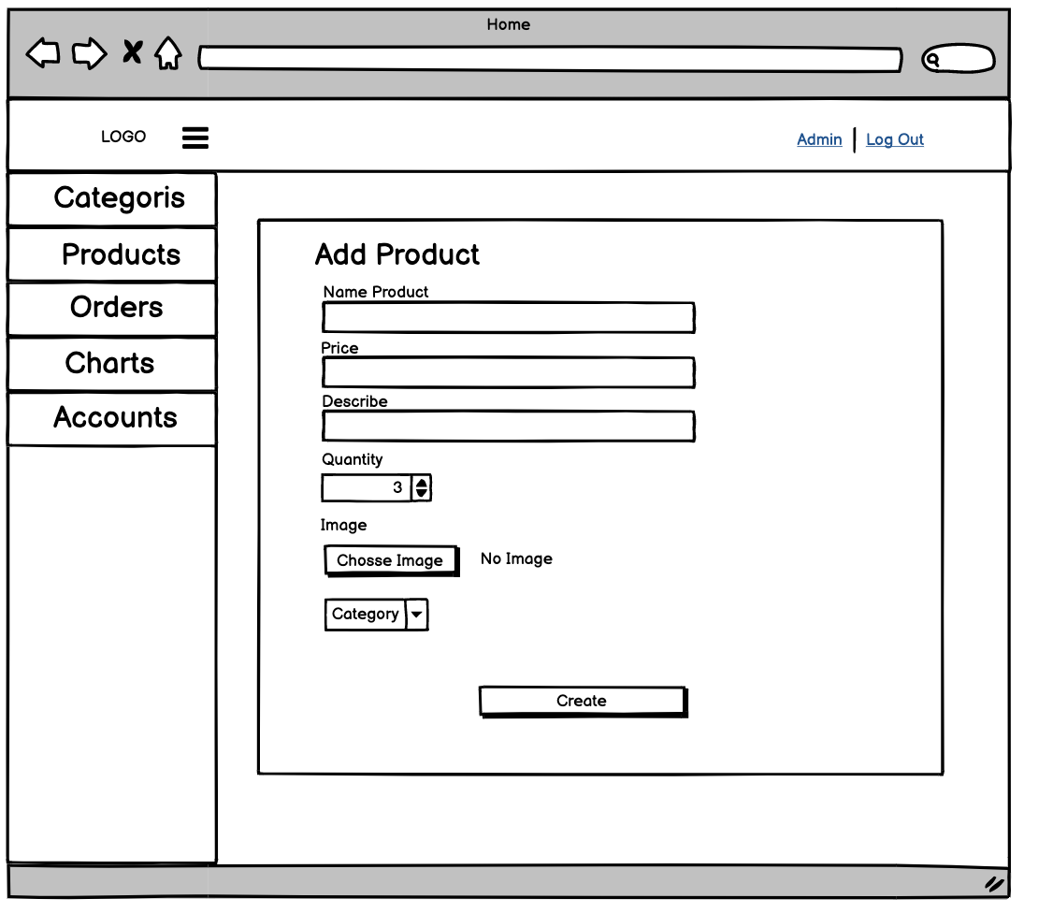

Figure 37 Admin add product page

Similar to the Admin Product Page, the interface is still the same, however, in the content, there will be empty boxes for the Admin to enter the product data they want to add, then the product and information will be saved system.

**4.9 Admin Dashboard Page**

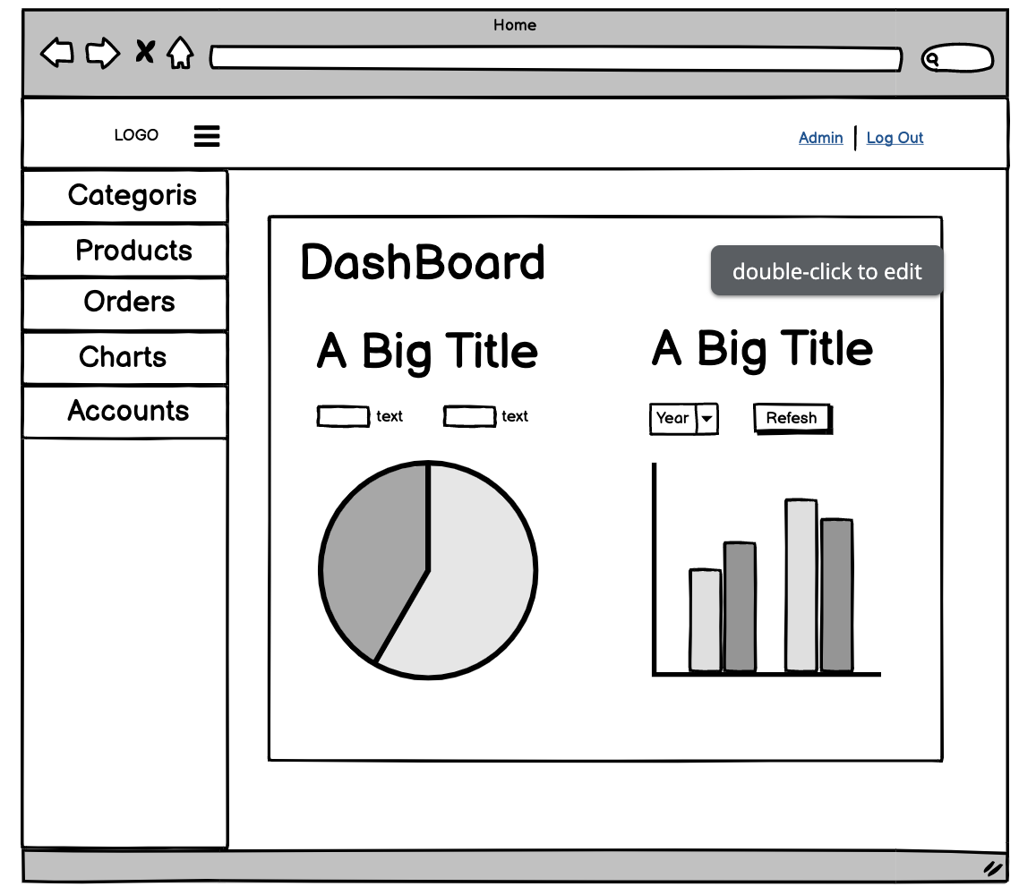

Figure 38 Dashboard page

Finally, the DashBoard Page still uses the admin interface as above, The main content is divided into 2 parts, the left side will display a pie chart, the right part will display a column chart, accompanied by a graph. The column chart will be the select button used to select the year the admin wants to see the sales, and next to it is the refresh button so that the page can be reloaded with the correct data.

1. **Class Diagram**
   1. **Class Diagran**

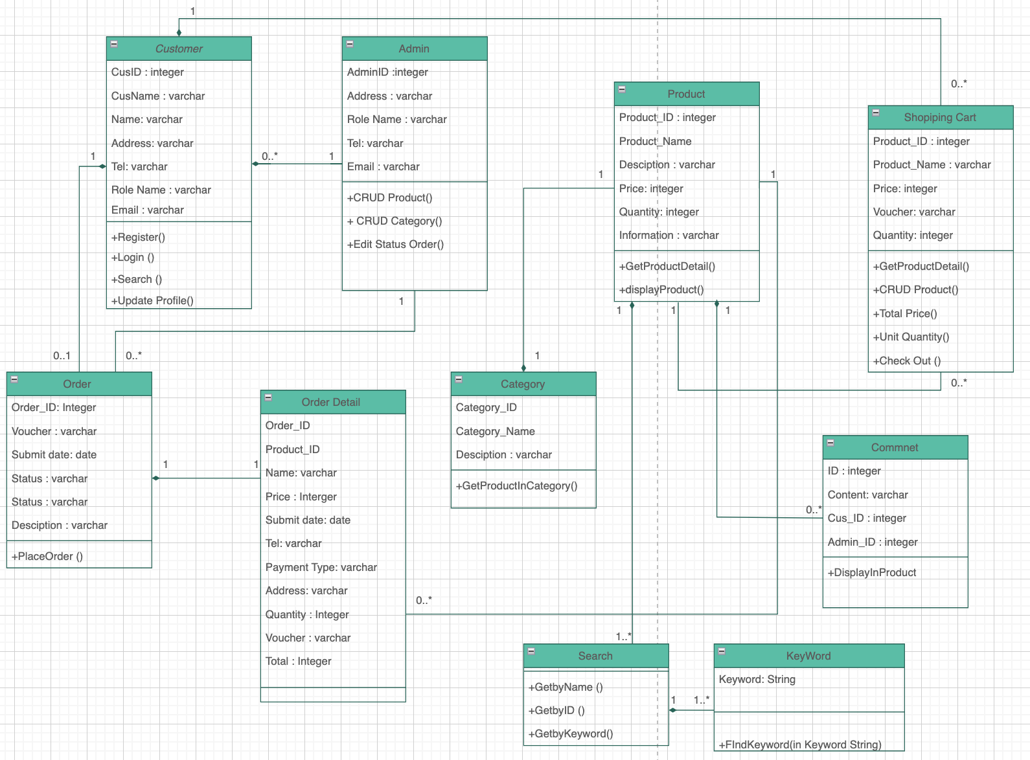

Figure 39 Class Diagram

* 1. **List of classes**

|  |  |
| --- | --- |
| **Class Name** | **Responsibility** |
| Categories | Store category information |
| Products | Store product information |
| Admin | Store account admin information |
| Customer | Store account customer information |
| ShopingCart | Store produtc in shopping cart information |
| Order Detail | Store order deatil information |
| Orders | Store order information |
| Commnet | Store content comment |

Figure 40 List classes

* 1. **Detail of classes**

**a) Admin**

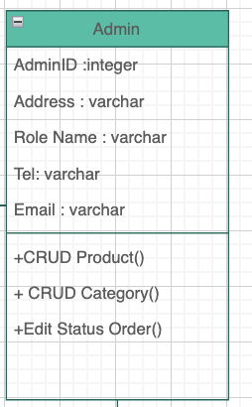

Figure 41 Admin class

|  |  |  |  |
| --- | --- | --- | --- |
| **Attribute Name** | **Data Type** | **Type** | **Meaning** |
| Admin ID | Integer | Public | Code of the Admin |
| Address | Varchar | Public | Address of admin |
| Role Name | Varchar | Public | Role name of admin |
| Tel | Varchar | Public | Telephone number of admin |
| Email | Varcahr | Public | Email of admin |

Figure 42 Detail admin class

The Admin actions are handled by this class. It takes over all of the duties and functions of the User class. When the admin needs to add a category or a product to the catalog, the functions createCatogory() and createProduct() are called. When eliminating a category or a product from a catalog, methods like deleteCategory() and deleteProduct() are used. There must be at least one category and product in the Catalog for these delete operations to be valid. Admins can also change the status of any order in the system.

CreateProduct Operation Requirements

1. Admin should be allowed to develop and add new products to the catalog.
2. Prerequisite: To create a new product, the administrator must be logged in. In addition, the catalog should include the department and/or category with which the new product will be connected.
3. Product will be added to the appropriate department and/or category after posting.
4. To create a new product, the administrator will input the name and essential details and then click the "Add" button to complete the activity.
5. Output: The changes to the catalog will be updated and stored after the action, and a notice will be displayed as a result.

**b ) Customer**

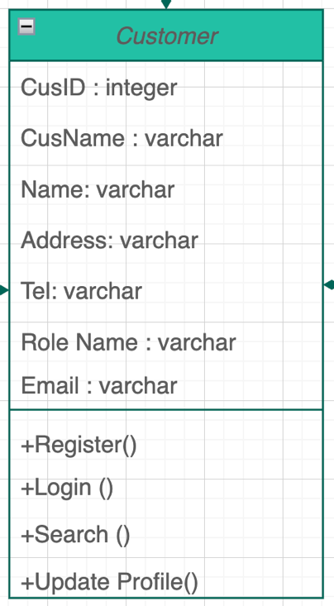

Figure 43 Customer class

|  |  |  |  |
| --- | --- | --- | --- |
| **Attribute Name** | **Data Type** | **Type** | **Meaning** |
| CusID | Integer | Public | Code of the Customer |
| Cus Name | Varchar | Public | Address of Customer |
| Name | Varcahr | Public | Full Name of customer |
| Tel | Varchar | Public | Telephone number of Customer |
| Email | Varcahr | Public | Email of Customer |
| Role Name | Varchar | Public | Role name of Customer |

Figure 44 Detail customer class

This class is in charge of consumer activities. It takes over all of the duties and functions of the User class. When a consumer wants to edit, update, or save his or her personal information on the website for future use, the updateProfile() method is used. However, in order to edit their profile, customers must first register and then login using the register() and login() methods in the Register.aspx and Login pages. When a consumer looks for a product and enters certain Key-Words in the text-box on the Search bar, the search() function is also invoked.

**c ) Category**

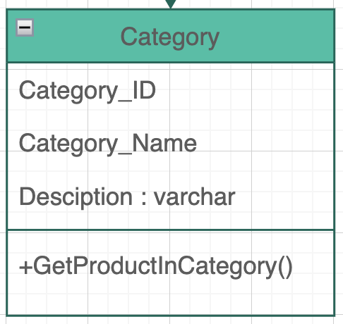

Figure 45 Category class

|  |  |  |  |
| --- | --- | --- | --- |
| **Attribute Name** | **Data Type** | **Type** | **Meaning** |
| Category_ID | Integer | Public | Code of the Category |
| Category_Name | Varchar | Public | Name of Category |
| Desciption | Varcahr | Public | Desciption of Category |

Figure 46 Detail category class

This class contains all of the individual departments' categories. This class has a secret method called getProductsInCategory that returns all of the goods that belong to a specific category and department. One or more departments can be assigned to a category. A category might also have zero or more goods in it.

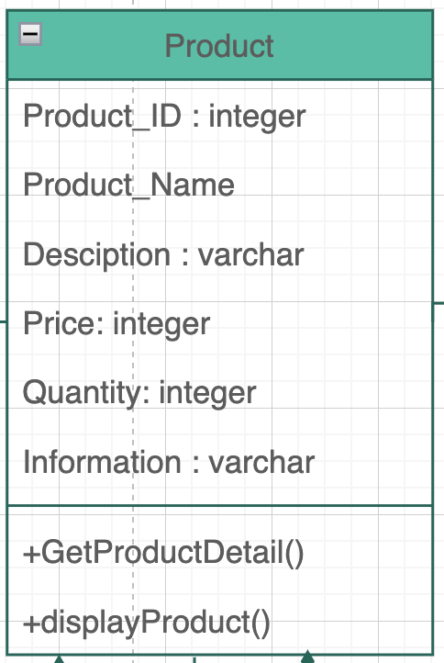**d) Product**

Figure 47 Product class

|  |  |  |  |
| --- | --- | --- | --- |
| **Attribute Name** | **Data Type** | **Type** | **Meaning** |
| Product_ID | Integer | Public | Code of the Product |
| Product_Name | Varchar | Public | Name of Product |
| Desciption | Varcahr | Public | Desciption of Product |
| Price | Integer | Public | Price of Product |
| Quantity | Integer | Public | Quantity of Product |
| Information | Varchar | Public | Information of Product |

This class describes a group of items belonging to a specific category and/or department. When a user clicks on a product or the "Search" button on the Search form, the displayProduct() and getProductDetails() methods are invoked. When a consumer clicks on a product, the displayProduct() function retrieves the picture of the product, and the getProductDetails() method retrieves the product's details as a data set. A product may be classified into one or more departments or categories.

**e ) Order**

### 

Figure 49 Order class

|  |  |  |  |
| --- | --- | --- | --- |
| **Attribute Name** | **Data Type** | **Type** | **Meaning** |
| Order_ID | Integer | Public | Code of the Order |
| Voucher | Varchar | Public | Voucher of Order |
| Submit date | Date | Public | Submit date of Order |
| Status | Varchar | Public | Status of Order |
| Desciption | Integer | Public | Desciption of Order |

Figure 50 Detail order class

This class will keep track of all information about each customer's orders. When a consumer selects the "Place Order" button on the Order form, the placeOrder() function is invoked. If the order was placed successfully, it returns true; otherwise, it returns false. Only when the consumer has a legitimate shopping cart and has supplied valid personal, billing, and shipping information will the "Place Order" button be activated.

PlaceOrder Operation Requirements

1. The purpose of this page is to allow customers to place orders for goods that have been placed to their shopping cart.
2. To be able to place an order, the customer must be logged in and have at least one item in their shopping cart. In addition, the customer's profile information and credit card information should be correct.
3. Post-Condition: The customer will be able to place the order successfully.
4. Input: After the consumer has finished browsing, he requests that an order be placed by clicking the "Place Order" button on the website. Look into it.
5. Output: If the customer's profile information, payment information, and

credit card are all legitimate, the system will process the order form.

**f ) Order Detail**

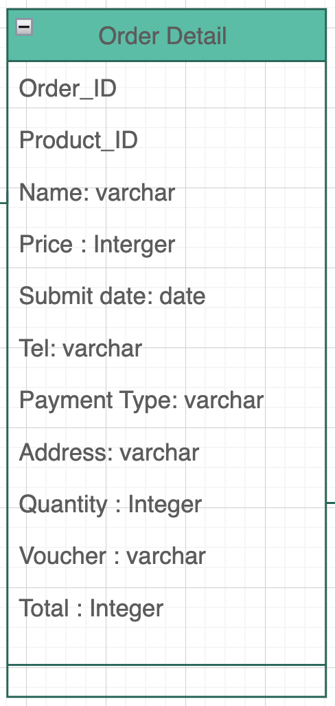

Figure 51 Order detail class

|  |  |  |  |
| --- | --- | --- | --- |
| **Attribute Name** | **Data Type** | **Type** | **Meaning** |
| Order_ID | Integer | Public | Code of Order |
| Product_ID | Varchar | Public | Code of Product |
| Name | Varcahr | Public | Name of Customer |
| Address | Varchar | Public | Address of Customer |
| Email | Varcahr | Public | Email of Customer |
| Tel | Varchar | Public | Telephone number of Customer |
| Payment Type | Varchar | Public | Payment of order |
| Quantity | Integer | Public | Quantity of product in order |
| Price | Integer | Public | Price of product in order |
| Voucher | Varchar | Public | Voucher of Order |

Figure 52 Detail order detail class

This class manages the information of every order placed by a customer. To compute the entire amount of the order, the total() function is used. Once the consumer has picked the shipping zone, the technique calculates the entire cost of the order, including shipping charges.

**g ) Shopping Cart**

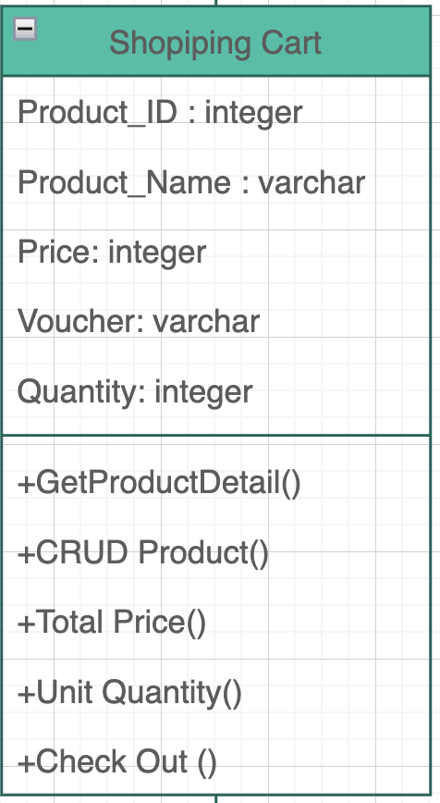

Figure 53 shopping cart classs

|  |  |  |  |
| --- | --- | --- | --- |
| **Attribute Name** | **Data Type** | **Type** | **Meaning** |
| Order_ID | Integer | Public | Code of Order |
| Product_ID | Varchar | Public | Code of Product |
| Name | Varcahr | Public | Name of Customer |
| Address | Varchar | Public | Address of Customer |
| Email | Varcahr | Public | Email of Customer |
| Tel | Varchar | Public | Telephone number of Customer |
| Payment Type | Varchar | Public | Payment of order |
| Quantity | Integer | Public | Quantity of product in order |
| Price | Integer | Public | Price of product in order |
| Voucher | Varchar | Public | Voucher of Order |

Figure 54 Detail shopping cart class

The ShoppingCart class contains all of the goods that a consumer has placed to their shopping cart. When a consumer takes actions like "Add to Cart" and "Delete" on the ShoppingCart, the addCartItem() and deleteCartItem() methods are invoked. When the customer presses the "Update" button on the ShoppingCart.aspx Webpage to raise or reduce the amount of goods in the cart, the updatequantity() function is invoked. When a consumer selects the "View Details" button to obtain a summary of their cart, the viewCartDetails() function is invoked. It will only show the summary if your cart isn't empty; otherwise, it will say "Your Cart is Empty."

AddCartItem Operation Requirements

1. The purpose of this is to allow customers to add things to their shopping basket while searching or exploring the catalog.
2. To add a product to the basket, the customer must first be logged in.
3. Product will be added to the shopping cart after posting.
4. Input: When a consumer discovers the goods he wants, he clicks the "Add to Cart" button to add them to his shopping cart.
5. Output: The product will be added to the shopping cart, and the system will save and track the information about the goods that have been added.

Checkout Operation Requirements

1. The purpose of this feature is to allow customers to purchase items that have been placed to their shopping cart.
2. To check out and place an order, the customer must be logged in and have at least one item in their shopping cart.
3. After successfully checking out, the customer will be able to change his profile information and place orders.
4. Input: When the consumer is through purchasing, he clicks the "checkout" button on the Cart.aspx page to request checkout.

If this customer's payment information is already on file, the system invites them to review or enter new information. If the payment card is legitimate, the system will process the order form and the checkout will be completed

**h ) Shopping Cart**

Figure 55 Comment class

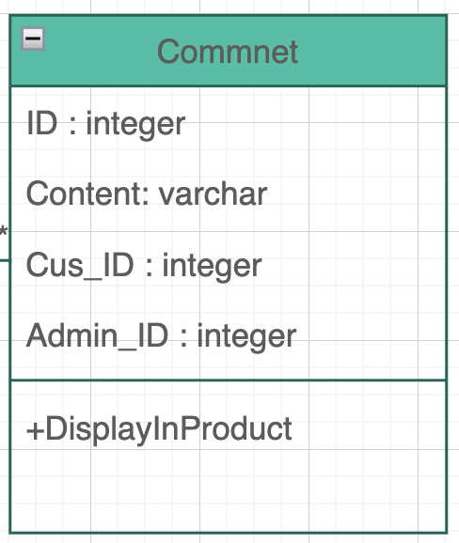

|  |  |  |  |
| --- | --- | --- | --- |
| **Attribute Name** | **Data Type** | **Type** | **Meaning** |
| ID | Integer | Public | Code of Comment |
| Content | Varchar | Public | Content of Comment |
| Cus_Id | Integer | Public | Code of customer in Commnet |
| Admin_ID | Integer | Public | Code of admin in comment |

Figure 56 Detail comment class

1. **Sequence Diagram**
   1. **Login Sequence Diagram**

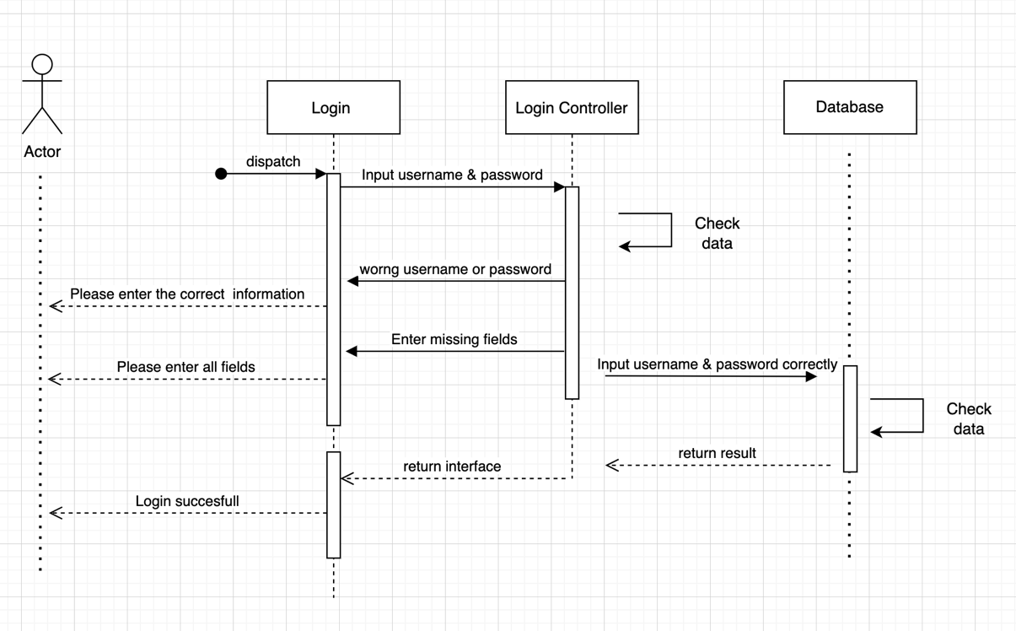

Figure 57 Login Sequence Diagram

* 1. **Register Sequence Diagram**

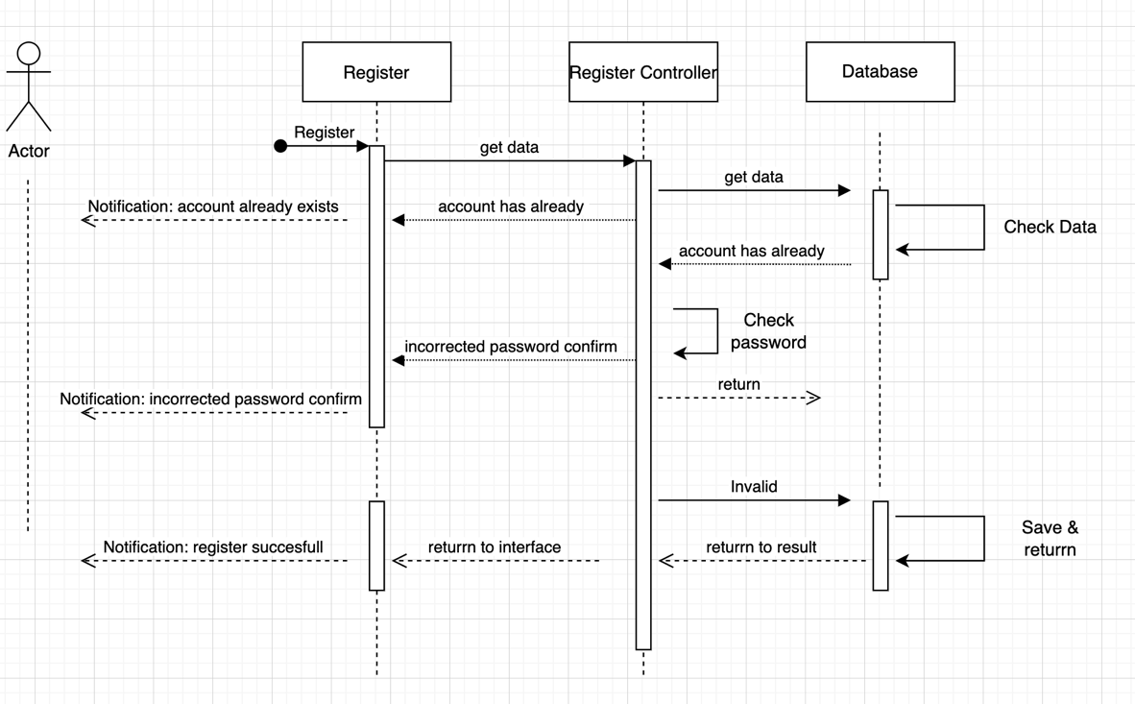

Figure 58 Register Sequence Diagram

* 1. **Category Sequence Diagram**

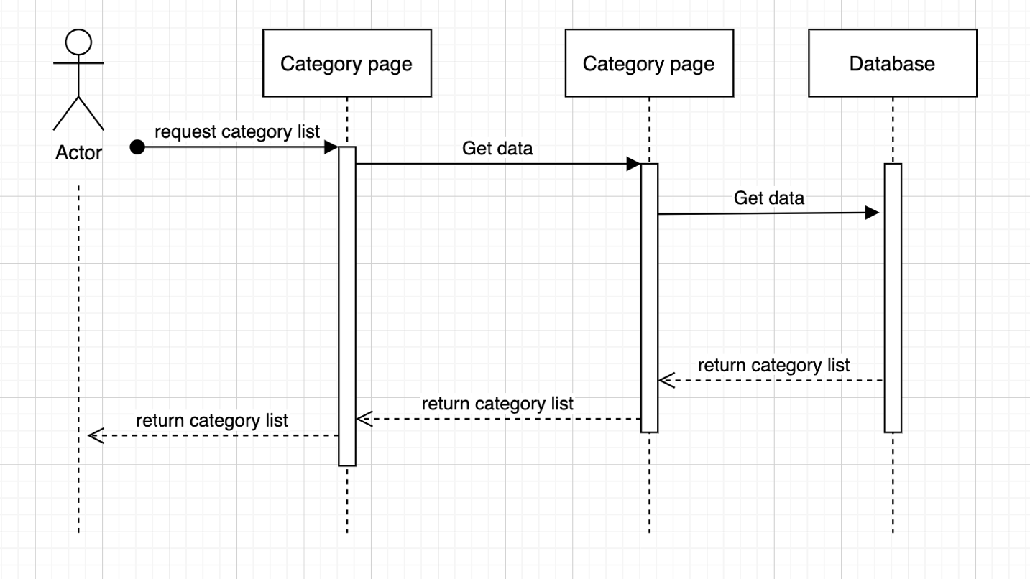

Figure 59 Category Sequence Diagram

* + - 1. **Product Sequence Diagram**

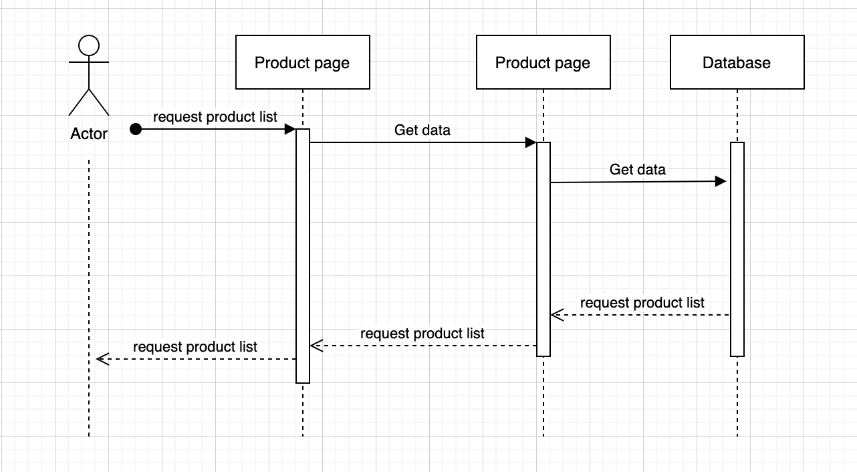

Figure 60 Product Sequence Diagram

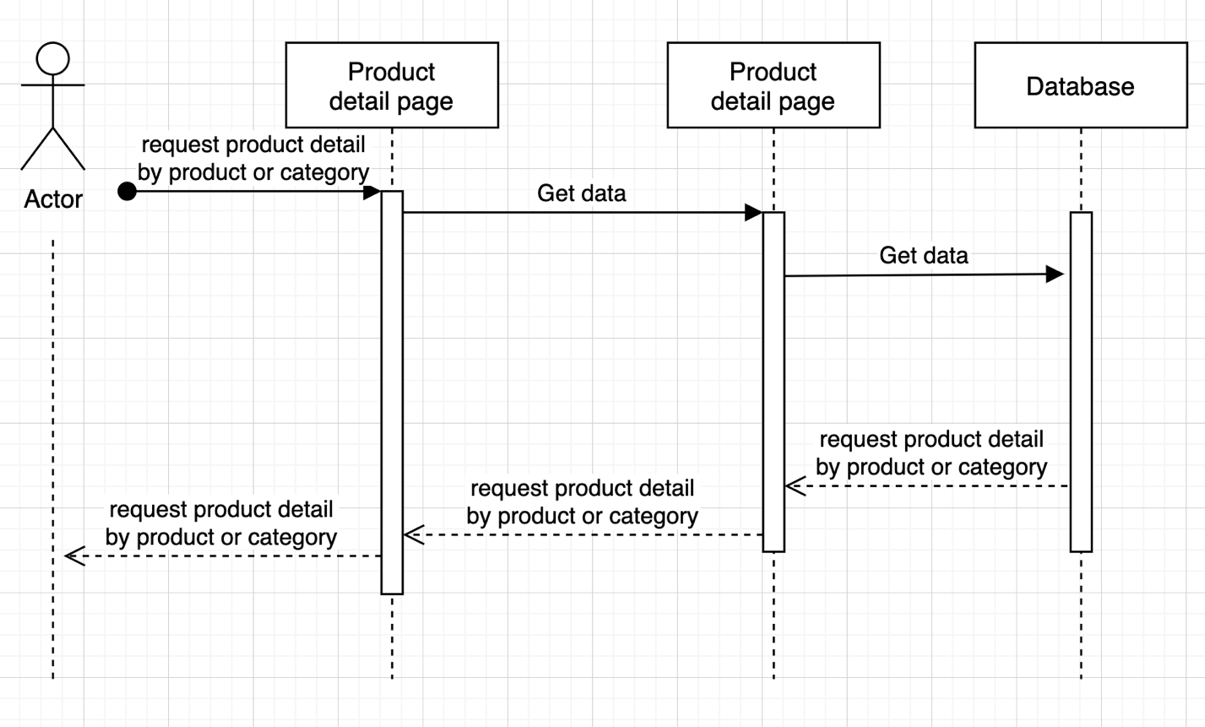

* 1. **Comment Sequence Diagram**

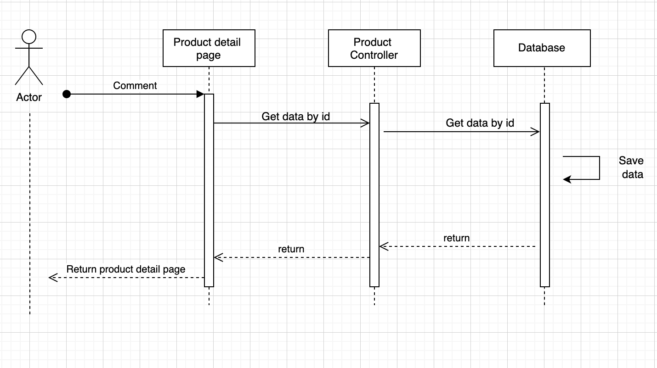

Figure 61 Comment Sequence Diagram

* 1. 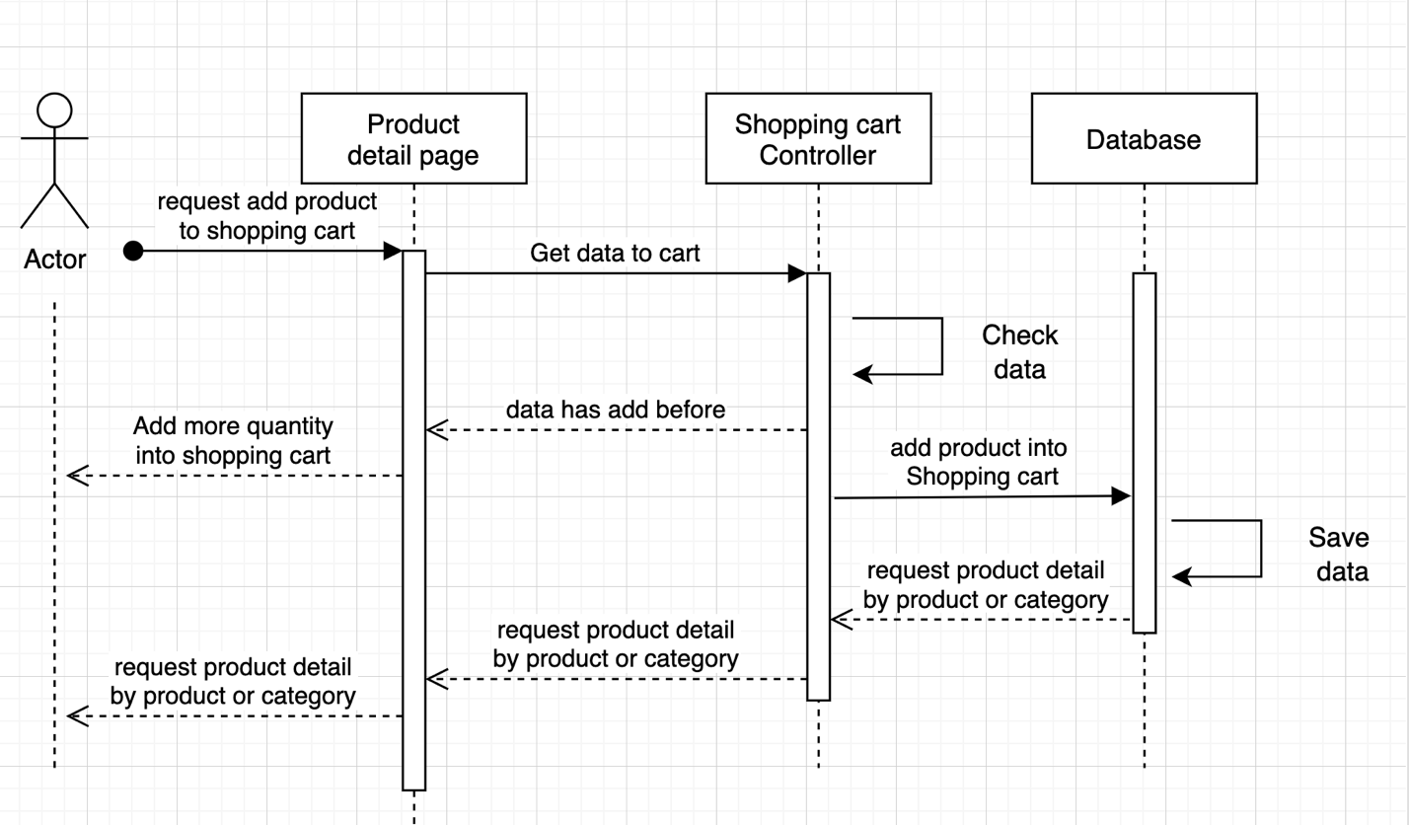 **Comment Sequence Diagram**

Figure 62 Add product to shopping cart

Figure 63 Shopping cart Sequence Diagram

* 1. **Shoppingcart Sequence Diagram**

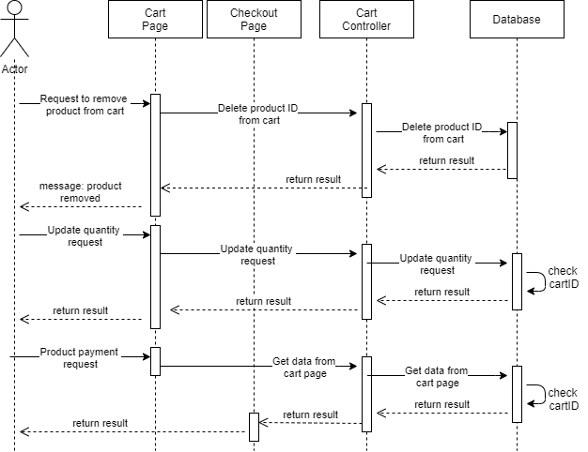

* 1. **Check out Sequence Diagram**

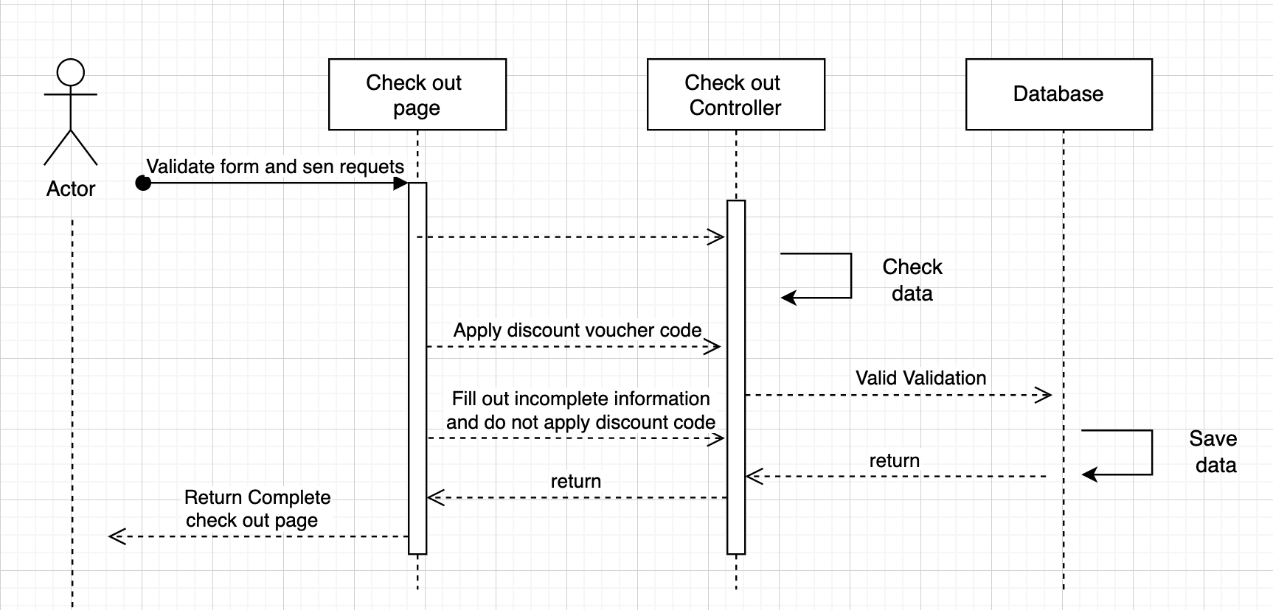

Figure 64 Checkout Sequence Diagram

* 1. **Admin manage product Sequence Diagram**

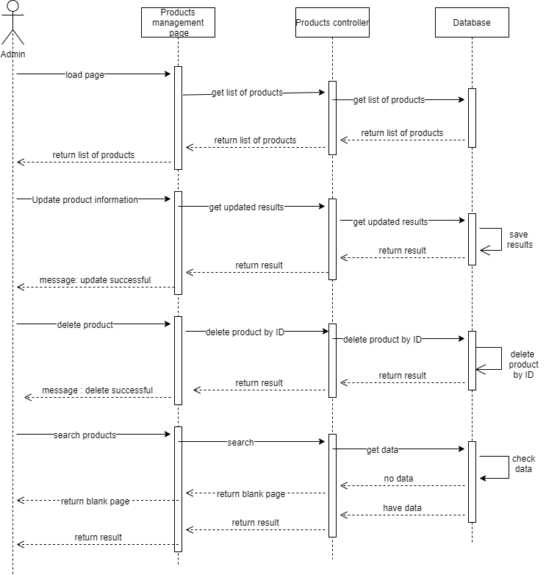

Figure 65 Admin manage product Sequence Diagram

* 1. **Admin manage order Sequence Diagram**

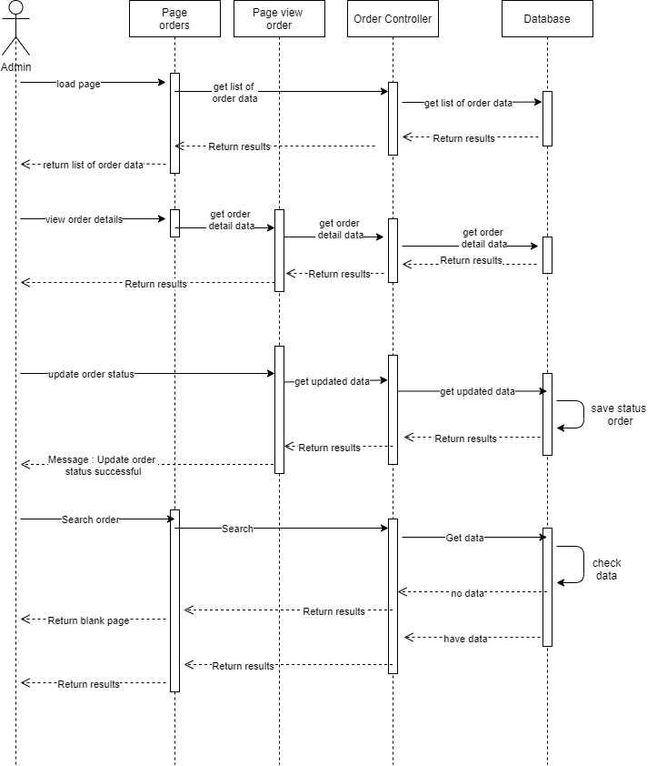

Figure 66 Admin manage order Sequence Diagram

* 1. **Admin manage product Sequence Diagram**



Figure 67 Admin mange product Sequence Diagram

* 1. **Admin manage category Sequence Diagram**

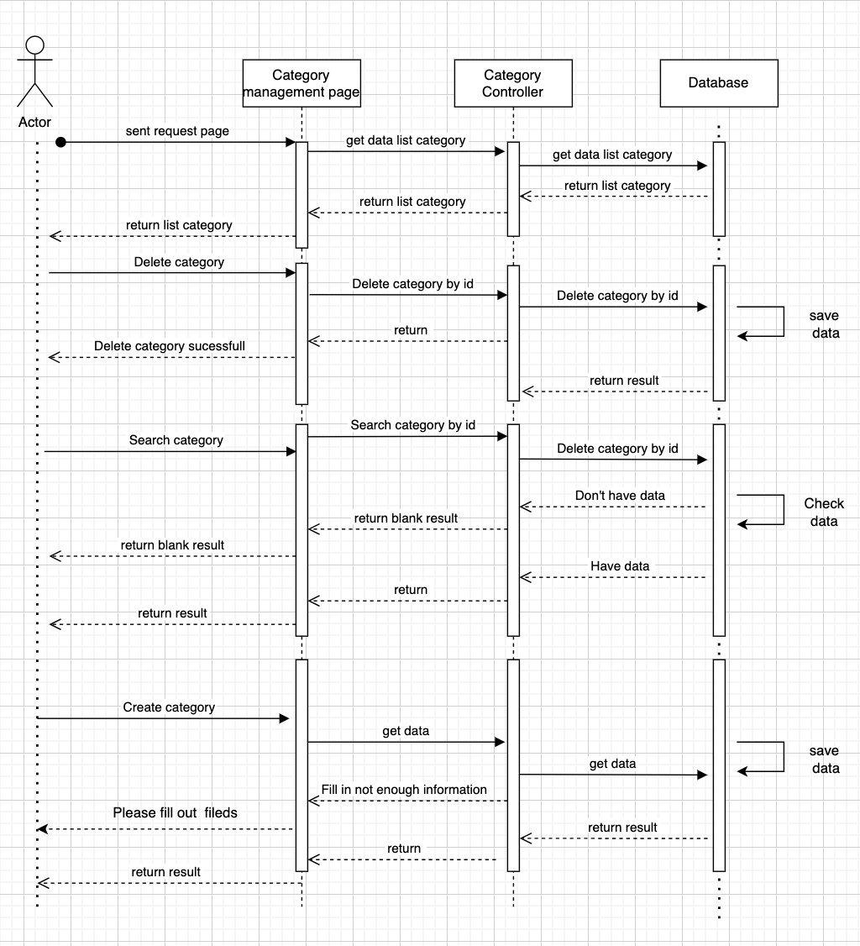

Figure 68 Admin manage category Sequence Diagram

* 1. **Admin manage account Sequence Diagram**

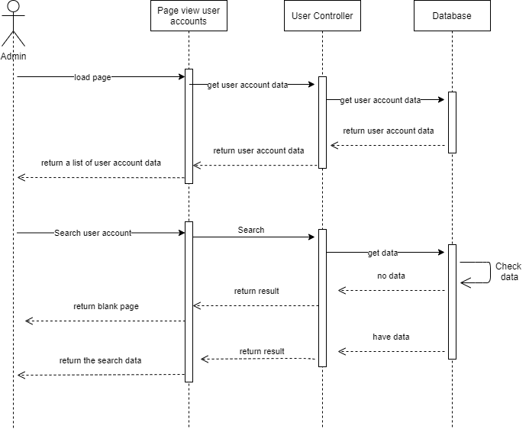

Figure 69 Admin mange account Sequence Diagram

**Sumary**: Sequence diagram helps to show the process of functions performed in the project, describes the order of objects easily, is an important document in software development, In addition to planning plan and how each function works. Through the Sequence diagram, I have shown the process and order of operation of each object, how the project works and specifically clarified: Login, Register, Shopping cart, check out, Produtc, Category. Thus users or project members can view this as important project documentation through figure

1. **Site Map**

Site map is an important document that provides information about websites and the relationships between them, in addition, it also helps us to know which pages are important pages of the web, this is also a document used for for users.

* 1. **Site map for customer**

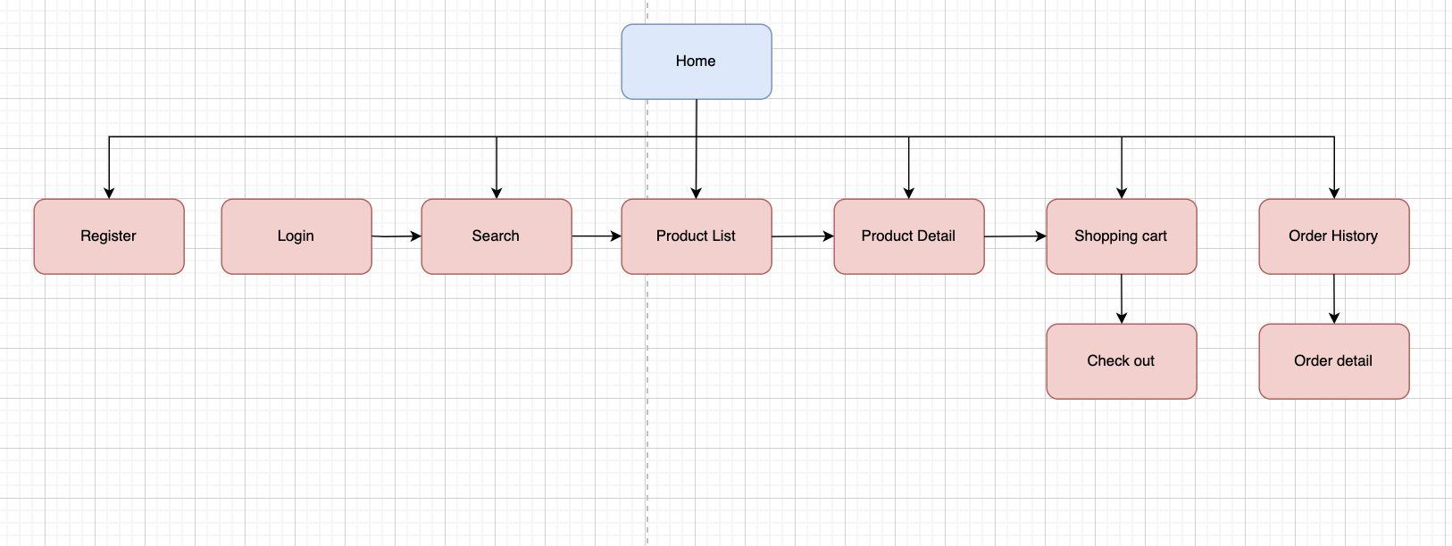

Figure 70 Site map for customer

Site map for customers: first from the home page, customers can log in or not to see the list of categories and product lists, at the same time customers can search for products, then customers can You can view product details on product detail page and add to cart, next customer check out to proceed with order payment, finally customer can track his order through order history. row

* 1. **Site map for Adm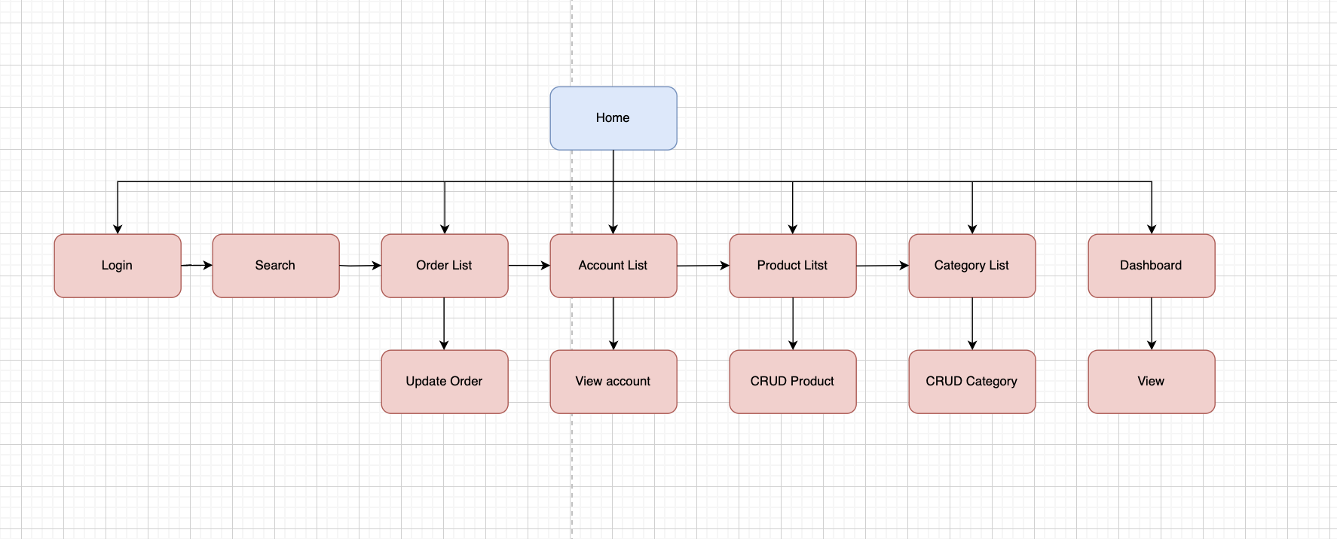in**

Figure 71 Site map for admin

Site map for admin, this is an important part of the system so I have described it with extreme care through Figure 71. From there it can be seen: admin is required to log in to be able to interact with the system, then they can search for the item they need to interact with, admin can go to: account list, order list, category list, product list. On these pages admin can perform actions: create, view, update, delete, depending on the part as I described in the figure. And finally the admin can go to the Dashboard to see the system's revenue and best-selling products

1. **Implemention**
2. **Home Page**

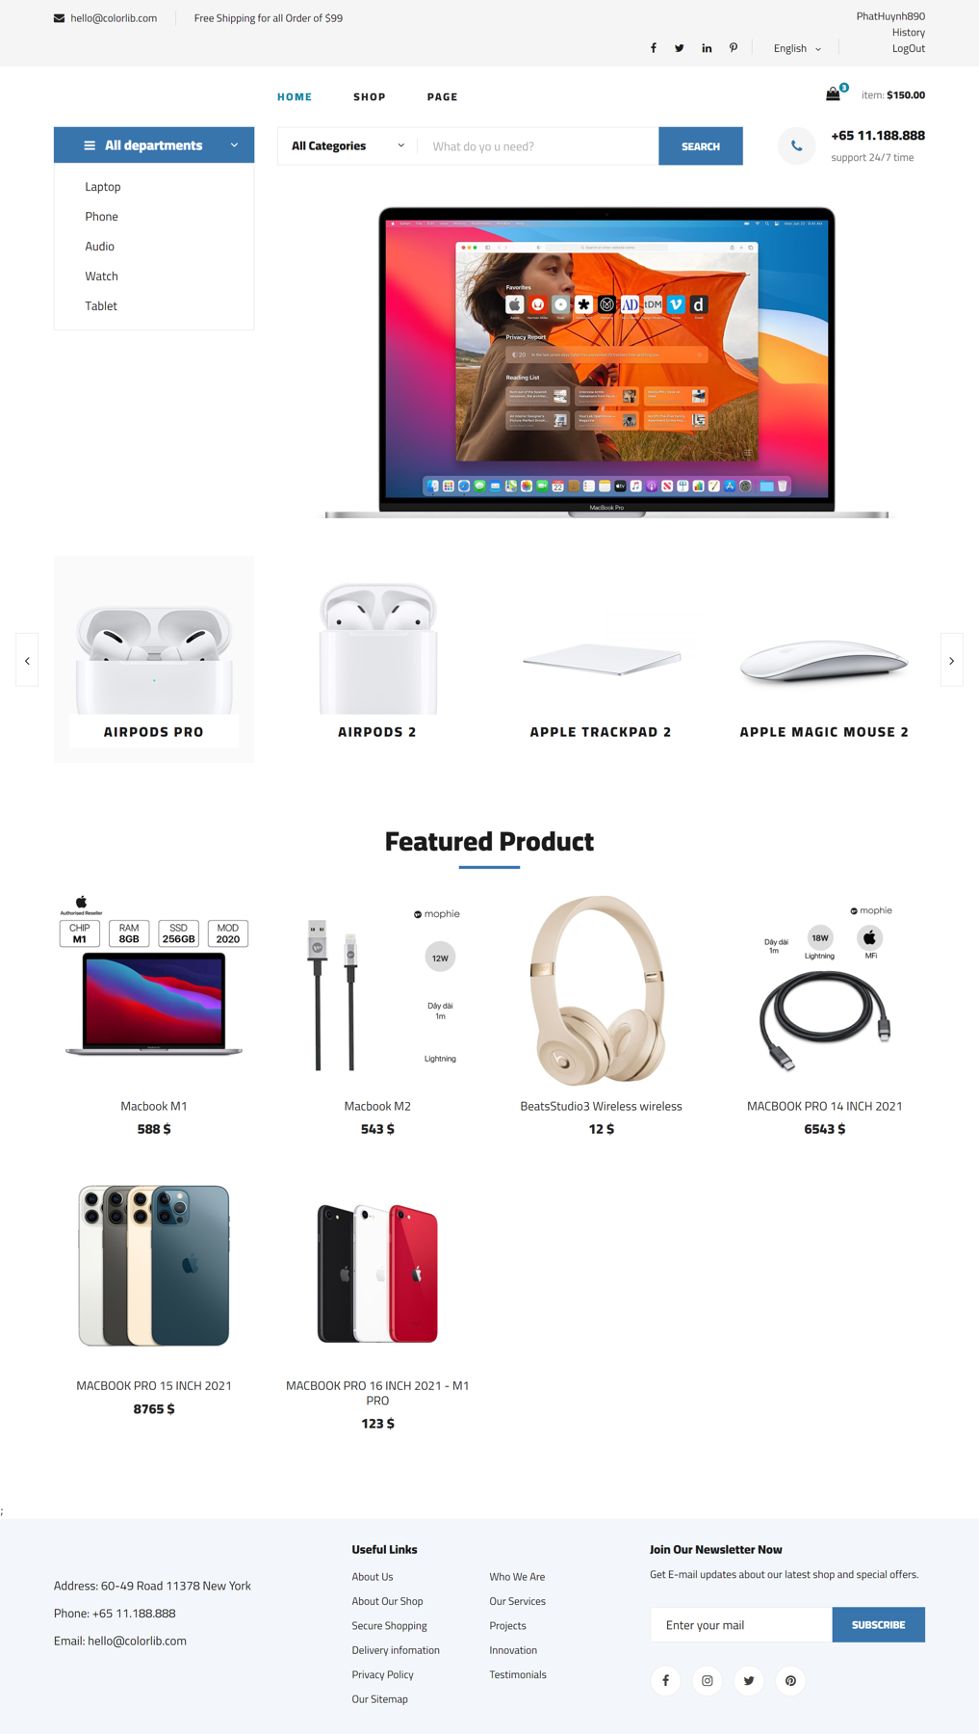

Figure 72 Home pgae

**Controller code**

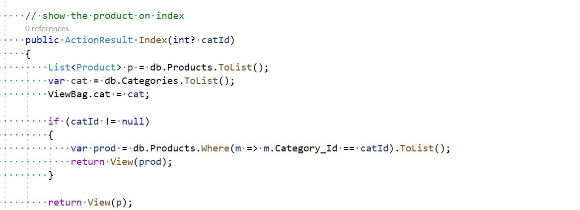

Figure Home page Controller

**Html code**

Figure Home page HTML

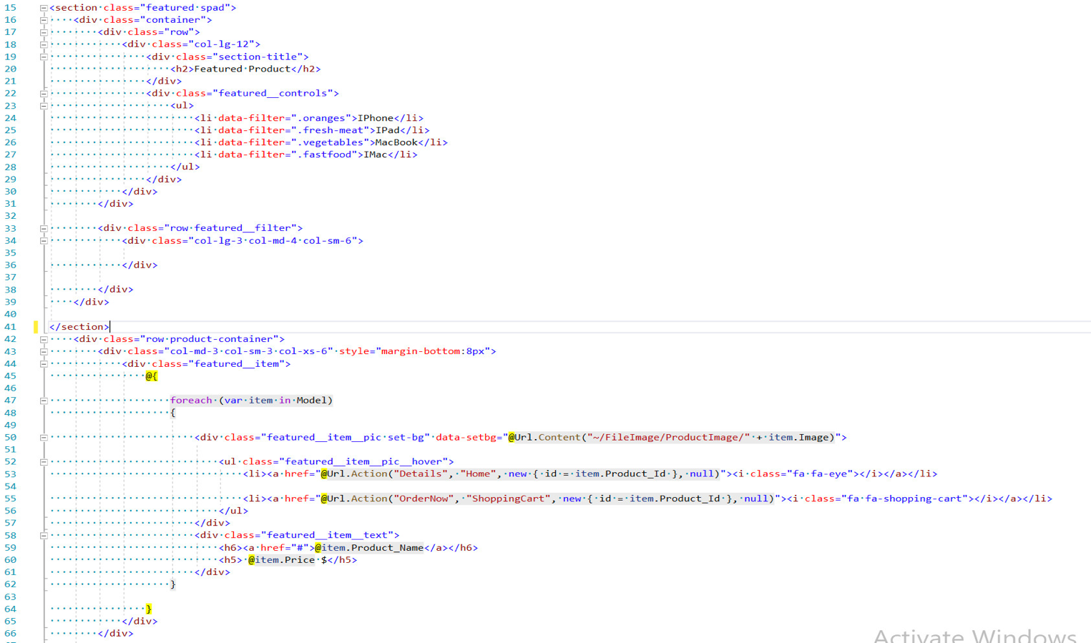

After designing the design as in the wireframe, I started to build the homepage for the system based on the initial design layout. For the homepage, it will be quite important impression for a website and especially for the users. sales system. In order to help customers have an objective view of the system, it is necessary to require aesthetics, but here I design in a simple style but lack the aesthetics, keeping the harmonious coordination between the layouts. Basics of the page like: header, navigation, content and footer . These will be the fixed sections that are used a lot on similar pages. In the header, there will be the website logo, login, registration, account logout, in addition to the shopping cart and product favorites. . Next, in the navigation section is the place containing the names of the categories and users can use them by clicking on the buttons on this bar to search for the corresponding products in that category. Below that will be the product and customer search bar. Customers can search for the products they want using this toolbar. For the content section, the homepage will display new products, each product will include a price, image and view, add button. shopping cart, When they click on that icon, the system will automatically go to the product detail page or shopping cart. In addition, the homepage also presents blog articles about products and brands for customers to read. and additional knowledge. Finally, the Footer is a permanent place and is used a lot on other pages, here showing the store's contact information, links to useful pages.

2. **Categories**
3. **Controller code**

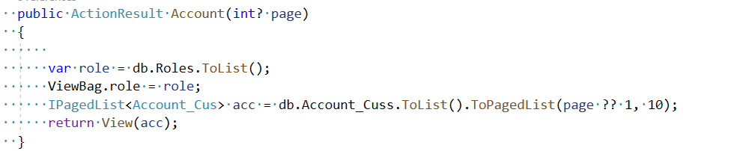

Figure 75 Category Controller

1. **HTML code**

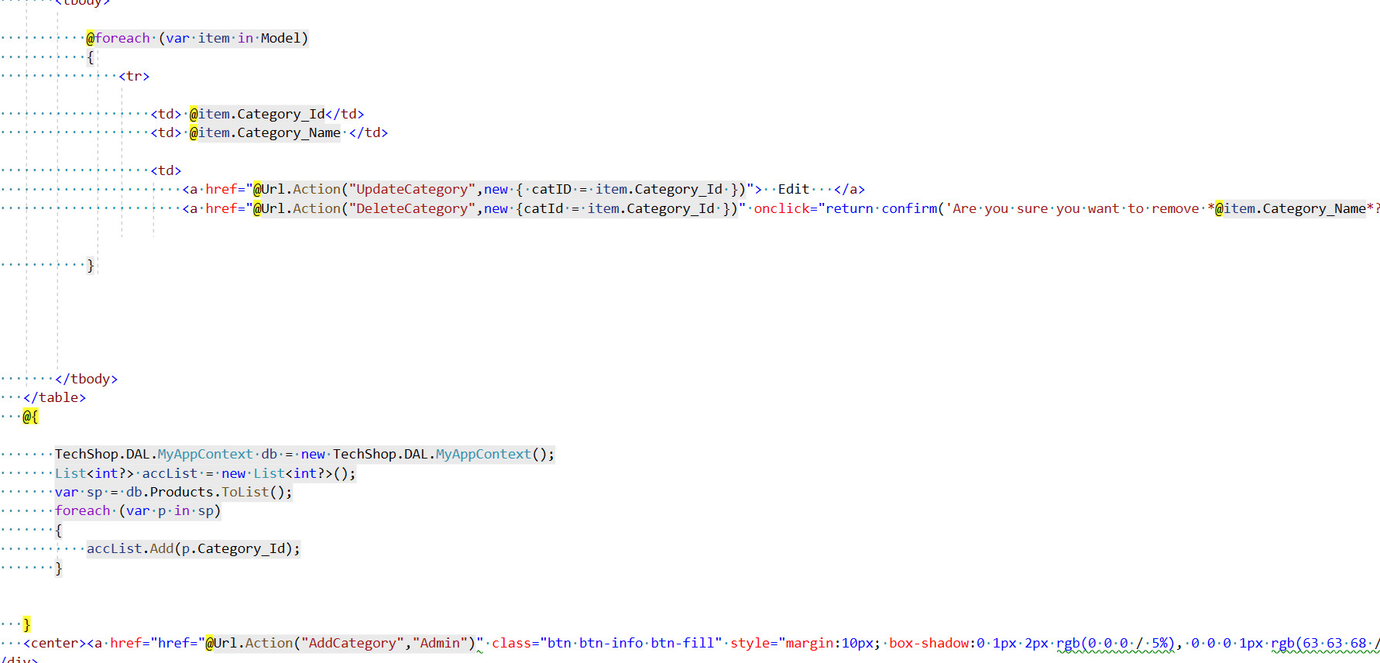

Figure 76 HTML category

All categories can be displayed on the left hand side, Just point to the bar it will show a list of product categories currently available in the system, this helps customers find products, view Get multiple products in the same category. Categories make managing products easier and more convenient

1. **Search Product**
2. **Controller code**

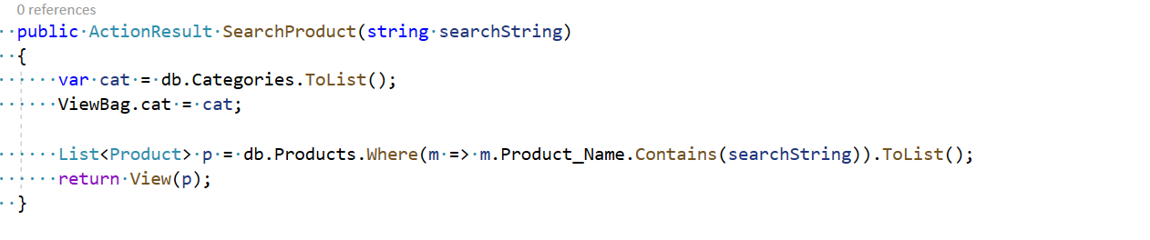

Figure 77 Search Controller

1. **HTML code**

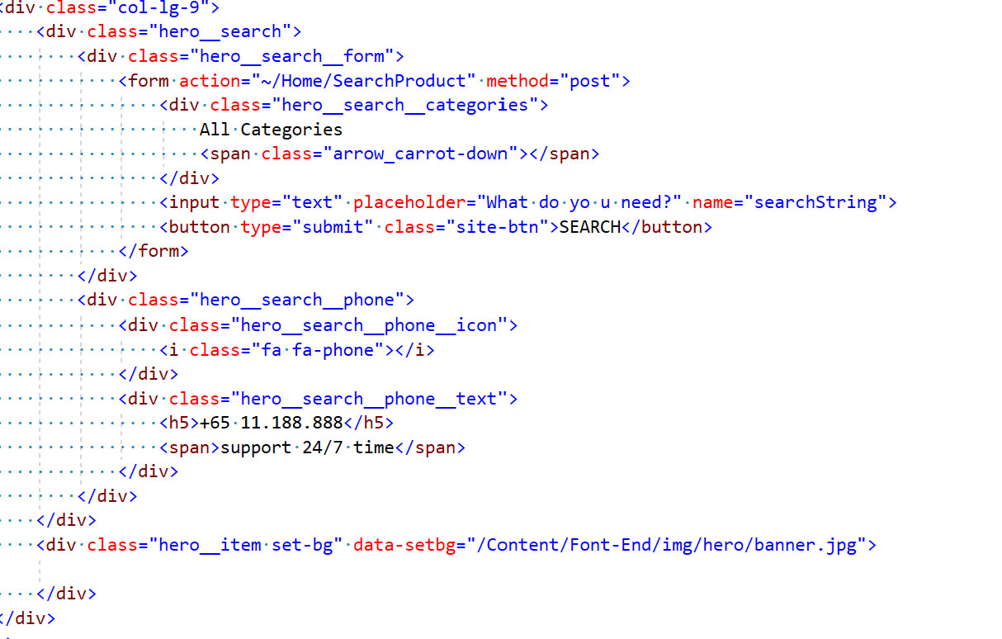

Figure 78 Search HTML

For the search bar, customers can enter any product name that customers want, then the system will return the products that customers search by name. Customers want to quickly find any product, it is inconvenient when customers are in a hurry to search for a product but have to see all available products on the system.

1. **Product Detail**

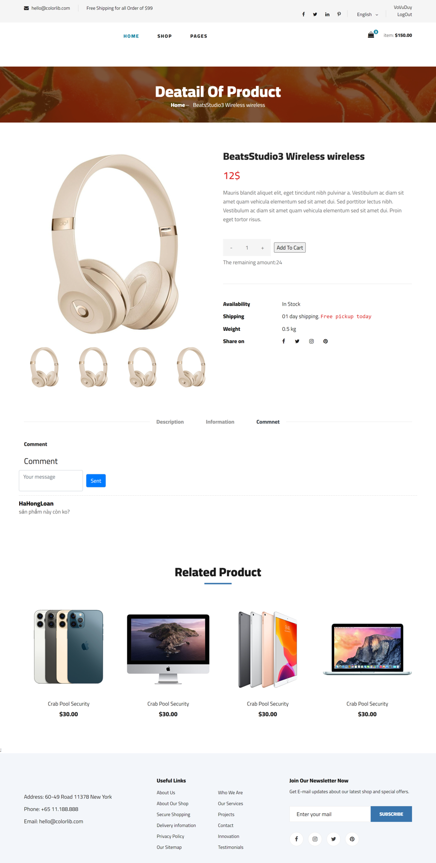

Figure 79 Product detail page

1. Cotroller code

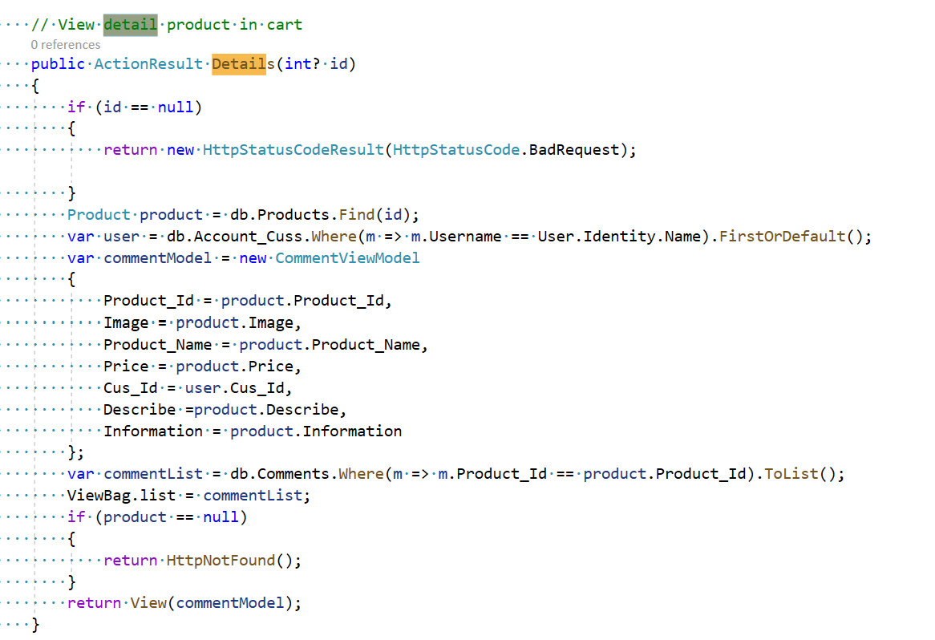

Figure 80 Product detail Controller

2. **HTML code**

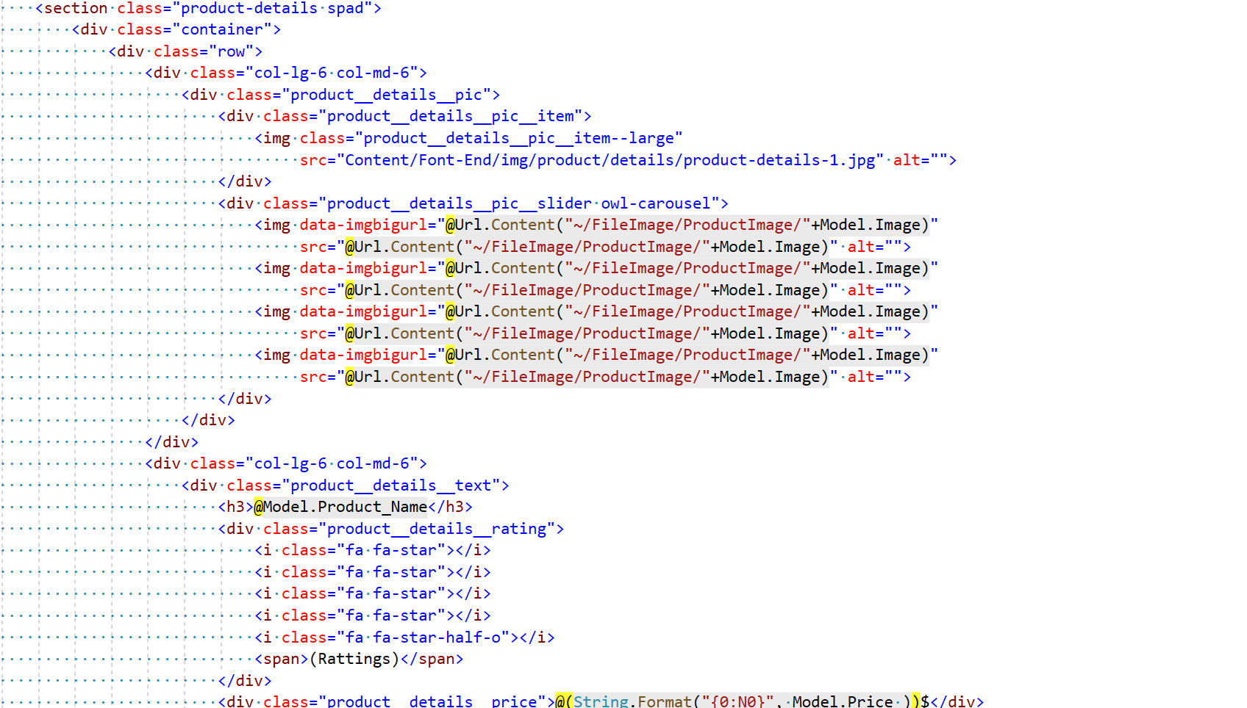

After the customer chooses to view the details of a product on the system, the page will access the product detail page and display the detailed information of that product, including images (customers can zoom in to see the details). product in the image), price, description, and detailed information about the product's parameters, The product detail page carries a high customer responsibility when the customer sees the product details, if the page presents the customer well Customers will feel that the product has a clear and detailed origin, they will increase their trust and make a decision to buy the product if the page meets the needs to satisfy the information of the product for the customer. Below is The section shows the comments of customers who have used the service and product, they will evaluate it directly on the detail page of that product, to state the quality of the product. That will increase objectivity and transparency for that product.

2. **Comment**

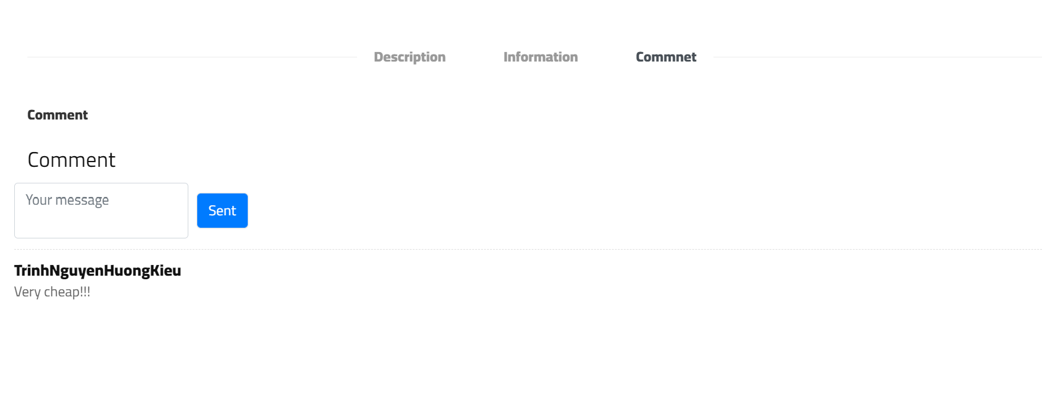

Figure 82 Comment product

1. 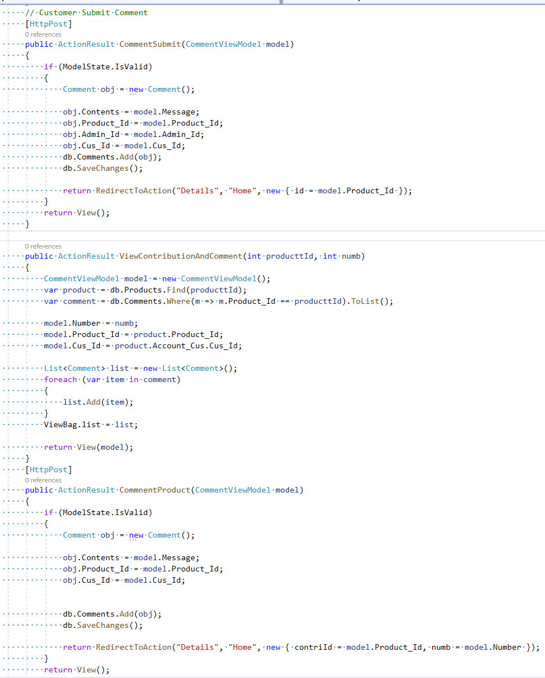Controller code

Figure 83 Comment Controller

1. HTML code

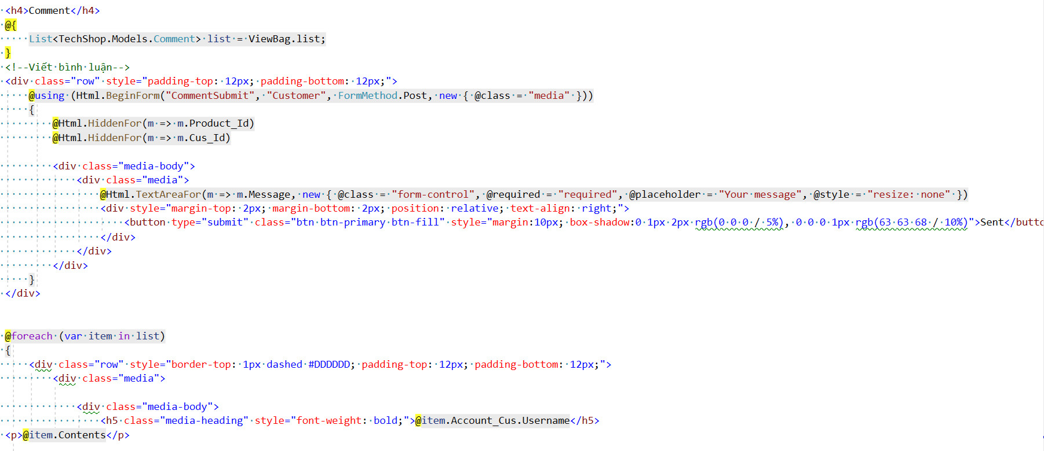

Figure 84 Commnet HTML

Commenting is a useful feature for the system that helps the direct selling system to increase transparency and product specificity, admins and customers can comment on products, but it is required account on the system

1. **Register**

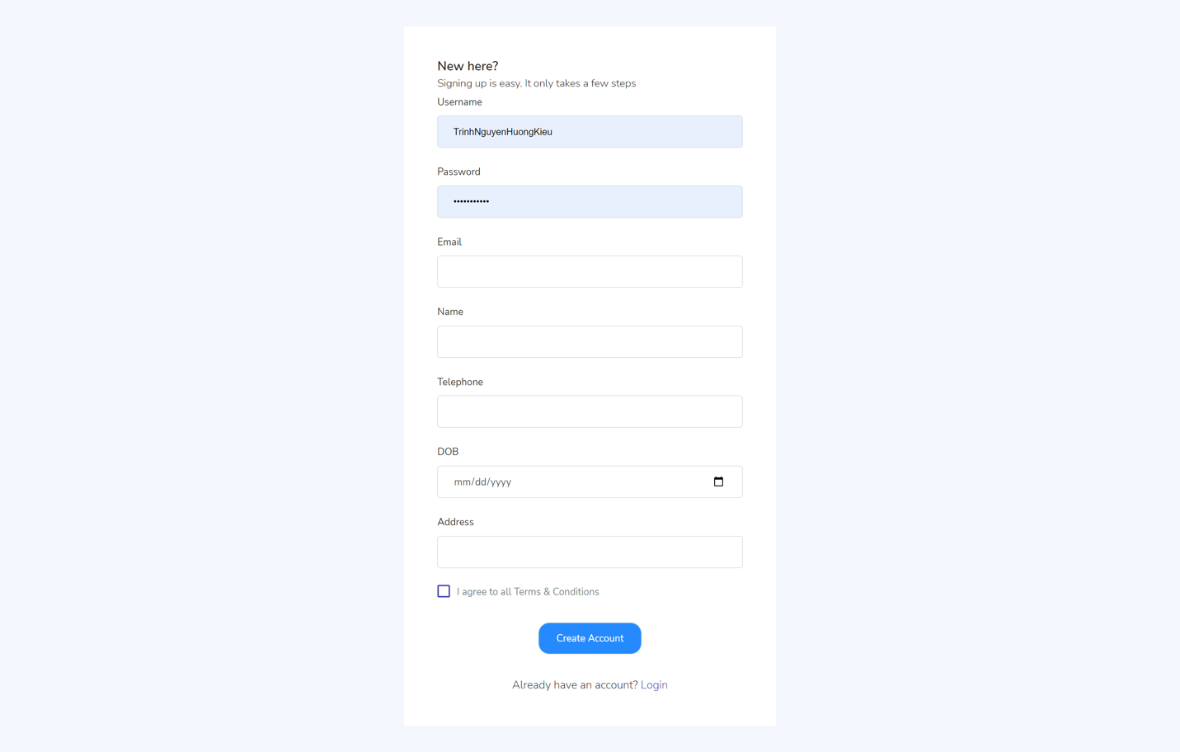

Figure 85 Register page

2. **Controller code**

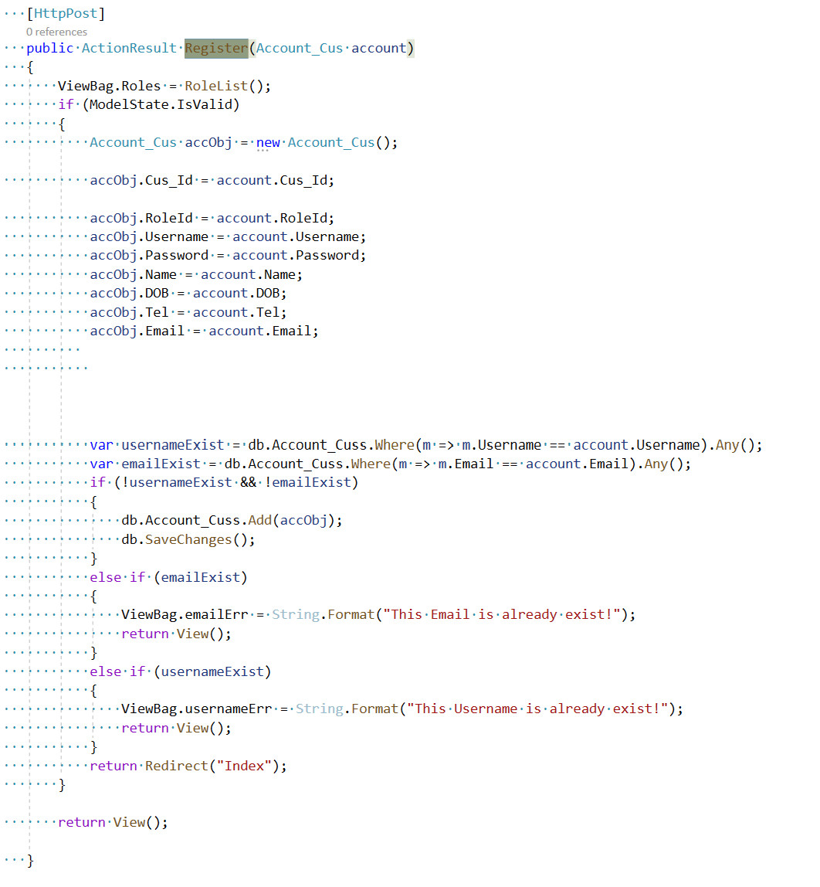

Figure 86 Register controller

1. **HTML code**

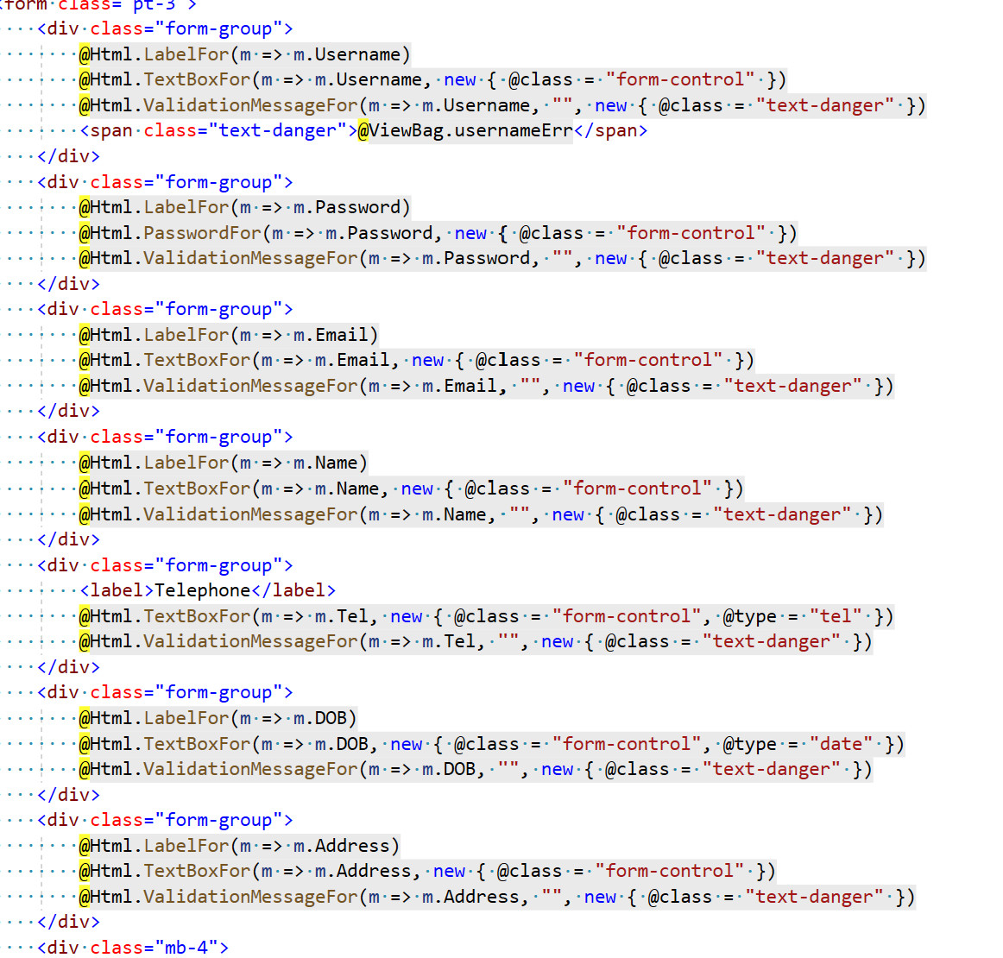

Figure 87 Register html

For users who already have an account on the system, this step is not necessary. Customers who do not have an account will need to register.As can be seen the image shown above, the user needs to enter fields with the following basic information. First of all, the profile section includes necessary information such as full name, phone number, and date of birth. Next is the login section with required information such as email (also username), password and confirm password. After the user is done enter the required information and click the register button, the system will perform check validation for each information has been entered. If it is valid, the system will display the success message and ask the user to check the email to confirm the email that the user has registered. On the contrary, the system will issue an error message as shown above and ask the user to enter again.

1. **Login**

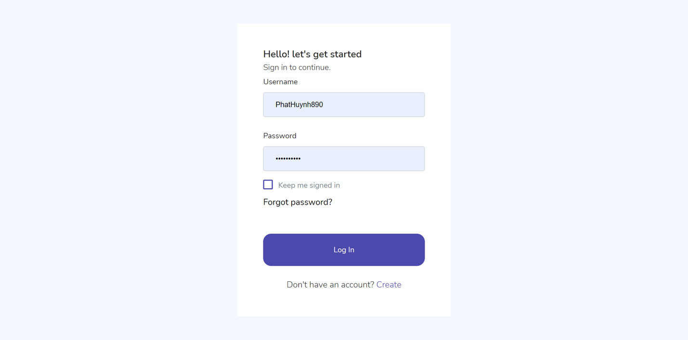

Figure 88 Login Page

1. **Controller code**

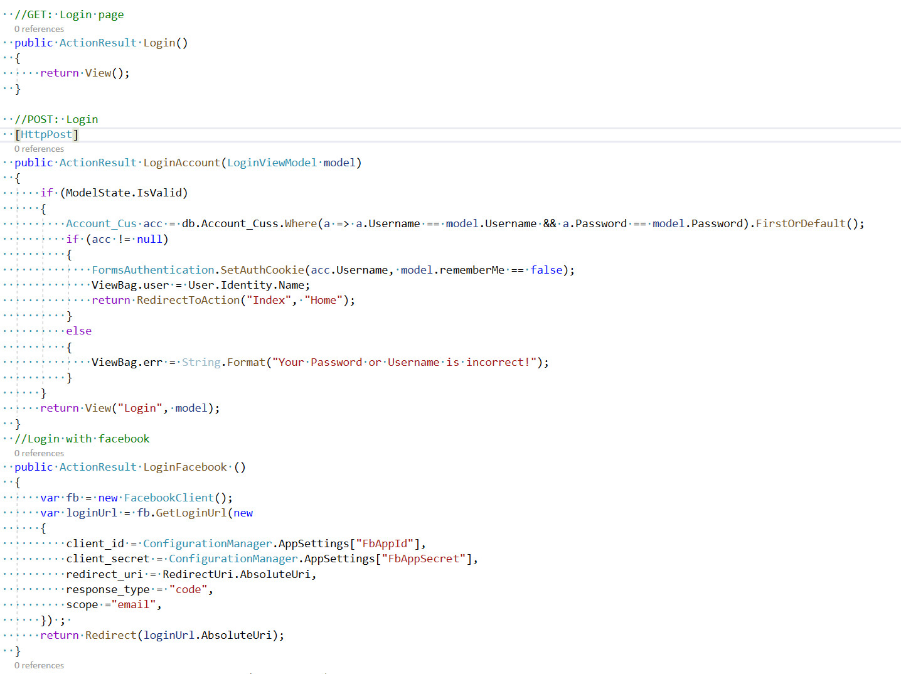

Figure 89 Login Controller

1. **HTML code**

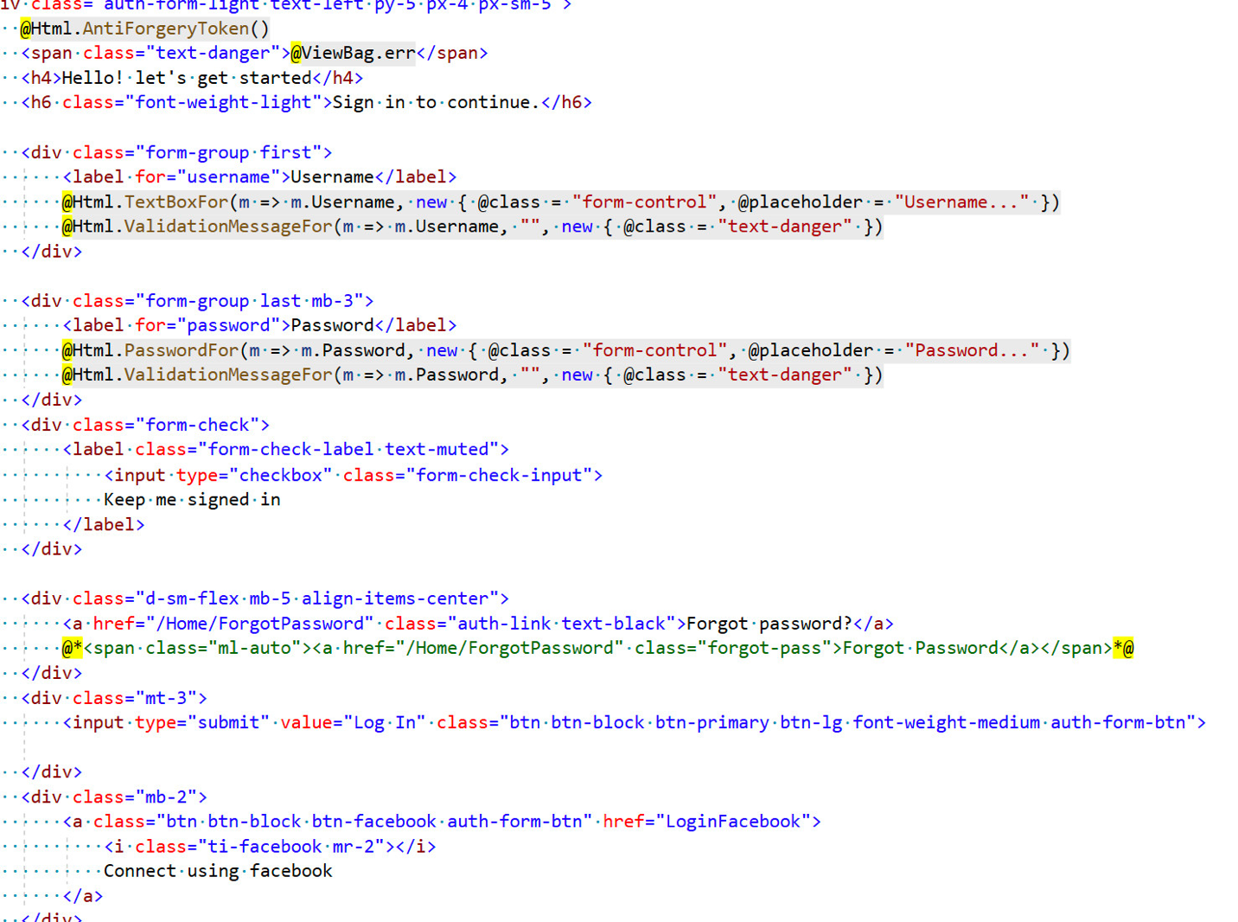

Figure 90 Login html

After successfully registering an account, or the user already owns an account on the system, the user can log into the system to use the features that the system has granted permission. On the login page the system requires requires the user to enter exactly 2 fields: username and password, after confirming if correct, the system will automatically redirect the page to the home page or not, the system will ask the user to re-enter the correct information. When you forget your password, you can click "Forget password" as shown to reset the password for your account.

1. 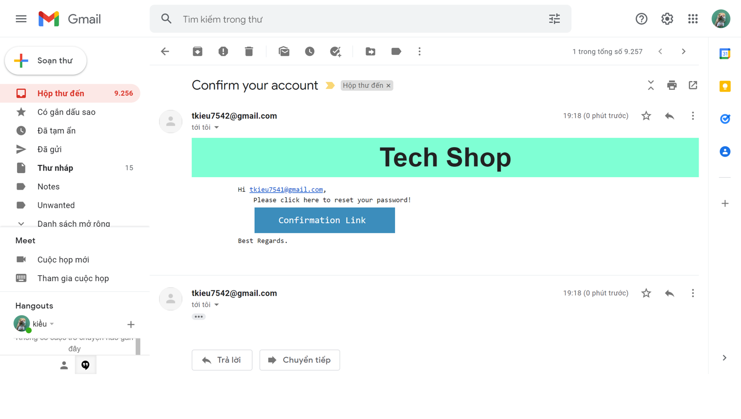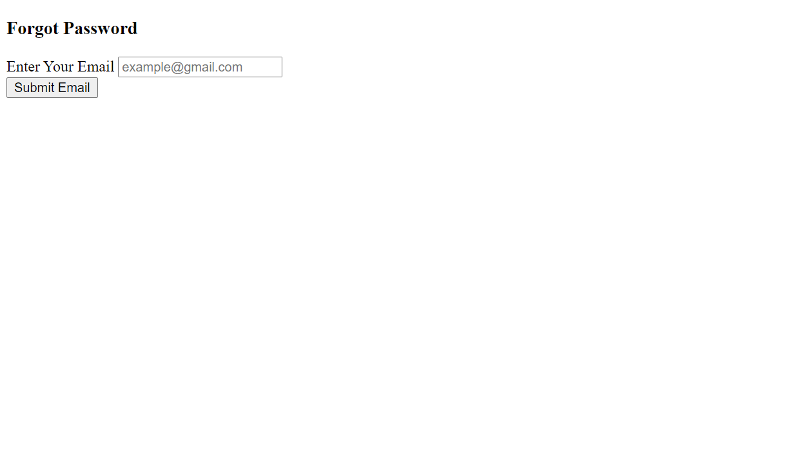**Change/ Reset passoword**

Figure 91 Email to confirm reset password

Figure 92 Forget password Controller

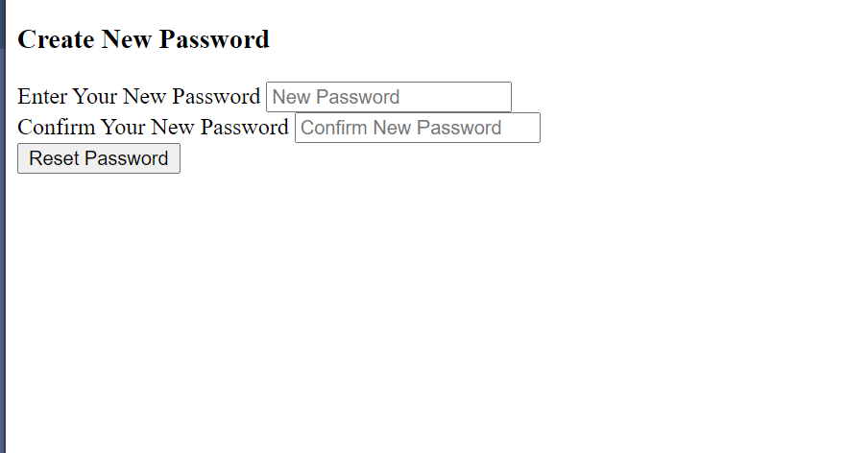

Figure 93 Reset password page

1. 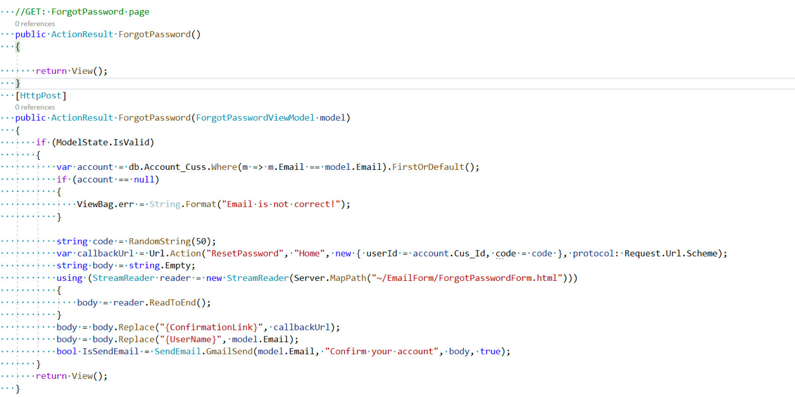**Controller code**

Figure 94 Forget password controller

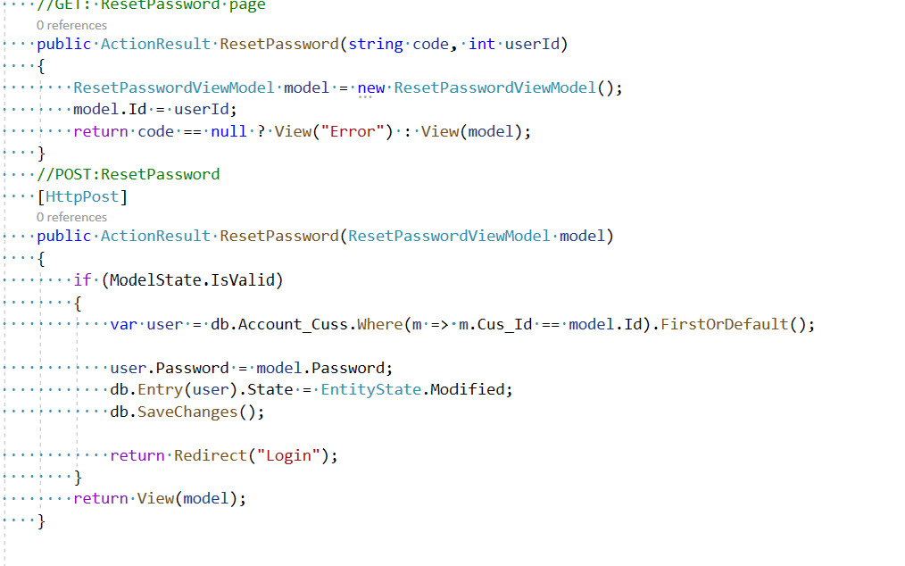

Figure 95 Reset password controller

1. **HTML code**

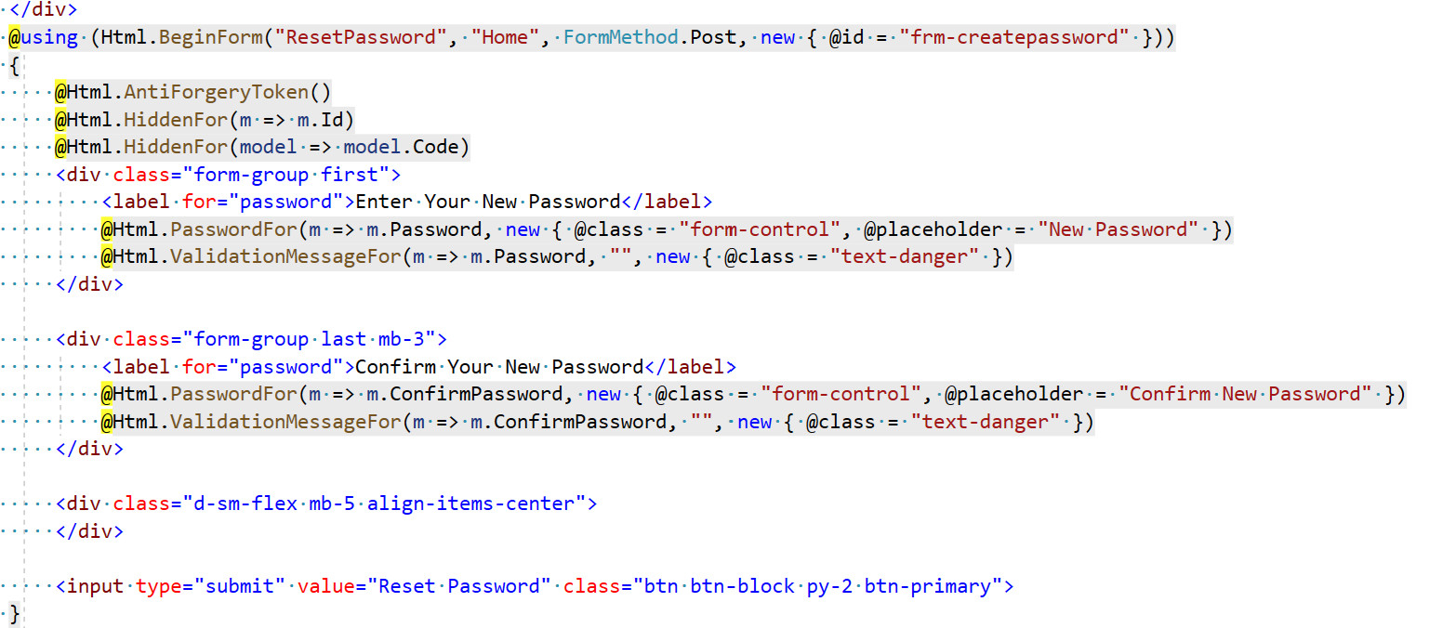

Figure 96 html reset password

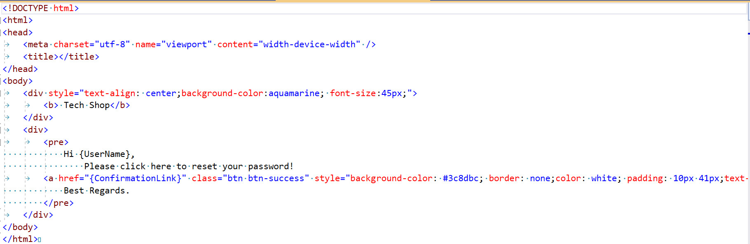

Figure 97 html send mail confirm reset password

There are cases where customers forget their password or learn to change their password. After they are on the login page they can click "Forget password" then they will be redirected to the forget password page. In order to recover the password, the user is required to enter the exact email that they used to register the account. Then the system will conduct a check and verify that the email address matches the registered account. If it is saved on the system or not, the system will notify "Valid email" and send a confirmation email to reset the password for customers to click on the link to the password reset page and proceed to reset the password. export. If not, the system will notify "Invalid email" and the user needs to re-enter the correct email.

1. **Profile**

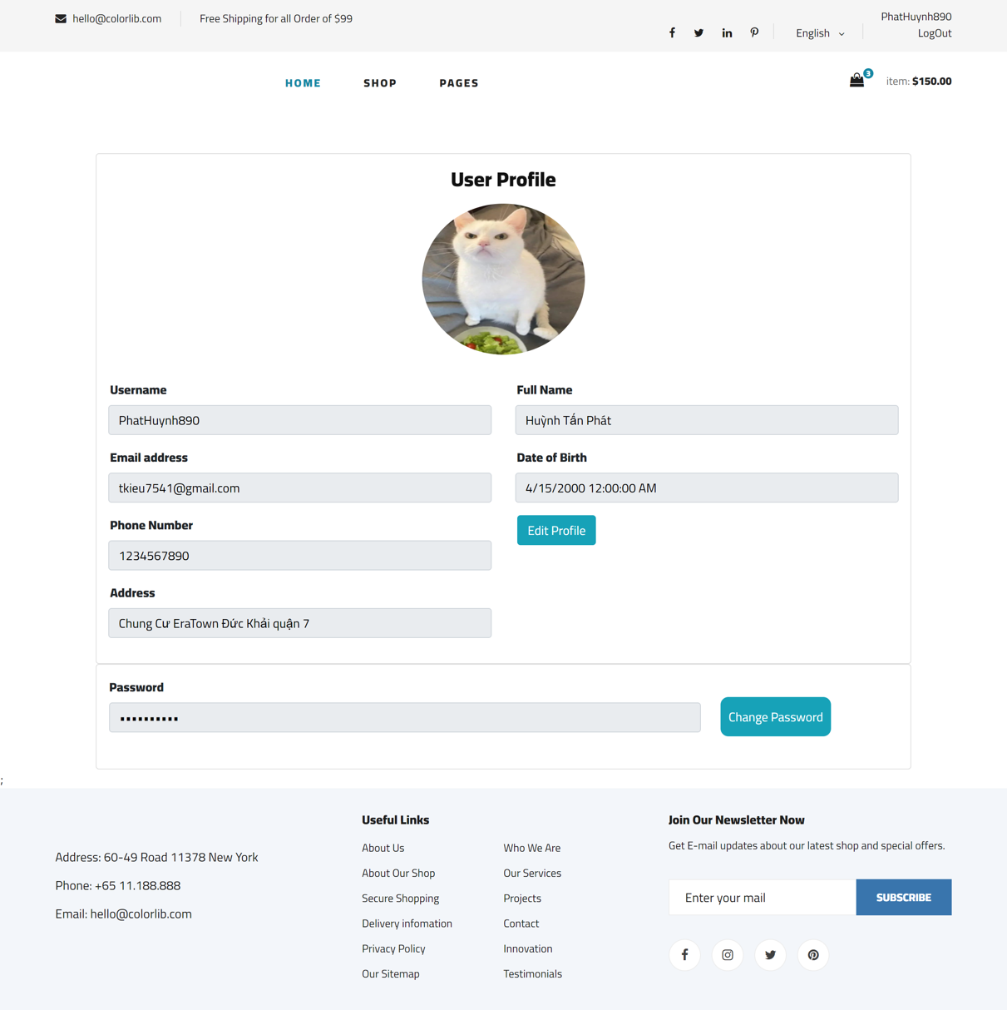

Figure 118 Profile customer page

1. Controller code

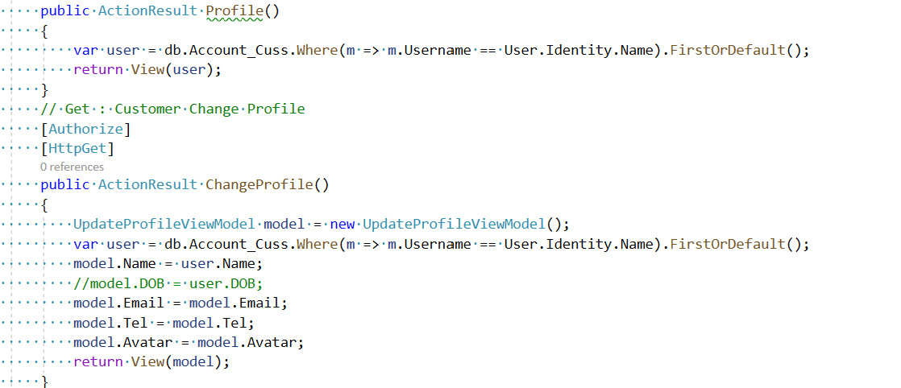

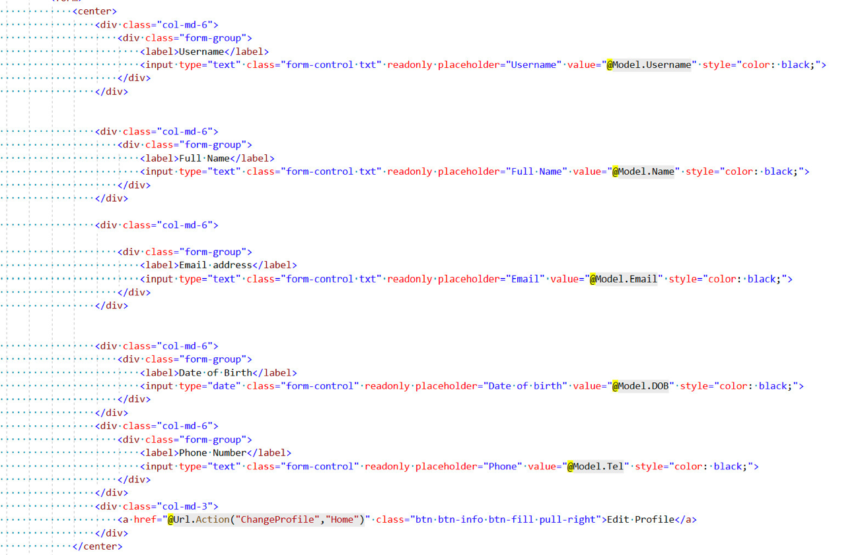Figure 119 proflie Controller

Figure 120 Profile html

1. HTML code

In this profile page I have built with display two important pieces of information, user's account information and user's order history information. specifically, users can access this page by clicking on the user icon in the header and then typing "user profile link". As can be seen in the figure, in the user's profile is shown the main information that the user entered in the registration section including name, email, date of birth, phone number and gender. In addition, this section also has a profile update function so that users can change the necessary information. Finally, the order history section helps users review the orders placed along with the status.

1. **Update Profile**

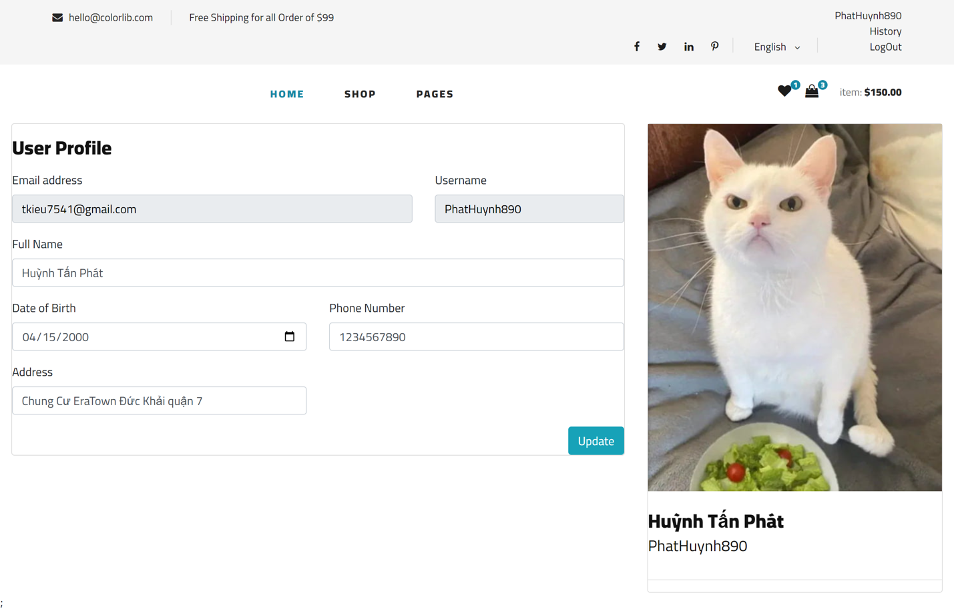

1. **Shopping Cart**

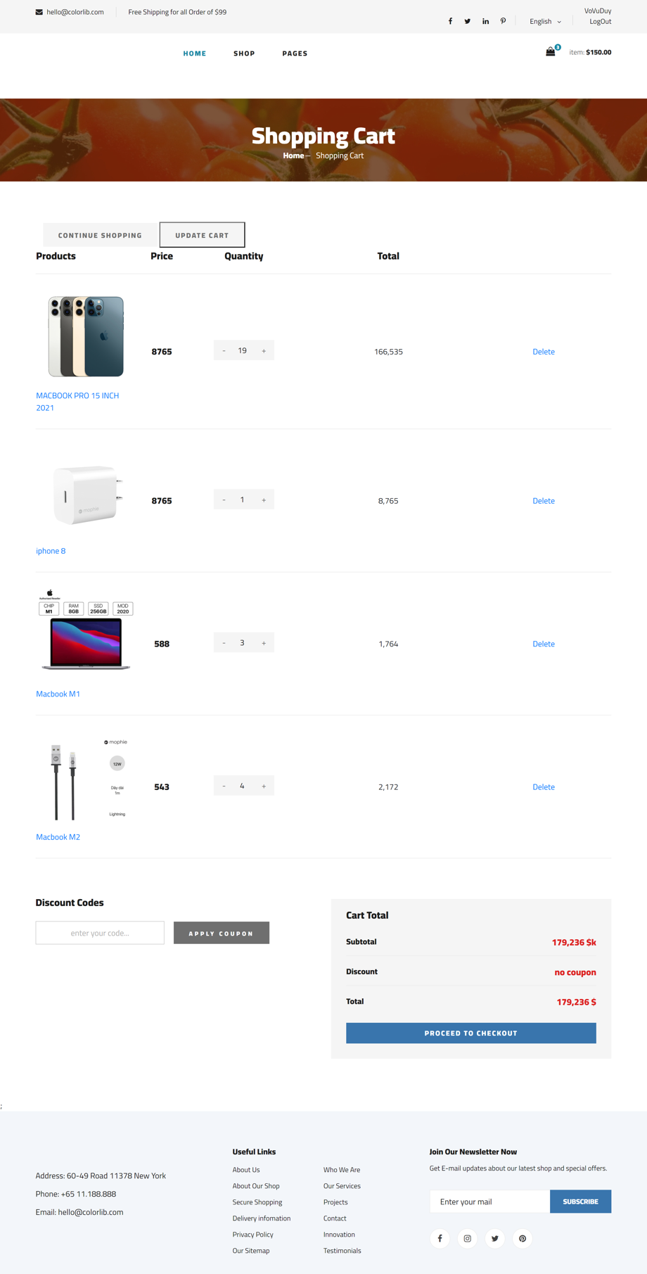

Figure 98 Shopping cart page

1. 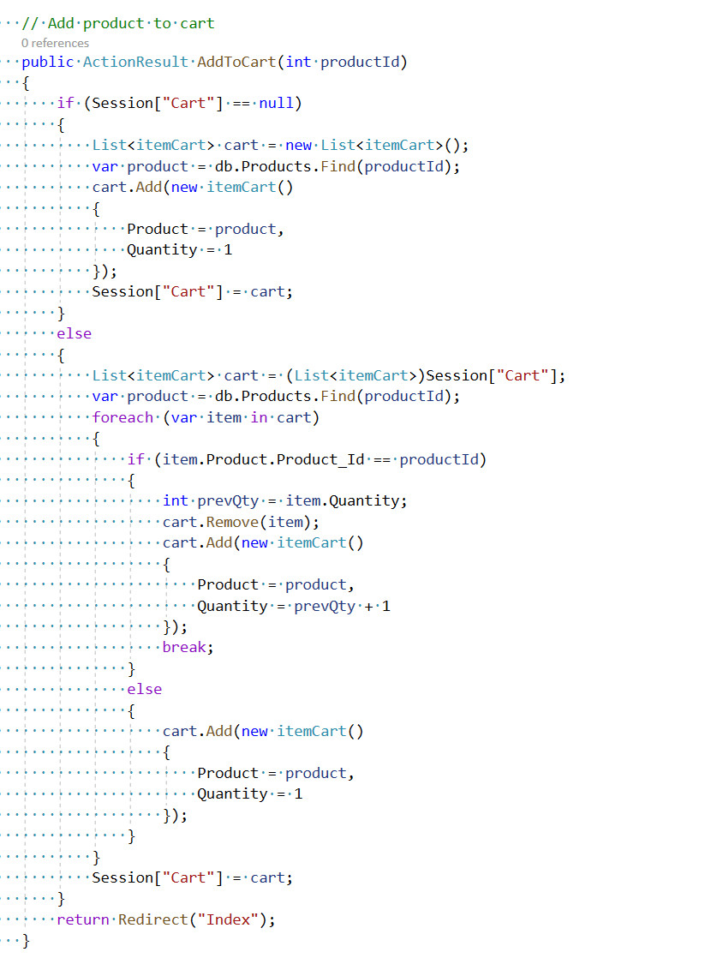**Controller cod**

Figure 99 Shopping cart don't have item

Figure 100 Add product to shopping cart Controller

1. **HTML code**

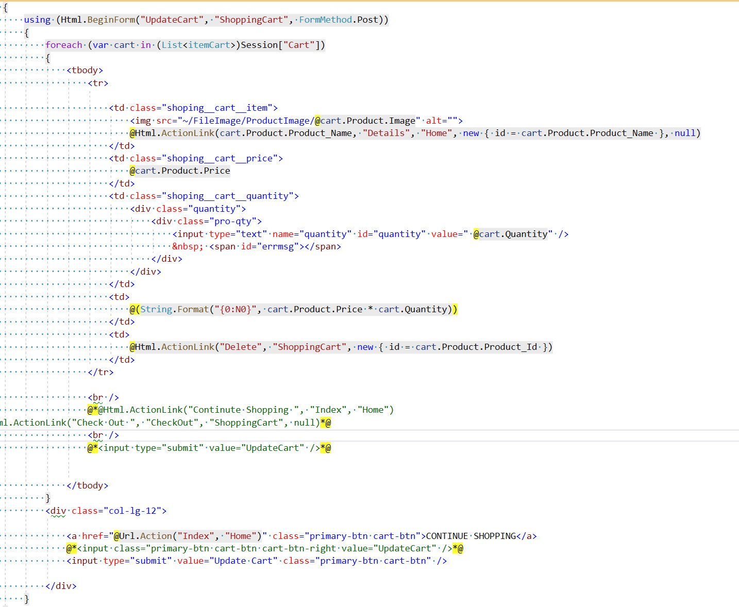

Figure 101 Shopping cart html

As shown in the picture on the shopping cart is a place to store the products that the user put in, The main content includes products, product images, prices and quantities, customers can optionally delete products that are not needed. Or customize and enter the quantity you need. Below are 2 buttons "Continute Shopping", "Update Cart" when clicked to return to the homepage to continue shopping and to update the cart when the customer has customized the number of products. .The section below is where customers can enter a discount code to receive a discount on the total order, next to it will be the total amount that the customer wants to buy. To continue shopping, click "Proceed To Checkout" to order payment.

1. **Check Out**

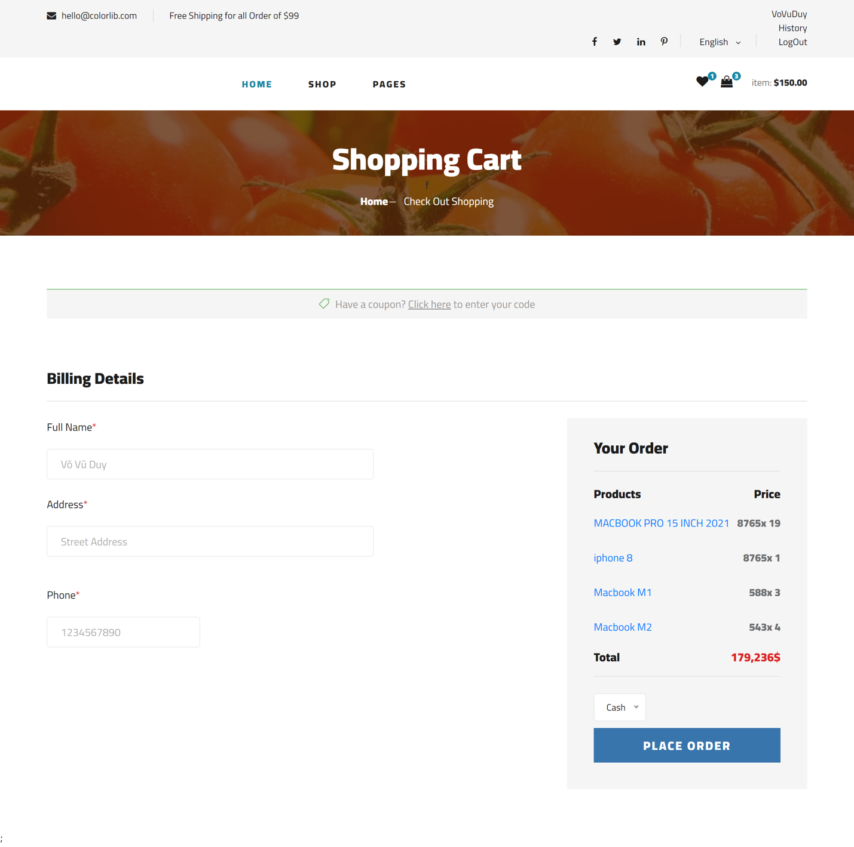

Figure 102 check out page

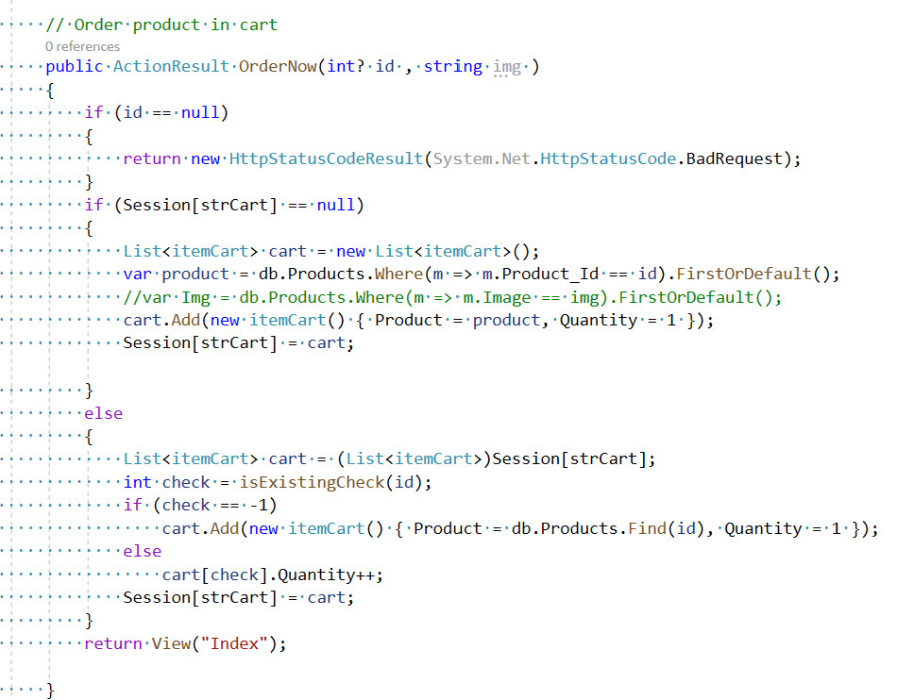**Controller code**

Figure 104 check out order controller

**HTML code**

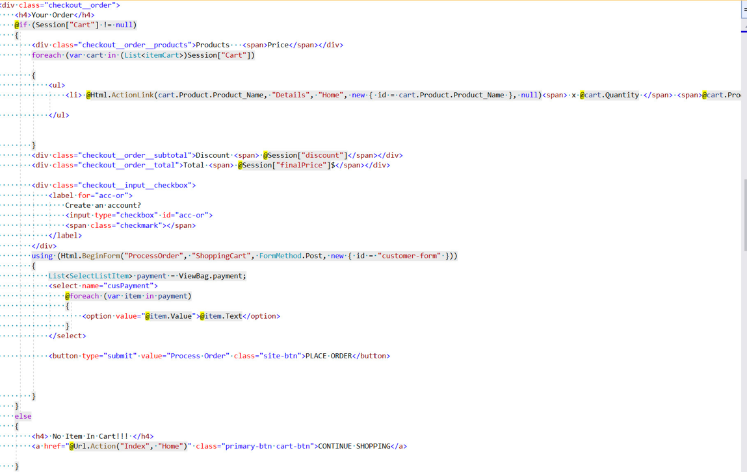

Figure 105 check out order HTML

After the customer clicks on "Proceed to Checkout", they will automatically go to the check out page. As shown above, they are required to enter the shipping information fields. Next is the Total amount of money the customer has to pay and the option to pay cash or papal. So they have completed the check out step and made a successful purchase on the system.

1. 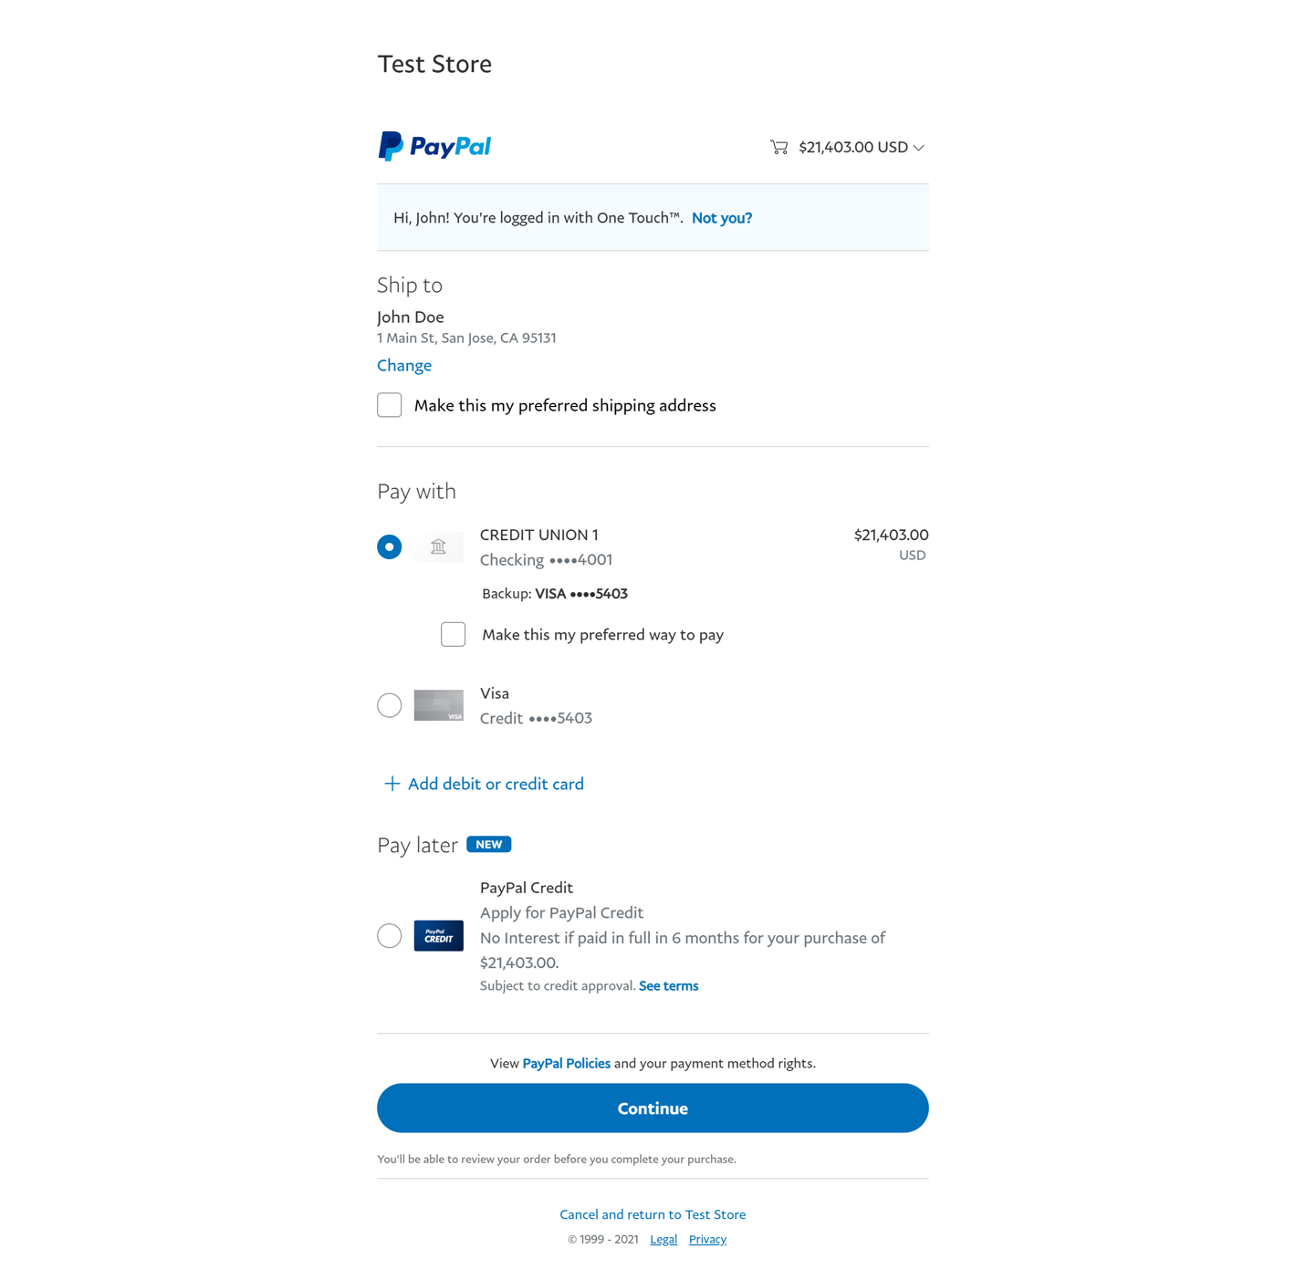**Check Out by paypal**

Figure 106 Paypal gateway

1. Controller code

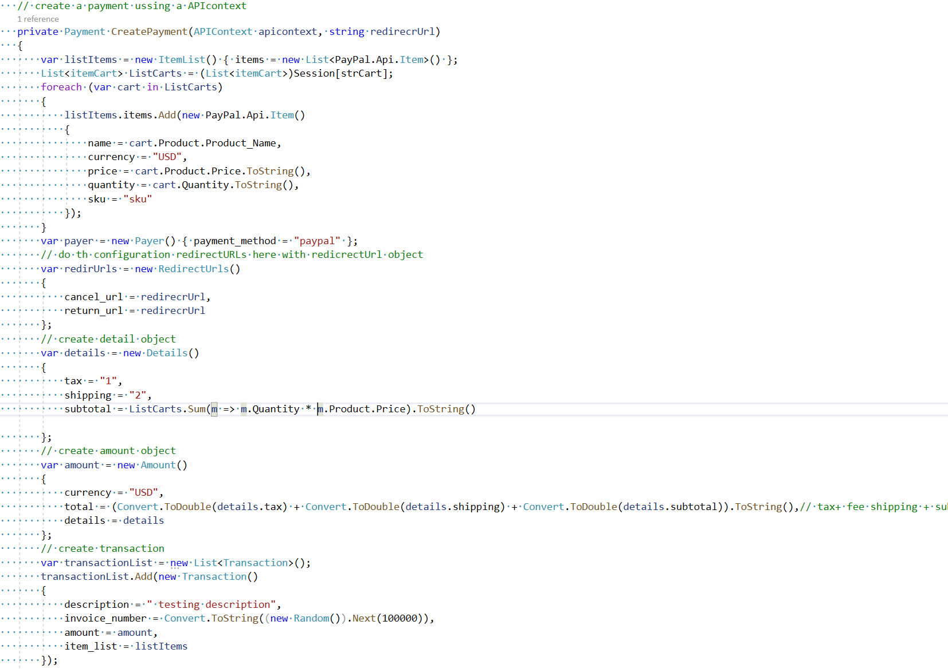

Figure 107 Paypal gateway controller

Paypay is considered the most popular international bank account payment gateway today, after check out is complete the system will automatically connect to the paypal payment gateway if the user chooses a payment method. Payment for the order is paypal. Then just check your account information and order information and click "continue" the payment gateway will process the order payment for the user, thus completing the payment process. Paying by paypal is extremely convenient and secure

1. **Check out by cash**

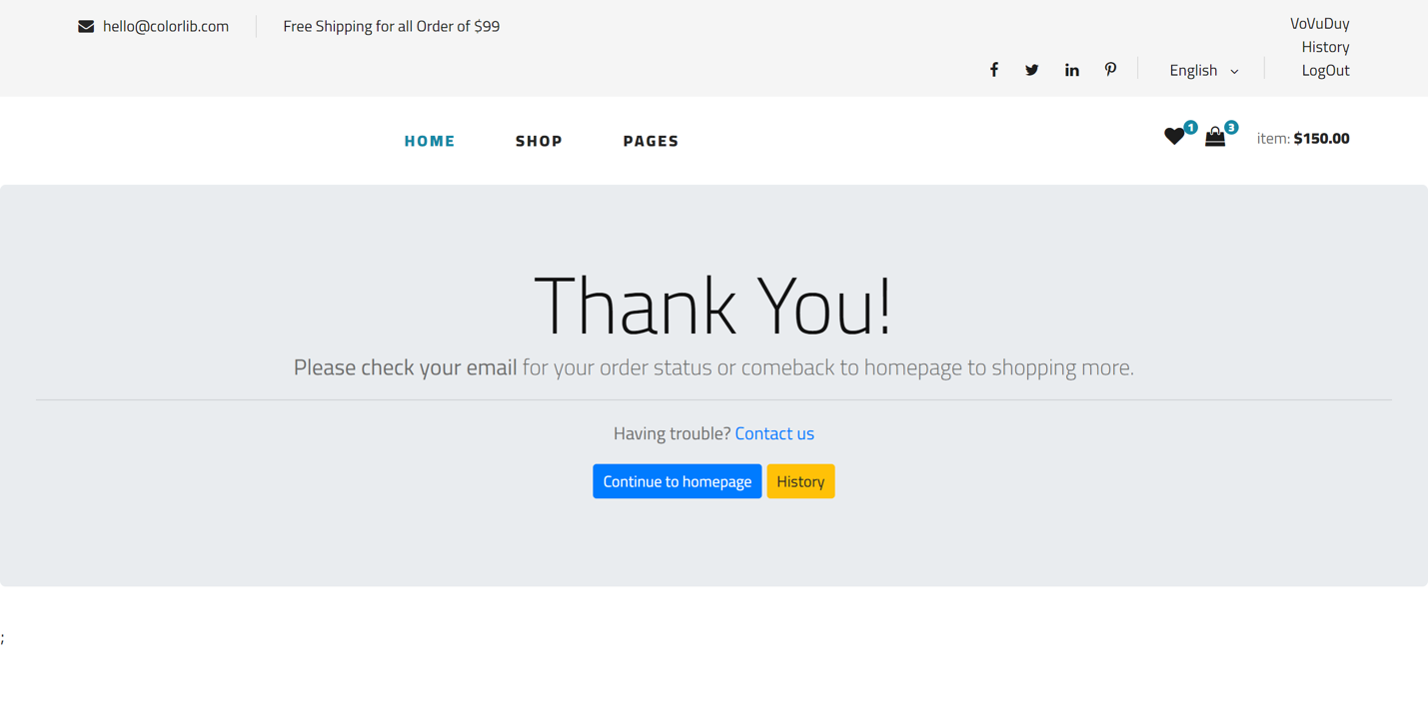

Figure 108 Successfull page check out by cash

After checking out your order is complete, the system will automatically redirect to the successful payment page. This means that the order that the user checks out and pays in cash has been successfully made, the order will be automatically saved to the system and waits for the admin to confirm and update the status of the order row

1. **History Order**

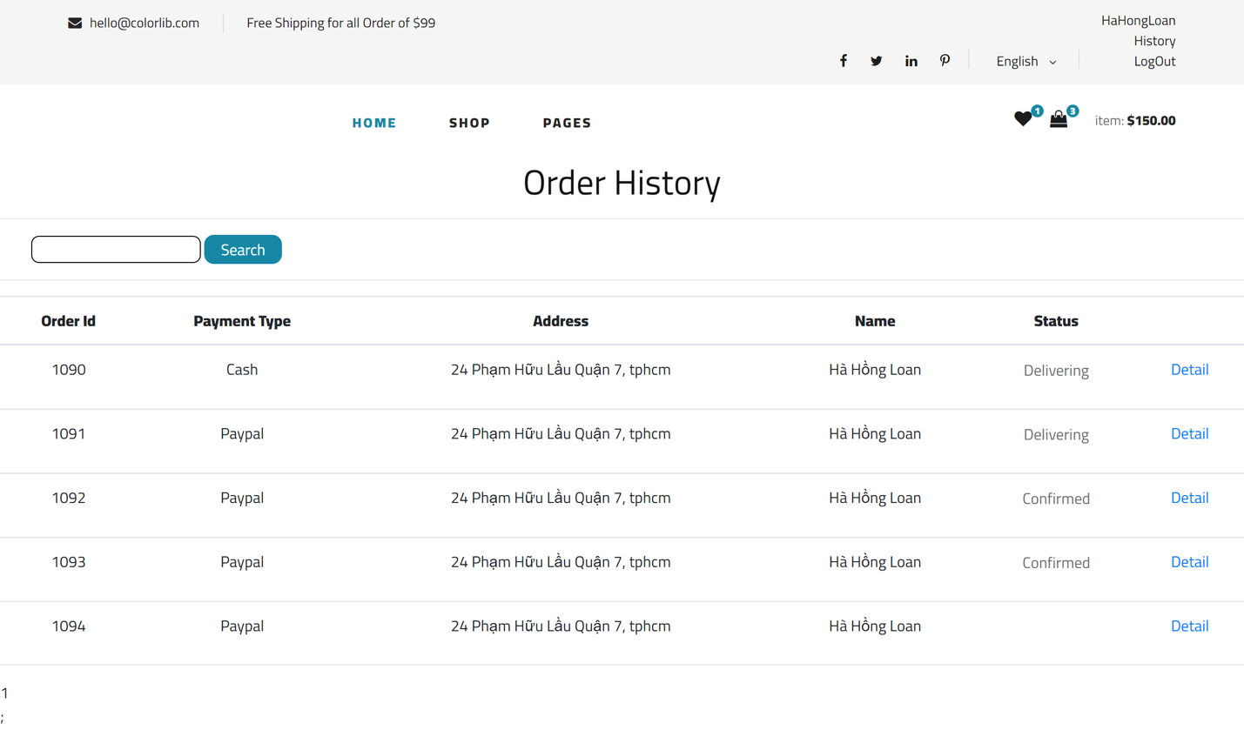

Figure 109 History order page

By clicking on the "OrderID," the user may obtain order information. Users may examine the specifics of their orders, including the order status, order information, payment method, payment status, and order date, on this page. In addition, the user's order information is listed below, including product name, price, quantity, total price for a product, shipping charge, and total order price.

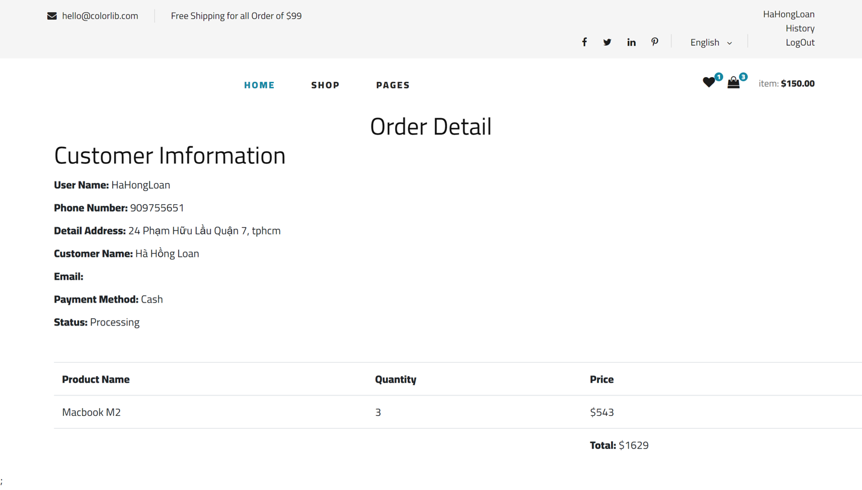

Figure 110 Order detail page

1. Controller code

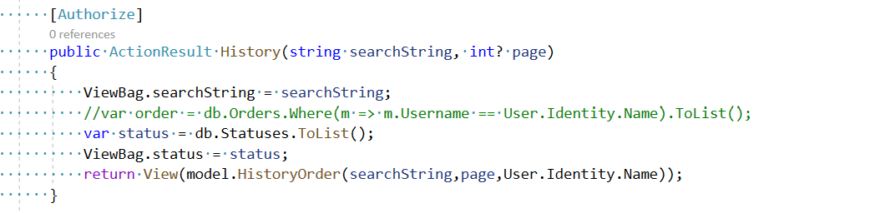

Figure 111 History order

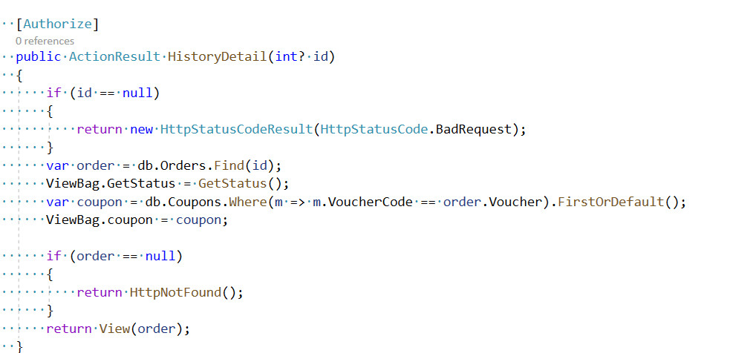

Figure 112 Detail history order

1. HTML Code

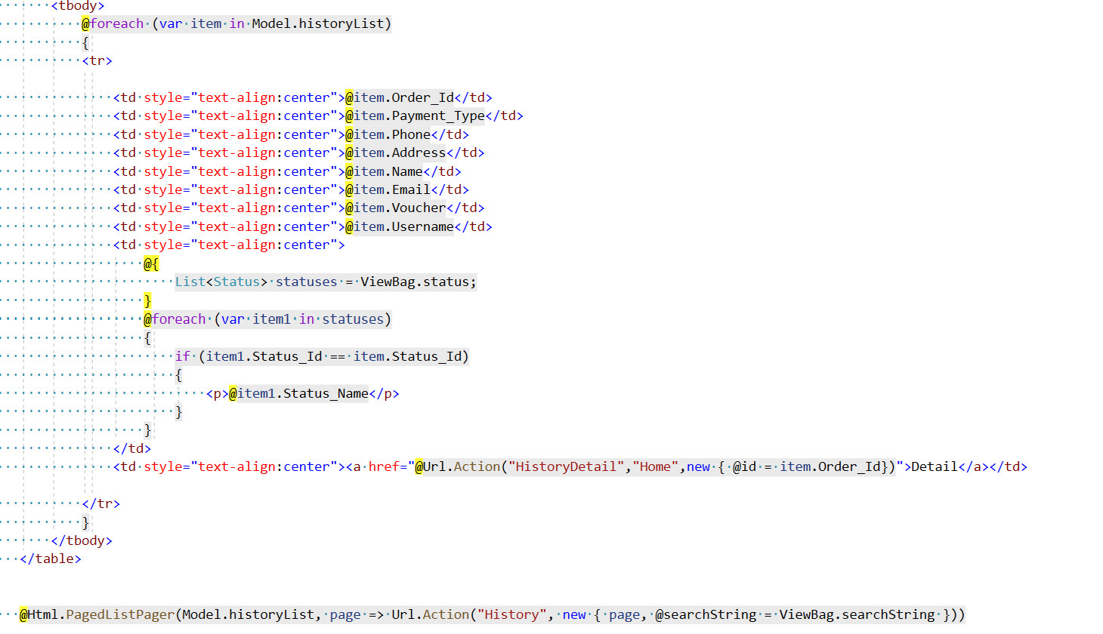

Figure 113 HTML history order

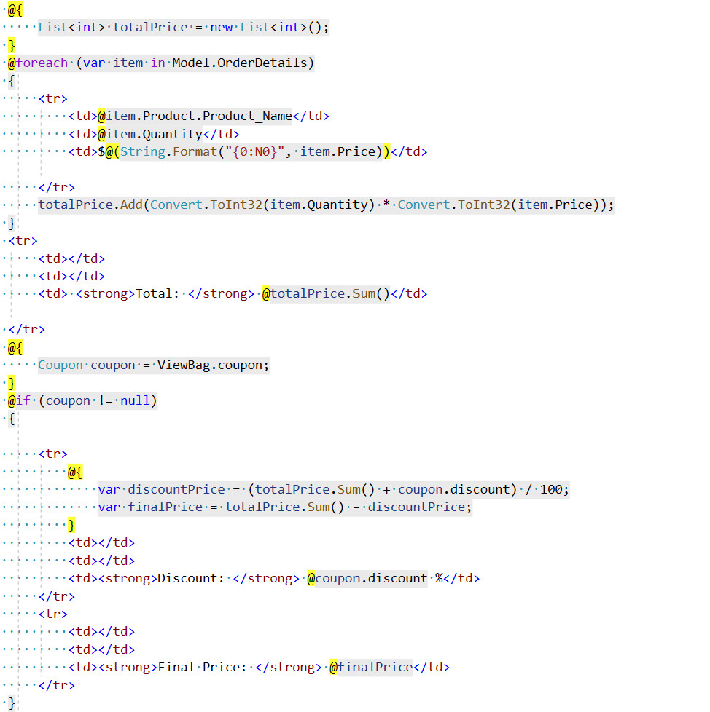

Figure 114 HTML Detail history order

The problem after placing an order successfully, how can the user review the order history? From there "history order" appears, in this section the user can track his orders placed on system that only the authorized user can access. The product details, order value and status of the order are fully updated in the "detail history order" section.

1. **Send to email to confirm order**

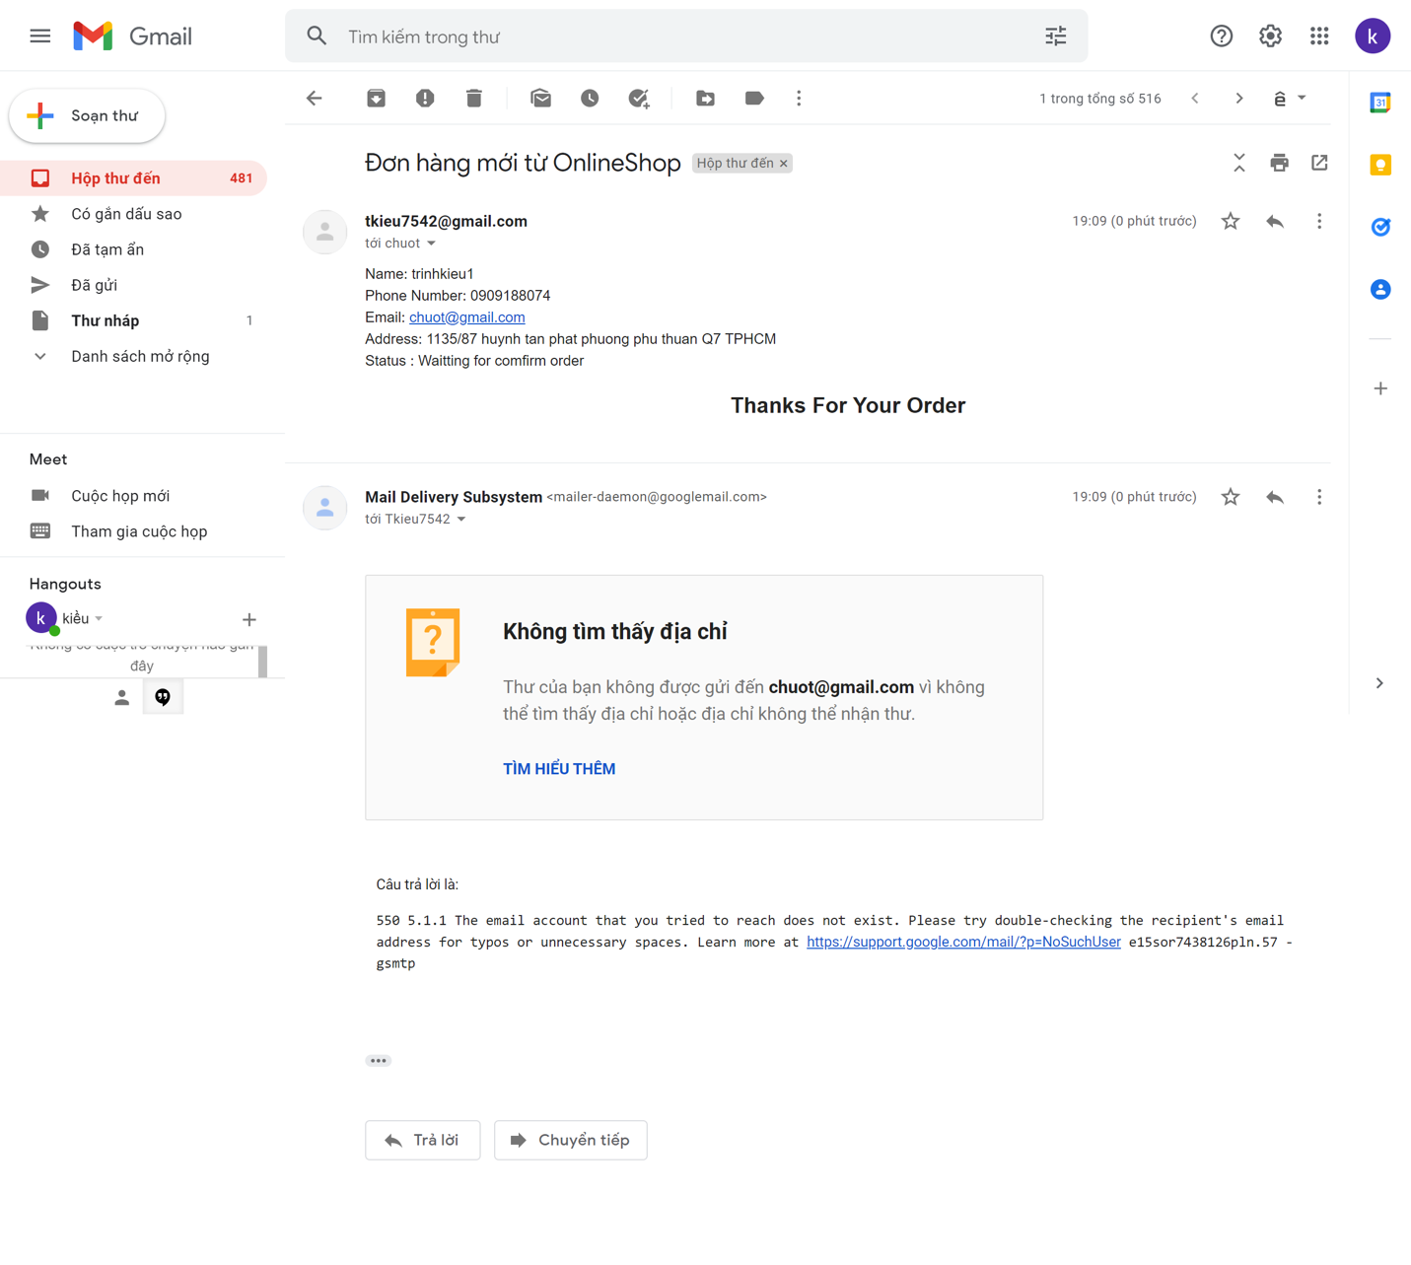

Figure 115 Mail to confirm order

1. **Controller code**

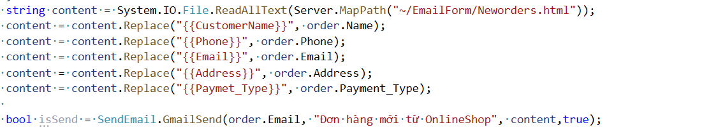

Figure 116 Sent mail confirm order Controller

1. **HTML code**

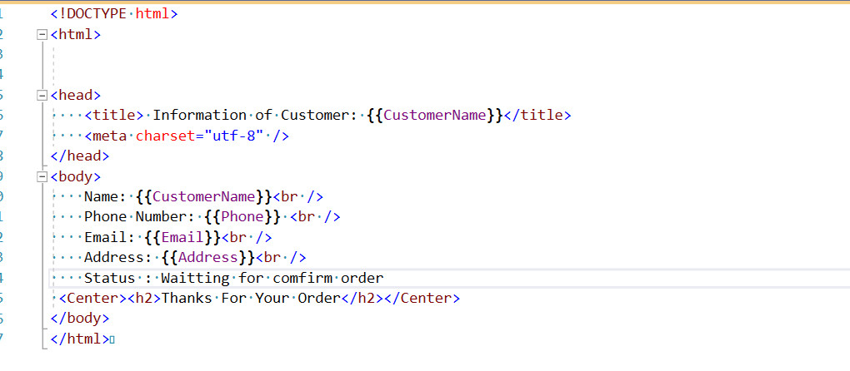

Figure 117 Sent mail confirm order html

When completing the purchase step, the system will send an email to the customer's email address to confirm the order and thank the customer for their support including order code, product information, total payment amount and consignee details

1. **Mange Product**

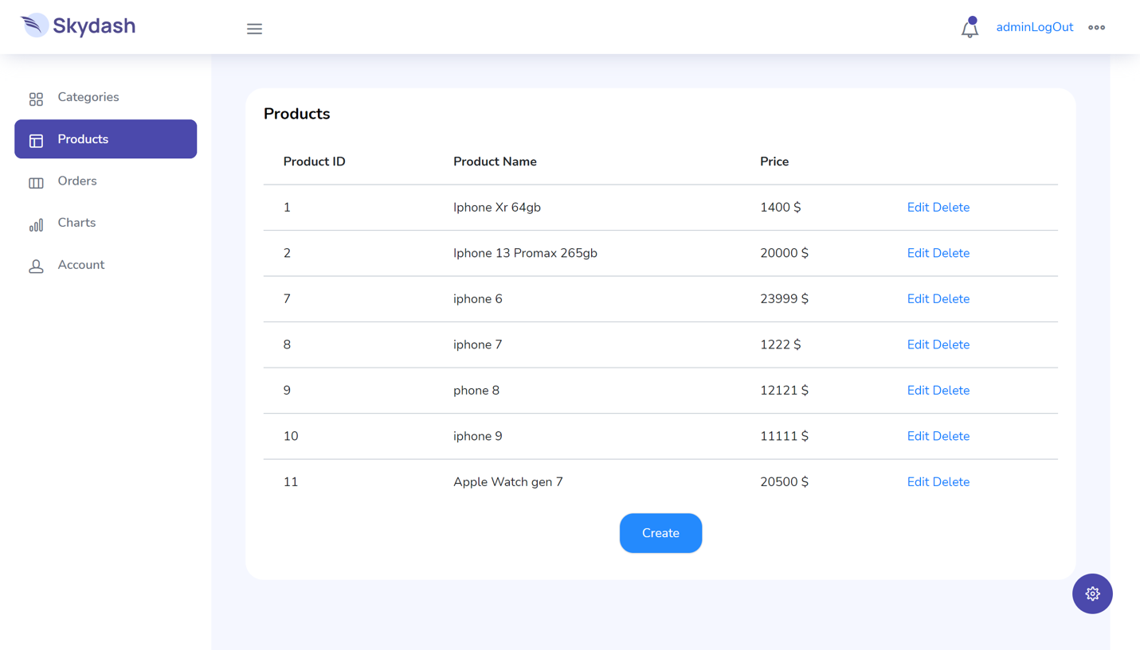

Figure 121 Admin mange product page

Product management of the Admin role is considered the most important part of the system, Figure shows a list of all the products that have and are currently on the system, admin can actively edit, add or Delete the product as described above

1. 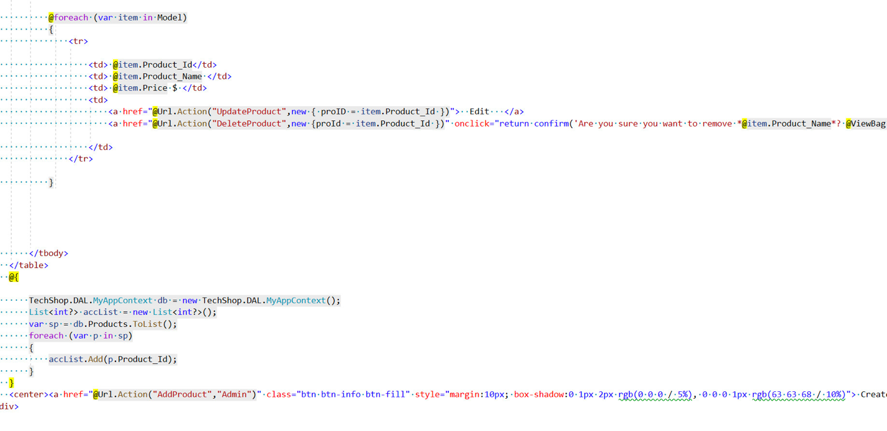**HTML code**

Figure 122 List product Controller

1. Add Product

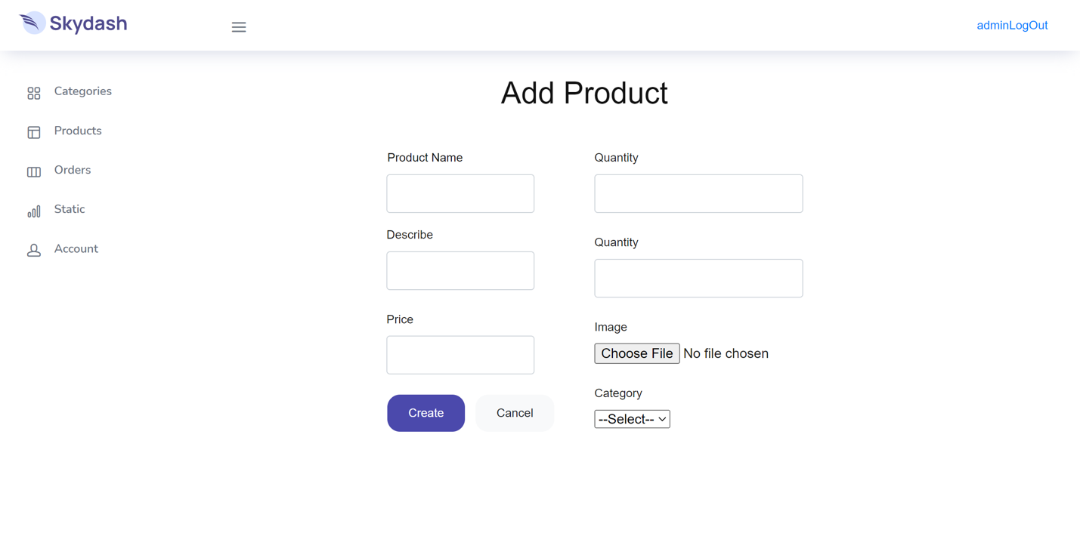

Figure 123 Add product page

1. 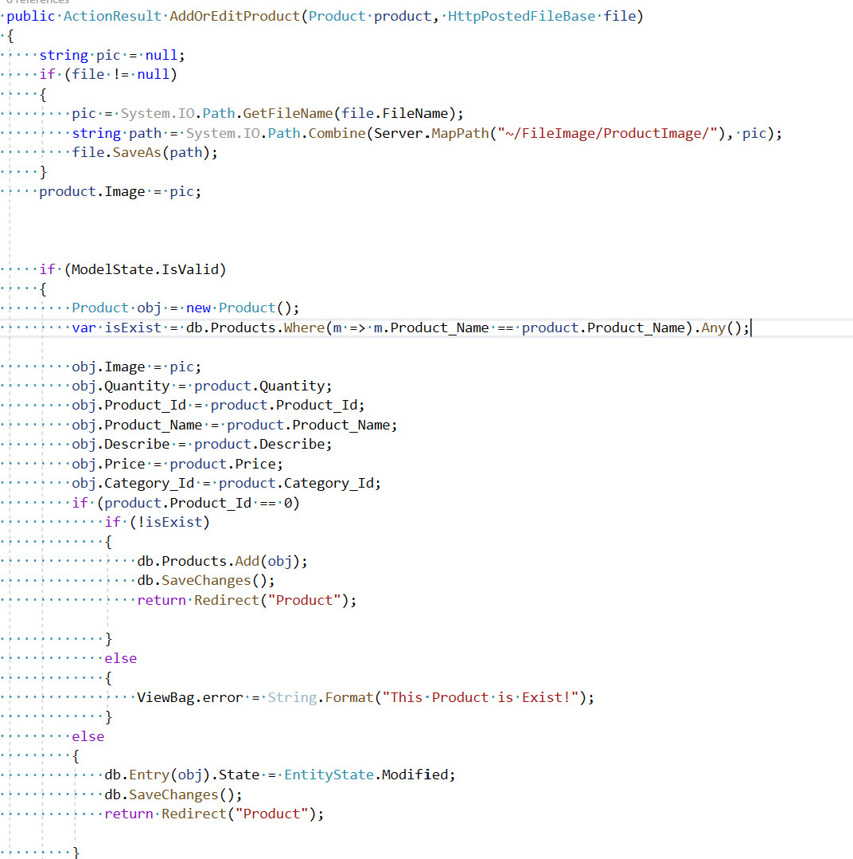Controller code

Figure 124 add product Controller

1. HTMl code

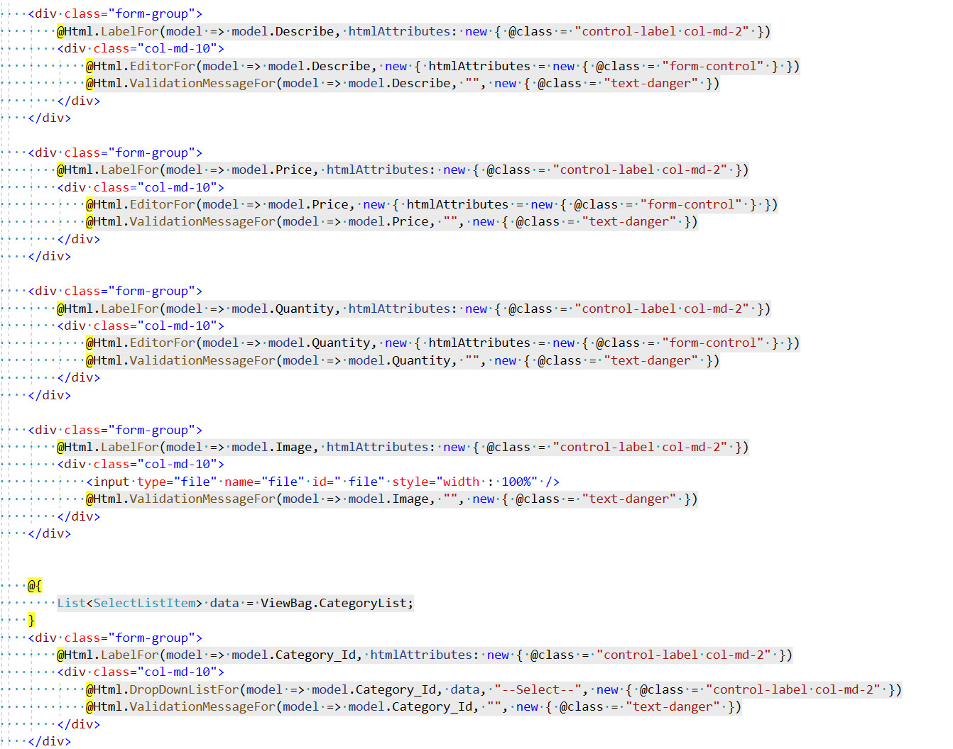

Figure 125 Add product HTML

The manager can use the add product page to create new goods that will appear on the website's main page. The manager can fill in product information such as the name,

Description, image, quantity, price, and category on this page. Before the data is loaded into the database, the system will check the fields to determine if the user filled in the fields correctly. If the information is accurate, the user will be returned to the product list page; if it is incorrect, the system will display an error message and prompt the user to re-enter.

1. Update Product

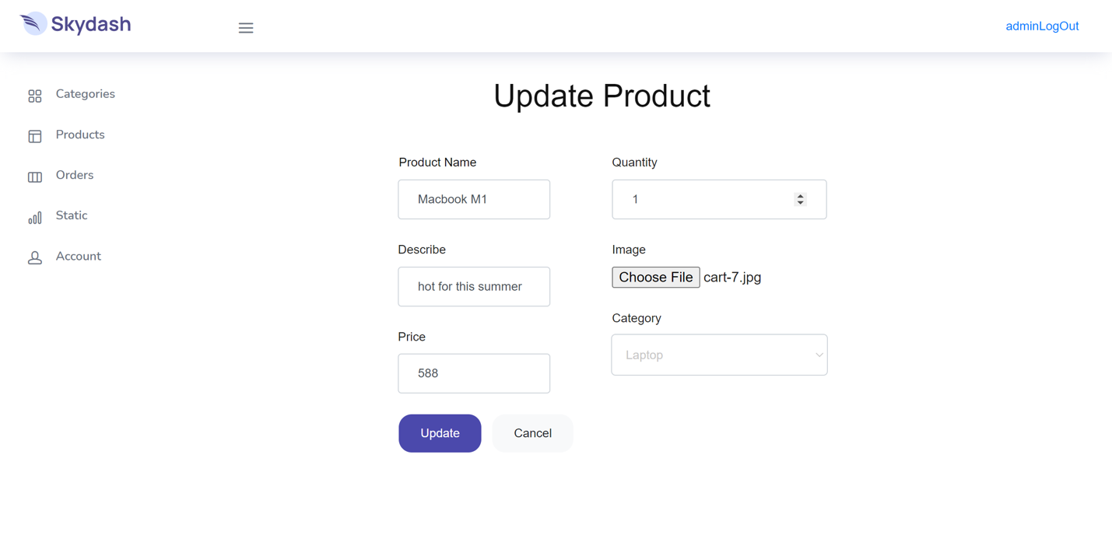

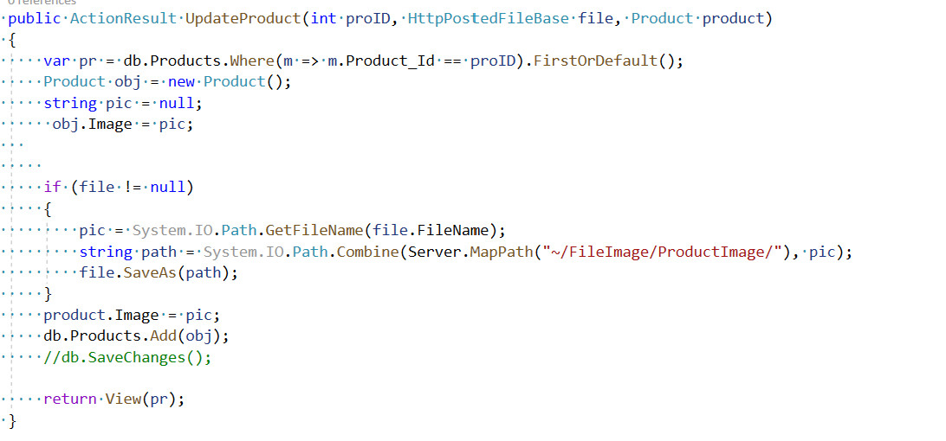

Figure 126 Update product Controller

The figures on the display reproduce the code so that the system can perform the functions of Update and Delete products in the system. First, the system checks and retrieves the data from the database, after the user enters the data, the system will record those data and save it to the system to replace the old data.

1. Delete Product

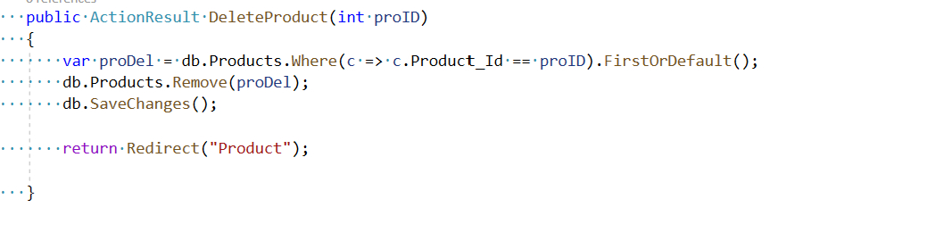

Figure 127 Delete product Controller

For Delete products, the system finds the product to be deleted by finding the product id, then hides that product, so the system has completed the process of deleting the product on the user's system, but still Also back up data on the database

1. **Dashboard**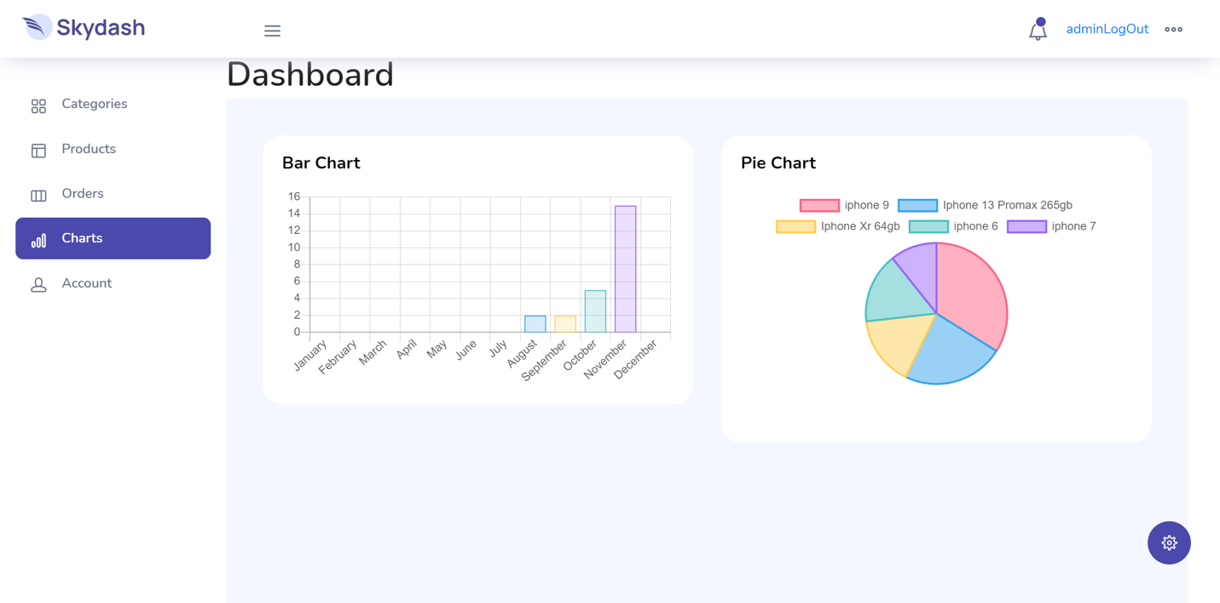

Figure 128 Chart page

Dashboard is a place to show numbers, pie charts and bar charts, Like figure shows a bar chart showing the total number of orders sold in that month. As for the column chart, it shows the number of best-selling products on the system. From there, the admin can review and comment on the number of orders and currently popular products

1. Controller code

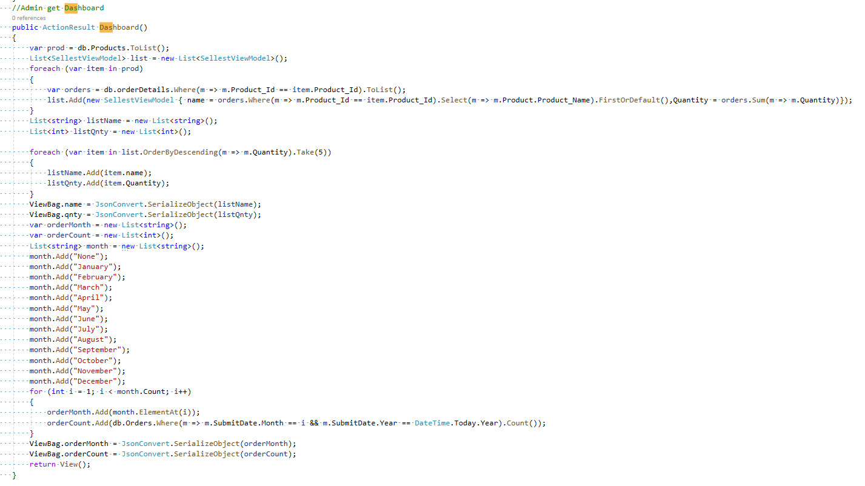

Figure 129 Chart Controller

1. HTML code

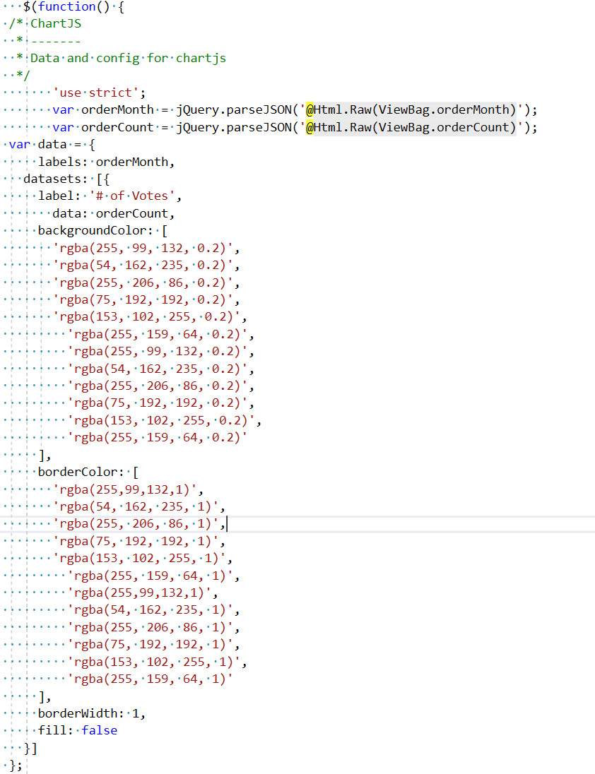

Figure 130 Colum chart html

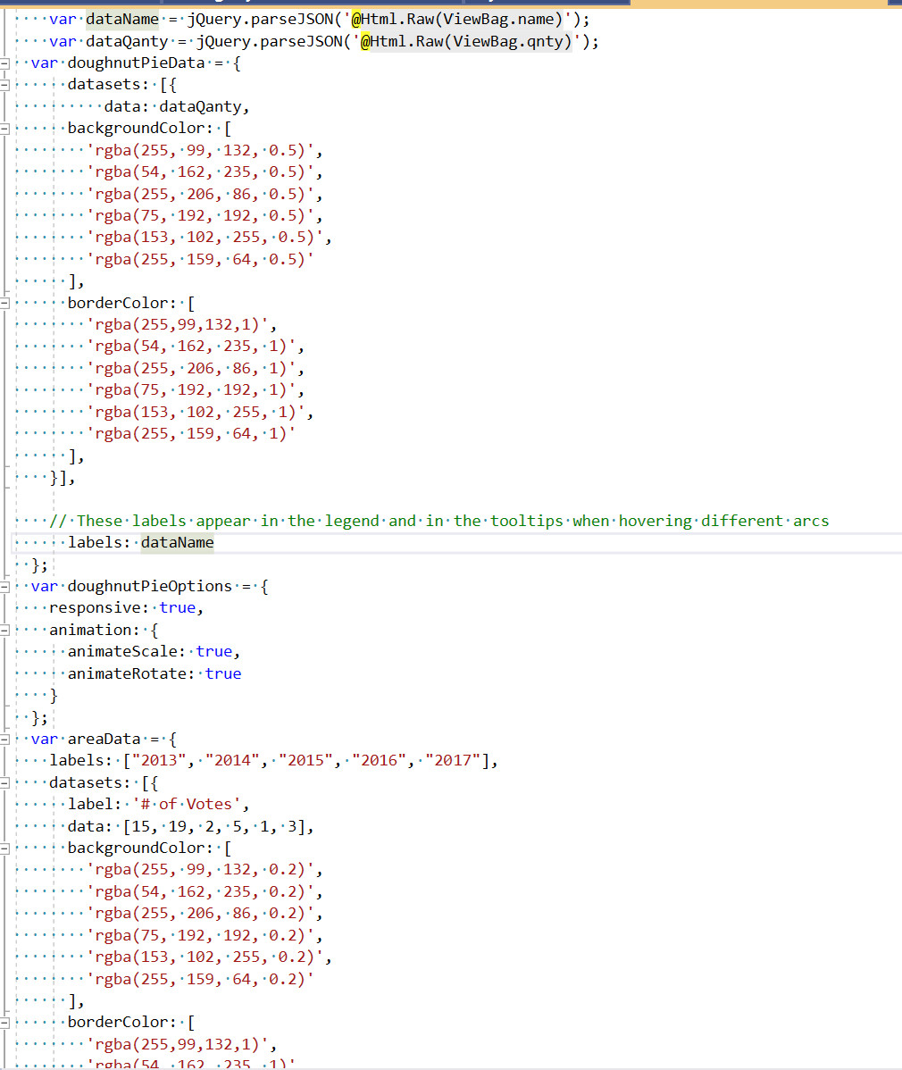

Figure 131 bar chart html

According to the layout in the Wireframe section, the dashboard is designed according to the original design. The page is divided into 2 to display 2 types of charts representing parameter data based on column charts and pie charts.The first is a column chart on the left side of the website that displays the number of invoices ordered by customers throughout the year and after the new year has ended. The displays for the prior year's months will be reset.

The objective of the pie chart on the right side of the page is to let the user notice the names of the four most popular items, which are shown depending on the divided by percentage for each product.

Furthermore, there are shortcuts such as the names of the system's most significant dashboards within the dashboard, allowing users to click and visit the administration pages of their choosing.

2. **Manage Order**
3. Orders

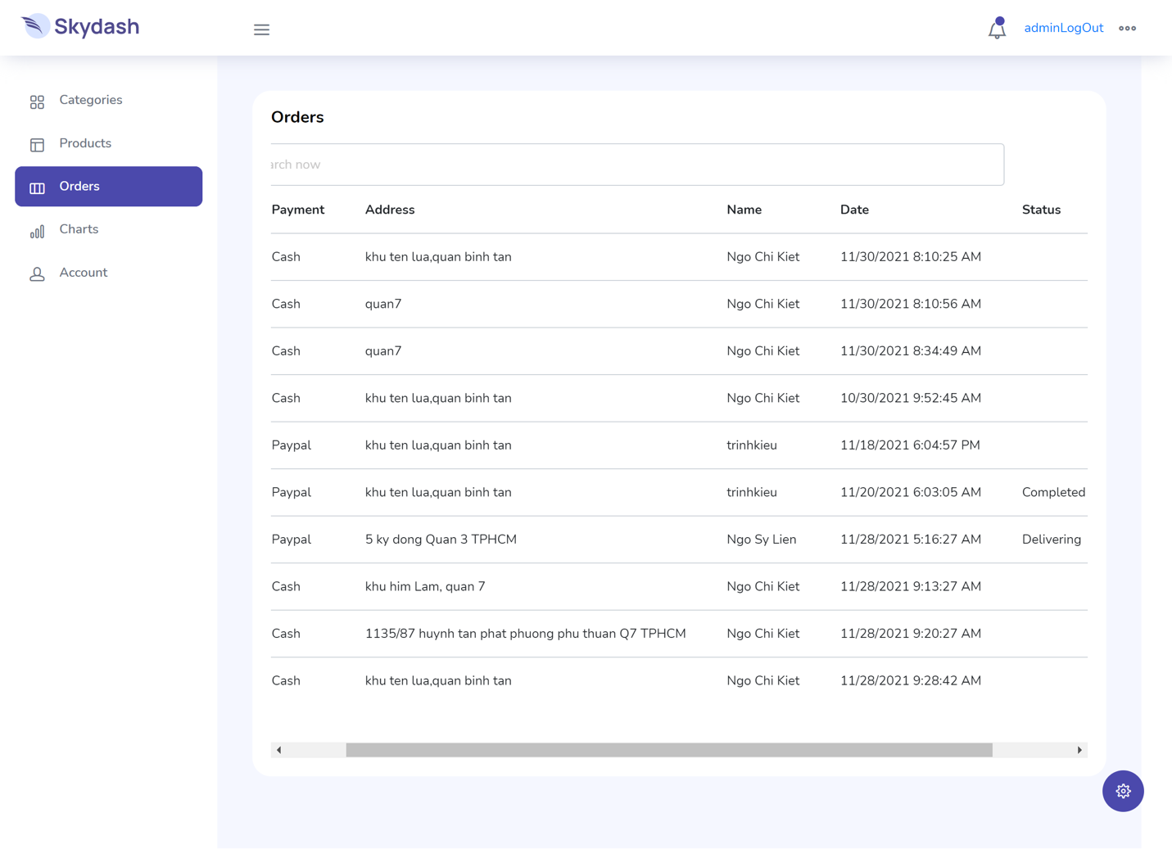

Figure 132 List order page

1. 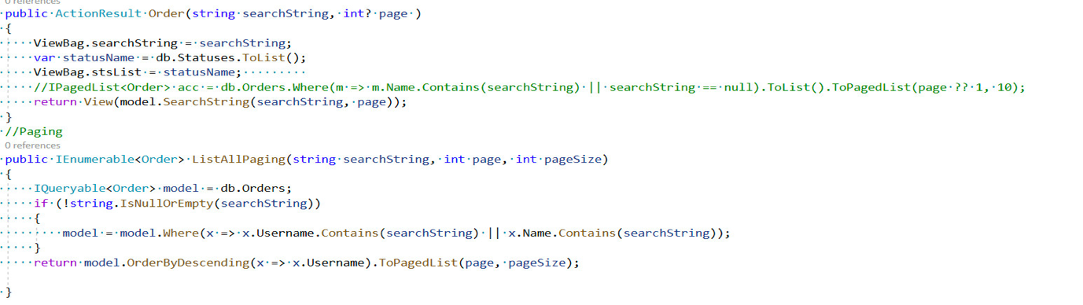Controller code

Figure 133 List order Controlle

1. 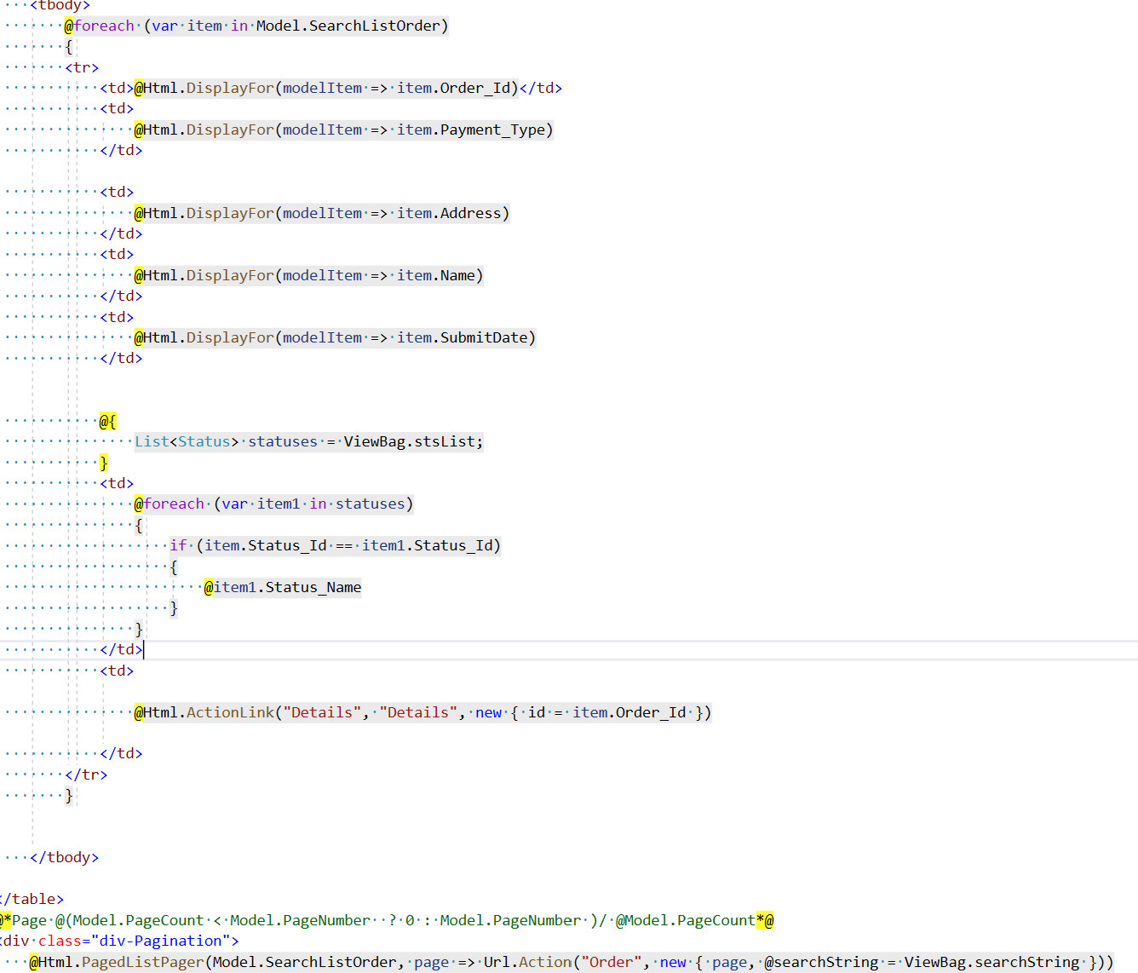HTMl code

Figure 134 list order html

This is considered the most important page in the system. This page is used to show the orders that the customer has placed. The system will display the following information: Order ID, ..... In addition to the page, it also displays edit function to interact with the order

2. Order Detail/Update Order

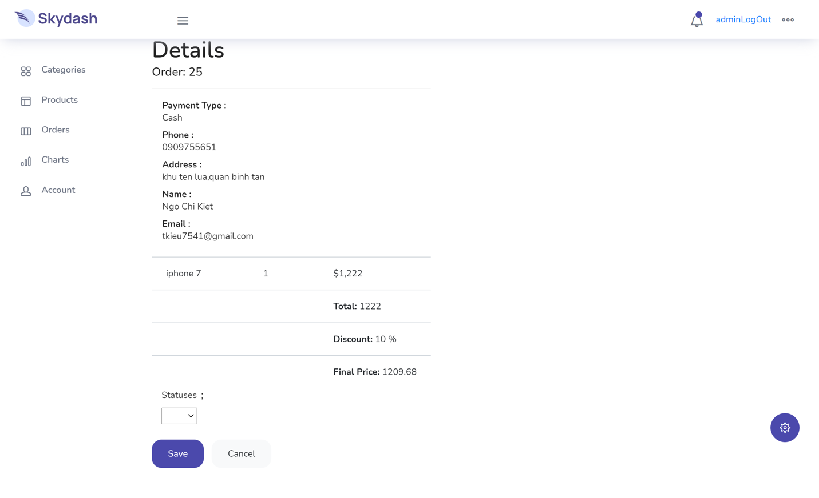

Figure 135 Order detail/ update status page

Order details are the place to show detailed customer information and product quantity information. From there, admin can prepare orders. Admin can update order status. Then the system will automatically update and the customer can see the order status from "History Detail".

1. 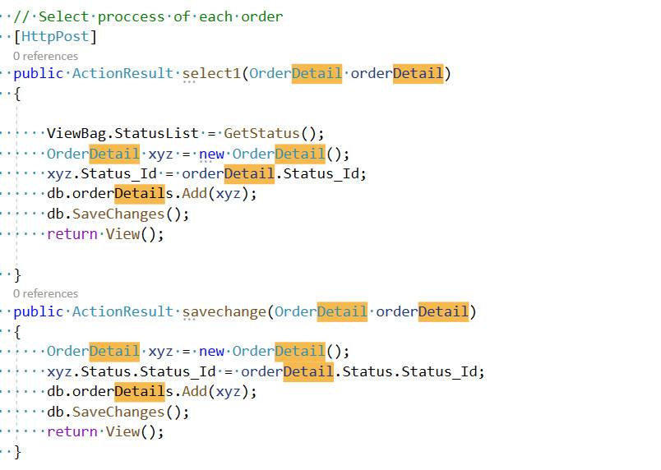Controller code

Figure 136 order deatil / update status Controller

1. HTML code

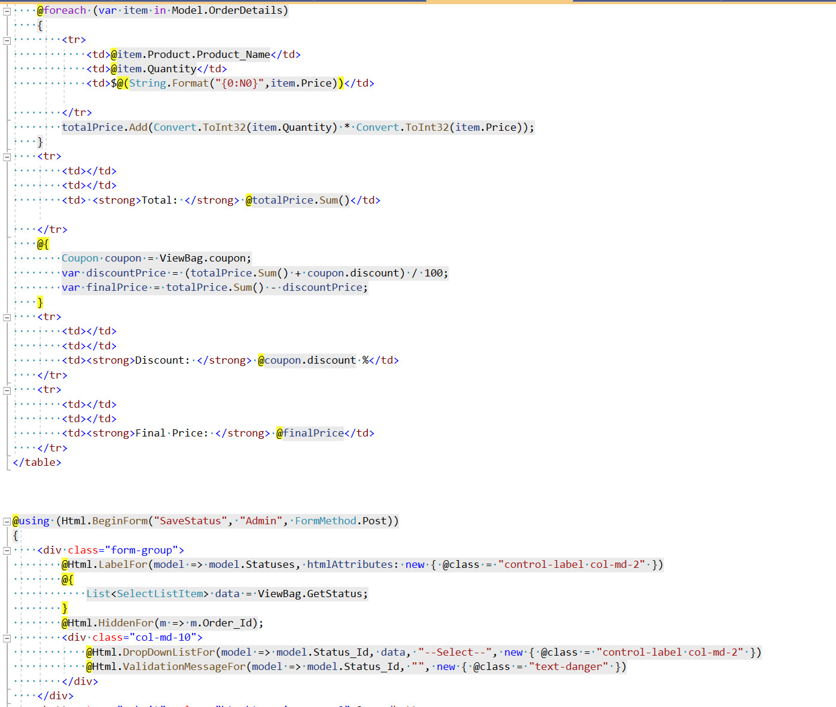

Figure 137 order detail/ upadate stutus html

Support page to manage orders that customers place, Here is the place to show detailed information of each order: Delivery information, products, quantity And finally Amin can set order status for each order. Menu : Confirm, Prepare, Delevering, Cancel.

1. **Manage Account**
2. View list

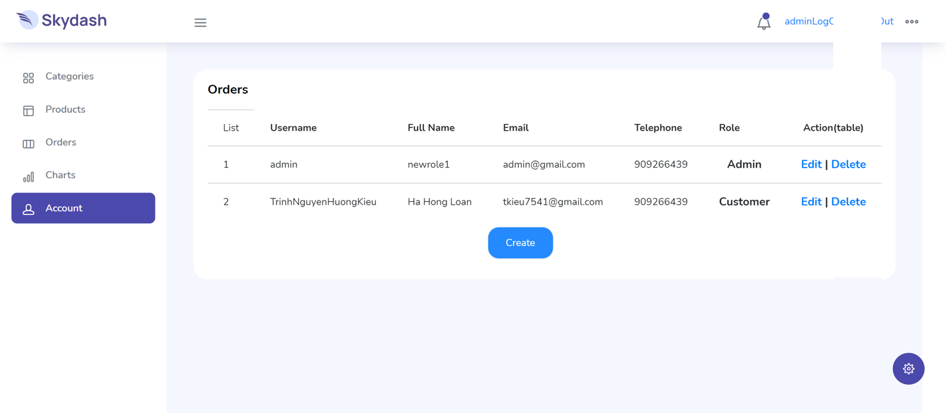

Figure 138 List account page

Admin can see the list of accounts that users or other admins can manage

1. 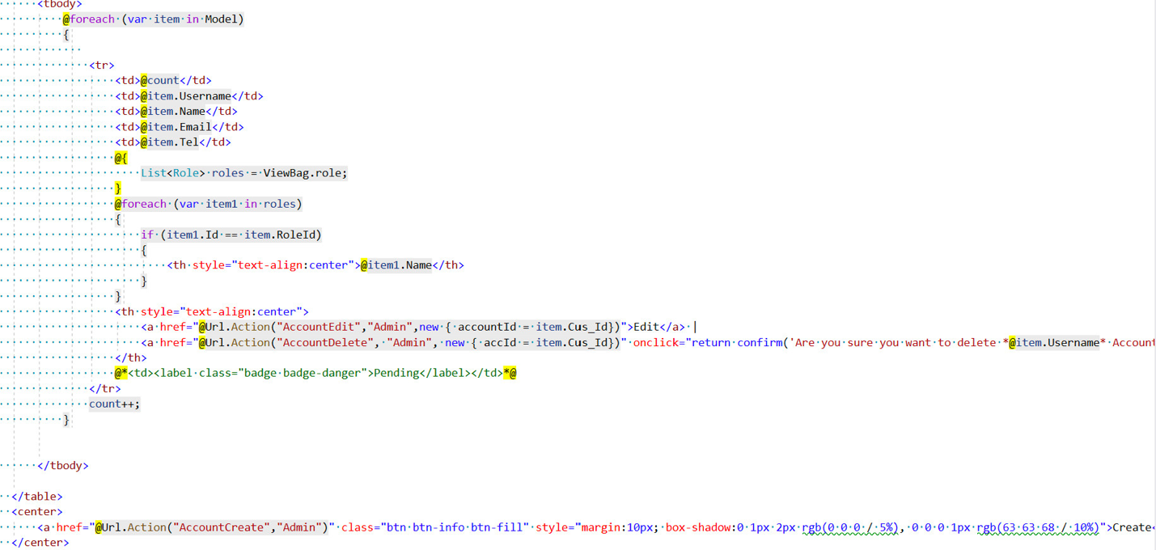Controller code

Figure 139 List account Controller

1. HTML code

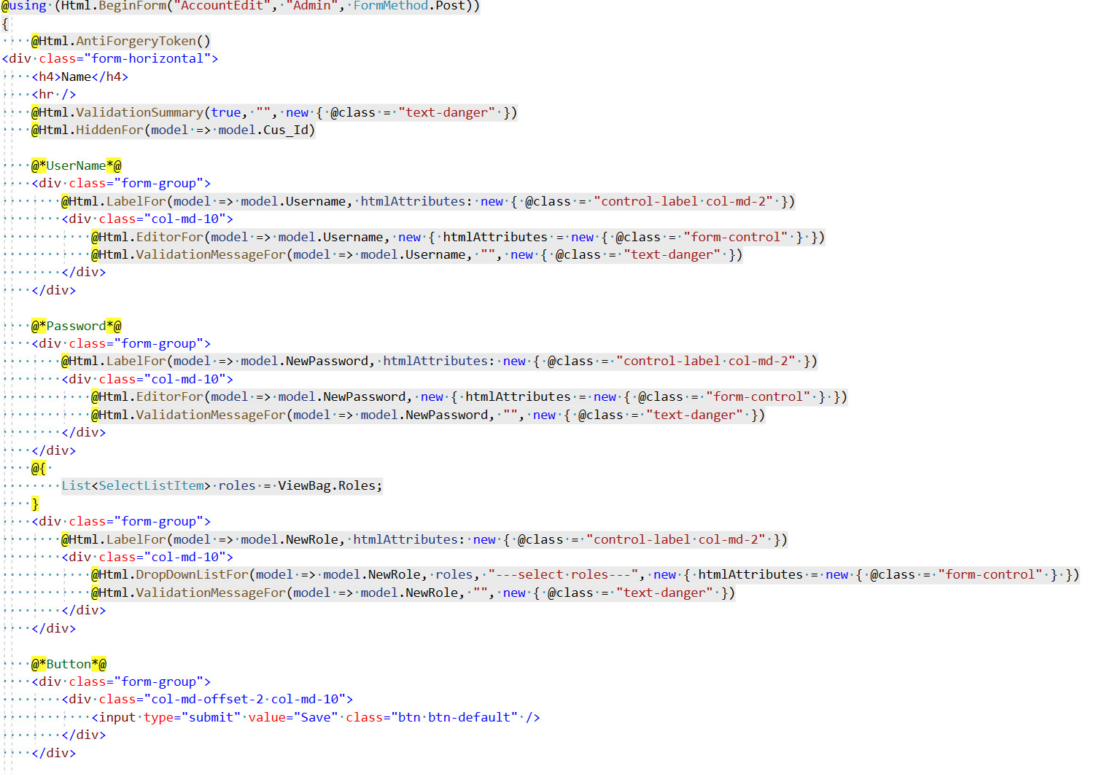

Figure 140 list account html

2) Update account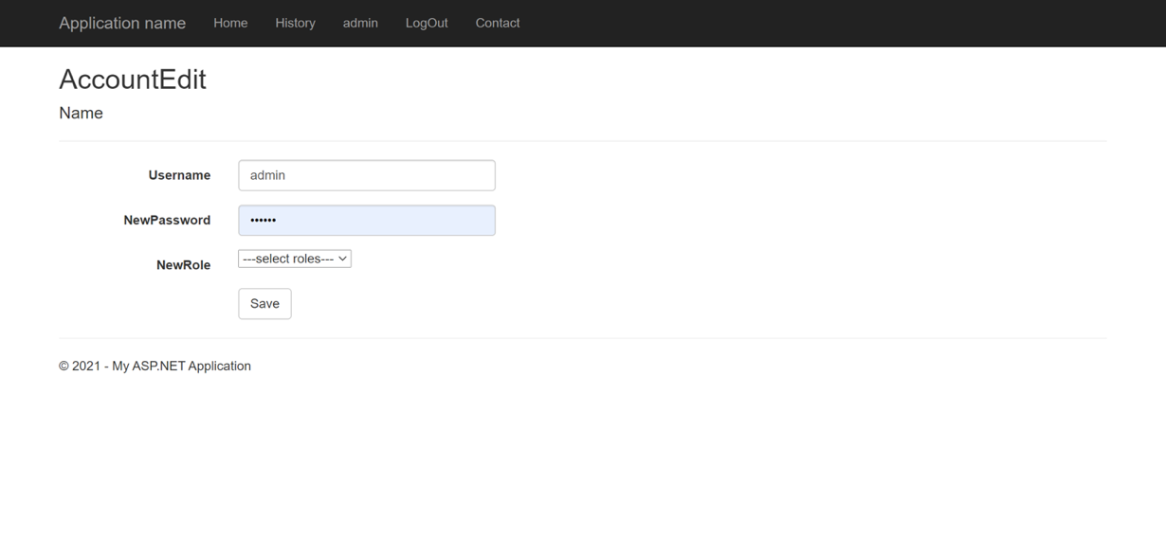

Figure 141 Update account page

The system allows admin to edit the customer's password and role, but the system does not allow admin to edit the customer's name and email

1. 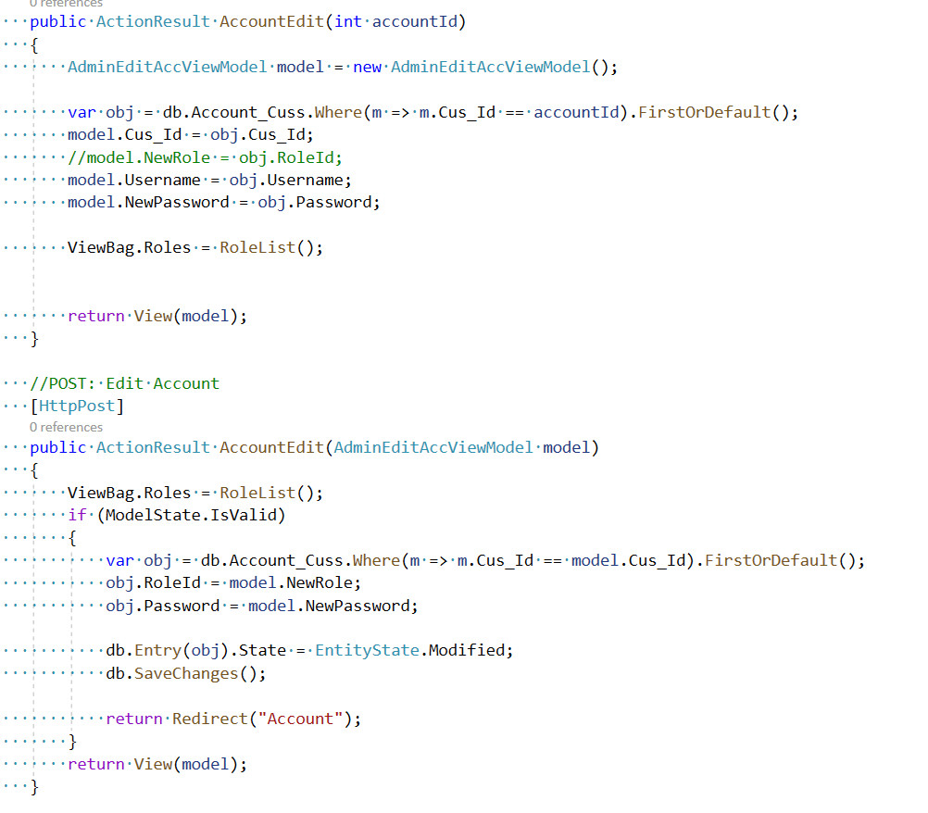Controller code

Figure 142 update account Controller

1. 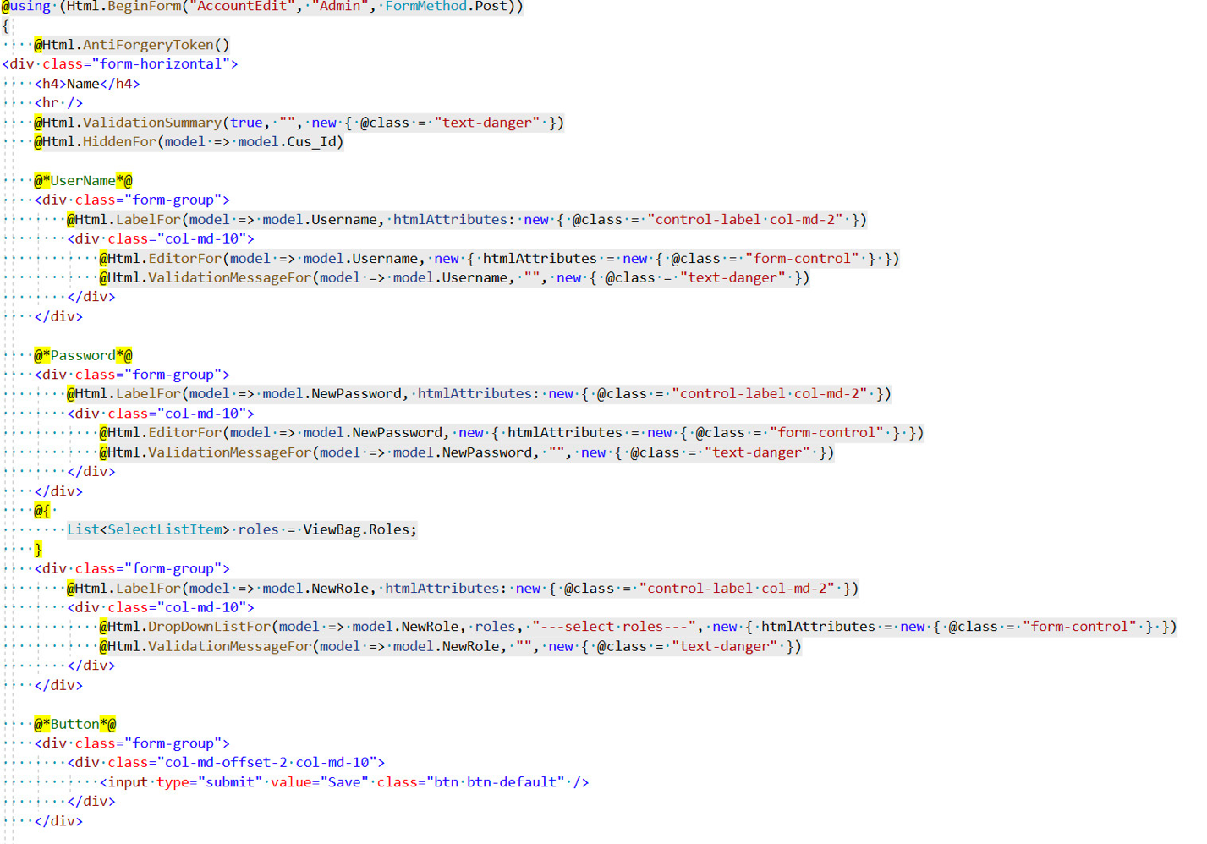HTML code

Figure 143 Update account html

They can edit the accounts they want, only admin access is required to perform the operation

1. **Manage Category**
2. **List category**

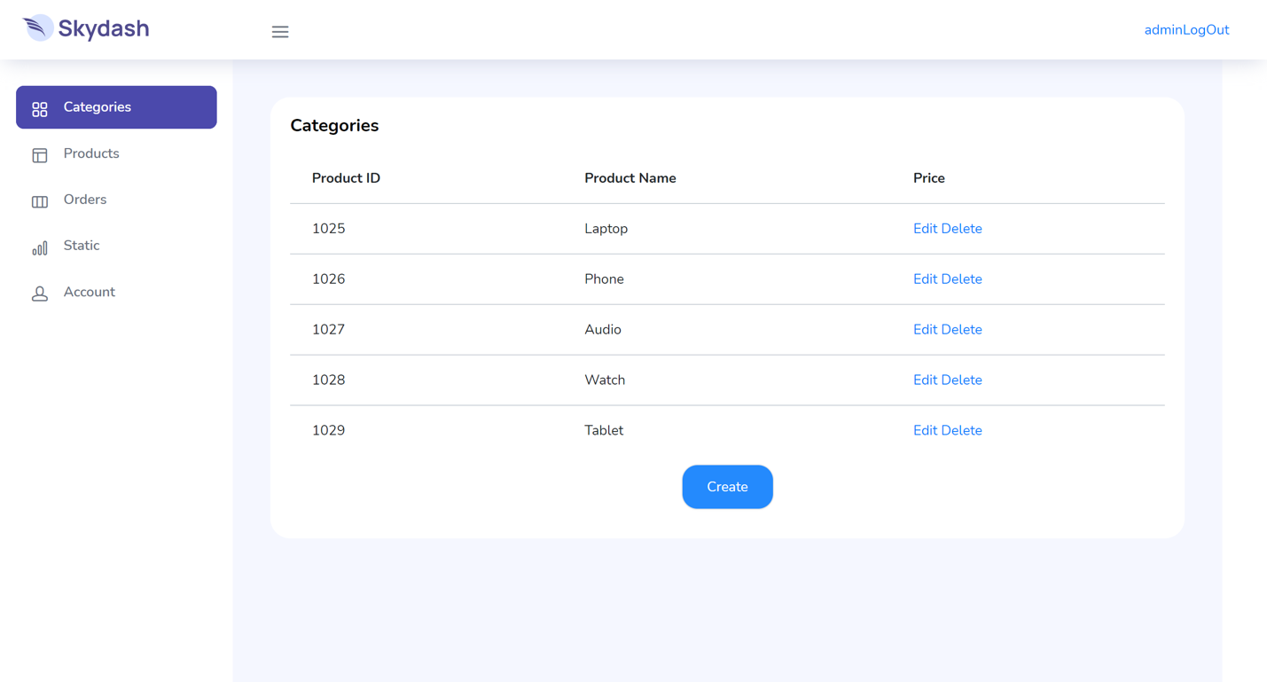

Category is an important object part of the system, it helps to sort products. So that users can easily find products. The figure above shows the Categories created by the Admin in the system. The system allows Admin to Create, Update, Delete products.

1. **Add Category**

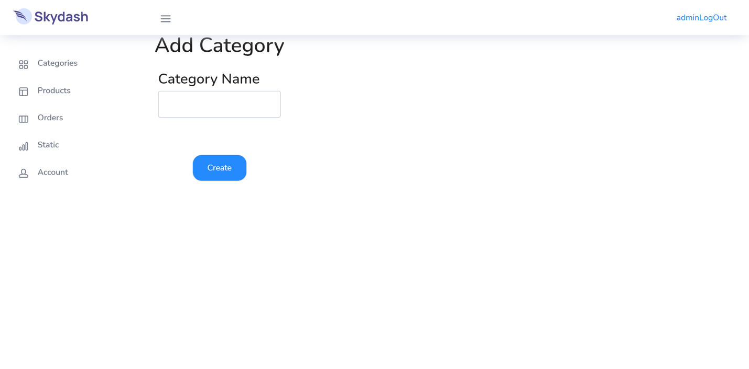

1. **Update Category**

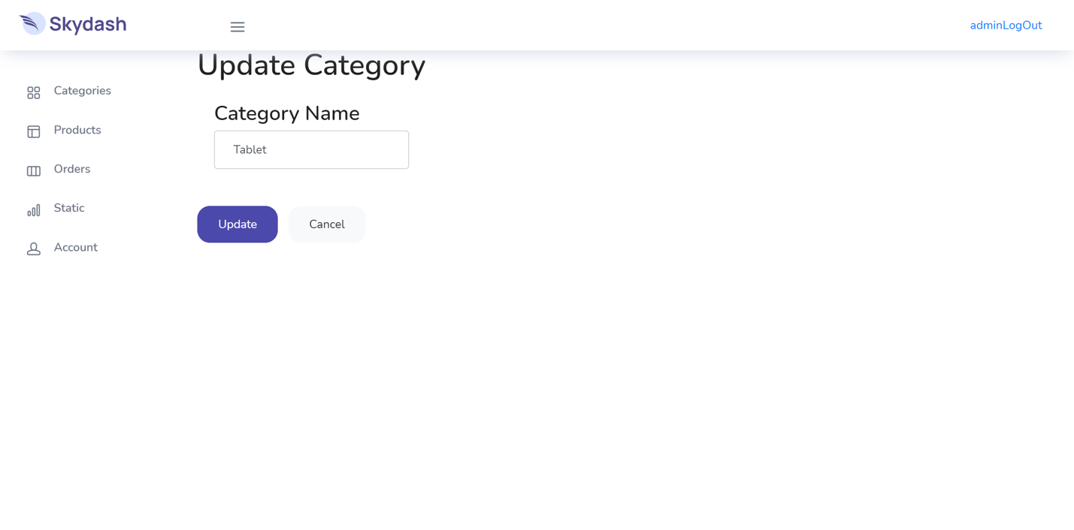

The system accepts Admin can Create and Update Delete products, In the Create product step, Admin system can create any new Categoty. However, CategoryName cannot be the same as the existing Categories on the system. If there is, the system will report the error "Category is Exist"

1. Controller Code

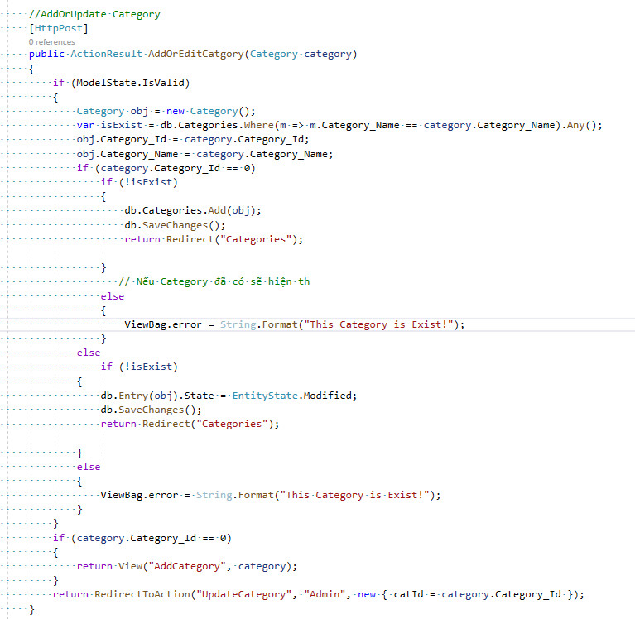

1. HTML Code

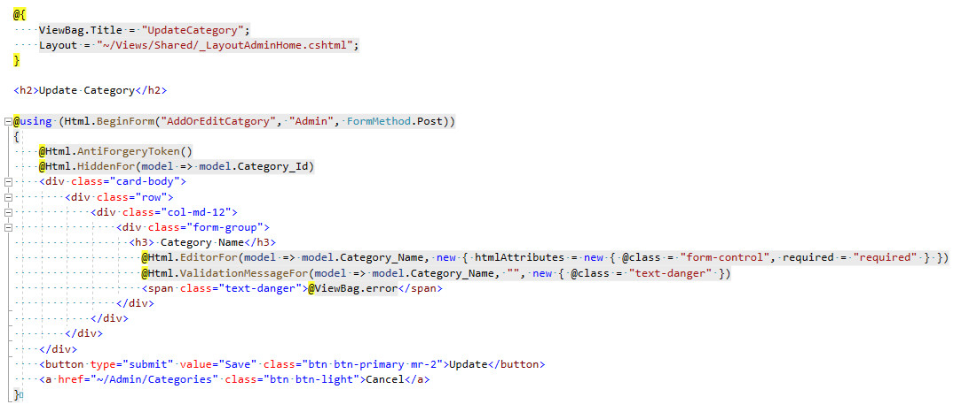

In the category editing section, the admin can edit the category he has selected, then edit the category in the data"CategoryName" section. The system will catch an error if data"CategoryName" has appeared in the database system and displays Alert"This" category is exist.Admin will choose other content to change the name of Category

1. **Testing**
2. **Aim**

When the project is completed, it is time for me to operate and check for errors during the working process of the system. Of course, it is necessary to make a detailed list of specific things to do and then do it based on the list. Error checking of the system is very necessary, so every stage needs meticulousness and absolute accuracy. So after checking and finding many errors, showing that it is a good sign from which I will improve the errors and problems. From there, the product that is delivered to the consumer will be more complete.

1. **Scope**

|  |  |  |  |
| --- | --- | --- | --- |
| **Scope Table** | | | |
| **No** | **Module** |  | **Description** |
| 1 | Register | Guest | Guests can create an account and log in to the system as a customer and use the website's services |
| 2 | Login | Admin | Admin can login and log out of the website |
| Customer | Customers can login and log out of the website |
| 3 | View | Admin | Admins can view their own profile details and even customer accounts |
| Customer | Customers can see their own profile and the orders they have placed on the system |
| 4 | Update | Admin | Admins can only edit their own basic information |
| Customer | Customer can only edit their own basic |
| 5 | Change PW | Admin | Admin can only change their password but they cannot change the password of other accounts |
| Customer | Customers can only change their own password |

**Admin Role**

|  |  |  |  |  |  |  |  |
| --- | --- | --- | --- | --- | --- | --- | --- |
| **Test case no.** | **Test case name** | **Action** | **Test data** | **Expected result** | **Actual result** | **Status** | **Note** |
| 1 | Category | Create Category | Category data | If the newly created Category matches the existing category in the dtb, it will report “This Category is Exist!” | Create Category | **Fail** | **You can still create a category with the macth name** |
| View Category | View Category Names | View Category Names | **Pass** |  |
| Delete Category | Deleting the category still does not affect the products that have been assigned that Category | Delete Category | **Pass** |  |
| 2 | Product | Create Product | Product data: NameProuct, Describe,Price,Quantity,Image, Category | Create a new product with the same product name as an existing product, | it will say “This Product is Exist” Pass | **Pass** |  |
| Quantity - Product price cannot be negative |  | **Fail** | **Value is negative** |
| Create Product | Create and save new products including values: | **Pass** |  |
| Edit Product | Product data: NameProuct, Describe,Price,Quantity,Image, Category | Edit the product's values: NameProuct, Describe,Price,Quantity,Image, Category | Edit Product | **Pass** |  |
| Delete Product |  | Delete the products but those products are still displayed in the order details, the order information of the old orders is not lost | Delete Product | **Pass** |  |
| Order | View Order | Order data: ID, Address, Name, Date, StatusPass | View the order information that the customer has checked out including: ID, Address, Name, Date, StatusPass | View data | **Fail** | **Mising data** |
| Search Order | Name | Orders can be searched by name |  | **Pass** |  |
| Set status |  | Change order status Cancelled, Completed,Comfirmed, Delivering, Prepared | Stored in system | **Fail** | **Cannot stored** |
| 4 | Account | Delete Account | Account data  Account data | Delete an account that already has orders but still keep the order history of that account | Does not affect old orders | **Fail** | **Delete account and lose orders** |
| View Account | Display full customer information such as: ID, USERNAME, PHONE, ADDRESSS |  | **Fail** | **Missing data** |
| Edit Account | Only the password of the account can be edited |  | **Pass** |  |
| Only the account's role can be edited |  | **Pass** |  |
| Create account | Check for the same UseName and Email Pass | Insert all data in to dtb | **Pass** |  |
| Insert all data in to dtb |

Figure 145 test log table

**Overview**

After the development project I tested 26 functions of the system. However, only 16 out of 26 work well, leaving 10 errors. So I tried. Retry and fix the errors in the system, it took a lot of time. To be able to complete the project and run smoothly, I tried to fix those 10 system errors. And finally on aprl,2022 I have perfected my system although it took a lot of time and effort for the system to reach consumers in the most complete way.

1. **Conclusion**

In today's technology era, e-commerce sites currently have an advantage in developing the service industry, so it is of great importance in building the economy. The e-commerce site that sells technology devices that I have built fully meets the basic requirements for the business, the basic functions are already complete. Its benefits are not at all. small, considered a lever to build the economy in the present time and especially in the time of difficult epidemic situation, limit direct contact, so the current direct business is taking a very high advantage. in the market. The project that I completed fully meets the requirements for content and features to serve users and admins. Functions: View, create, edit, delete products, Admin orders are done well. Besides, functions such as: view, add to cart, pay with cash or paypal all work very well. . In addition, the user interaction design also uses the User-centered Design research method. To study the target audience, the majority of customers are from young or middle-aged people because The design is based on simplicity and elegance that makes the user interface easy to use and interact with. The project is completed with basic features for business, but there are still some limitations in terms of ideas and advanced features compared to e-commerce sites on the market. So, after finishing the course, I will continue to research and develop the project in terms of design and advanced features such as: wishlist, customer product interactions or blacklist. Despite meeting many difficult in terms of ideas, knowledge and experience, but I always try my best to research documents on the Internet, or ask for help from friends and teachers to complete the project in the best way

.

1. **References**
2. The Interaction Design Foundation. 2021. *What is User Centered Design?*. [online] Available at: <https://www.interaction-design.org/literature/topics/user-centered-design> [Accessed 22 November 2021].
3. 2021. [online] Available at: <https://www.udemy.com/course/ajax-bootcamp-learn-asynchronous-javascript-and-xml/?utm_source=adwords&utm_medium=udemyads&utm_campaign=DSA_Catchall_la.EN_cc.ROW&utm_content=deal4584&utm_term=_._ag_88010211481_._ad_561092854203_._kw__._de_c_._dm__._pl__._ti_dsa-406594358574_._li_1028581_._pd__._&matchtype=b&gclid=Cj0KCQiA7oyNBhDiARIsADtGRZbj1hlneRtMSSlxqKT7treYRBySmlLcUkjIwdKeInOCyo_5IzaSbHIaAipFEALw_wcB> [Accessed 28 November 2021].
4. Docs.microsoft.com. 2021. *Step 7 View test results and log files*. [online] Available at: <https://docs.microsoft.com/en-us/windows-hardware/test/hlk/getstarted/step-7-view-test-results-and-log-files> [Accessed 29 November 2021].
5. 2021. [online] Available at: <https://www.merriam-webster.com/dictionary/scope%20out#:~:text=Definition%20of%20scope%20out,before%20deciding%20what%20to%20do.> [Accessed 29 November 2021].
6. Google Developers. 2021. *What Is a Sitemap | Google Search Central  |  Google Developers*. [online] Available at: <https://developers.google.com/search/docs/advanced/sitemaps/overview> [Accessed 29 November 2021].
7. business, , Lightspeed, S. and in, L., 2021. *Ecommerce Definition - What is Ecommerce*. [online] Shopify. Available at: <https://www.shopify.com/encyclopedia/what-is-ecommerce> [Accessed 29 November 2021].
8. Ecommerceguide.com. 2021. *What is Ecommerce? Ecommerce Definition Explained with Examples*. [online] Available at: <https://ecommerceguide.com/guides/what-is-ecommerce/> [Accessed 29 November 2021]
9. Know, 6. and William Craig on August 8, 2., 2021. *6 Advanced JavaScript Concepts You Should Know*. [online] WebFX Blog. Available at: <https://www.webfx.com/blog/web-design/6-advanced-javascript-techniques-you-should-know/> [Accessed 29 November 2021].
10. Dl.acm.org. 2021. *The Human-Dimensions of Human-Computer Interaction | Guide books*. [online] Available at: <https://dl.acm.org/doi/book/10.5555/1734072> [Accessed 29 November 2021].
11. The Interaction Design Foundation. (n.d.). What is Human-Computer Interaction (HCI)? [online] Available at: <https://www.interaction-design.org/literature/topics/human-computer>